# Kano Analysis: 3D Shield Product

## Feature Identification

* F1 - Adjustable Headband for Comfort
* F2 - Anti-Scratch Coating on Shield
* F3 - Stackable Design for Compact Storage
* F4 - Premium Optical Clarity
* F5 - Colour Options (e.g., black, blue, transparent)

## Questionnaire

<https://docs.google.com/forms/d/e/1FAIpQLSfJUsOD0t2YJ9FczwynZQeBYRhut7J1qKuB0HzsNgRrfD_u0Q/viewform?usp=header>

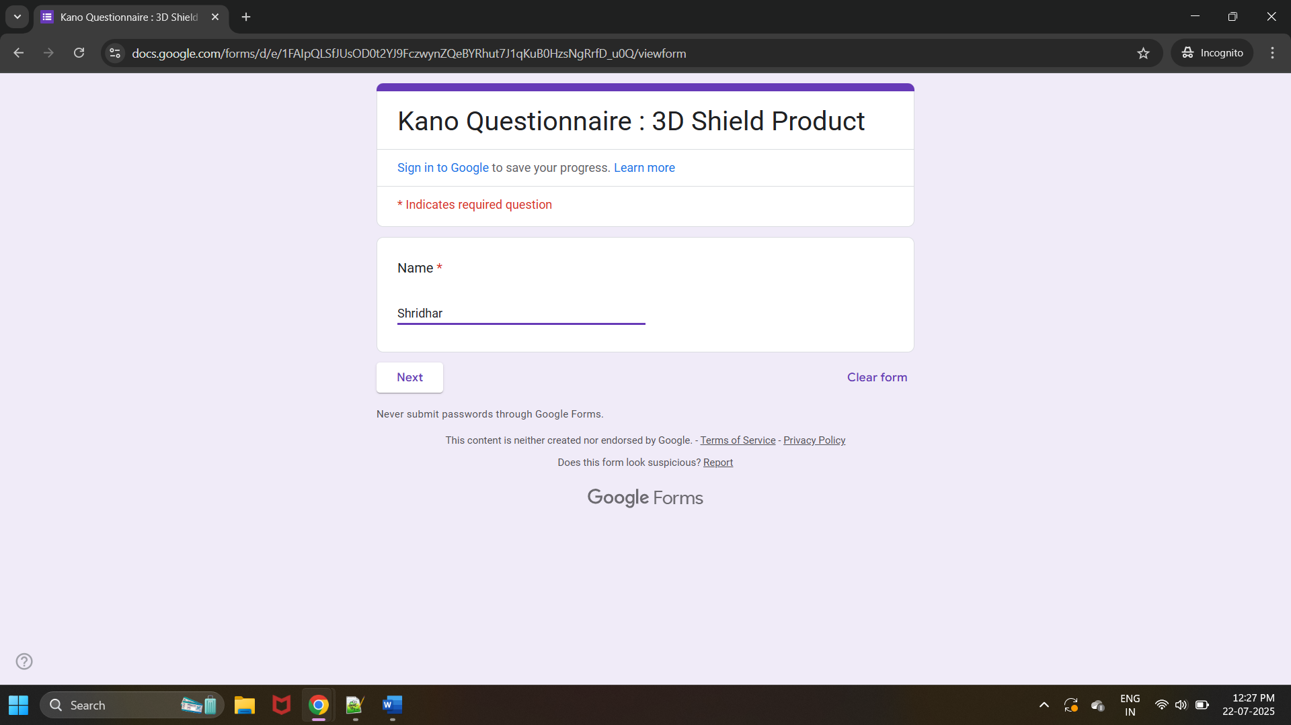

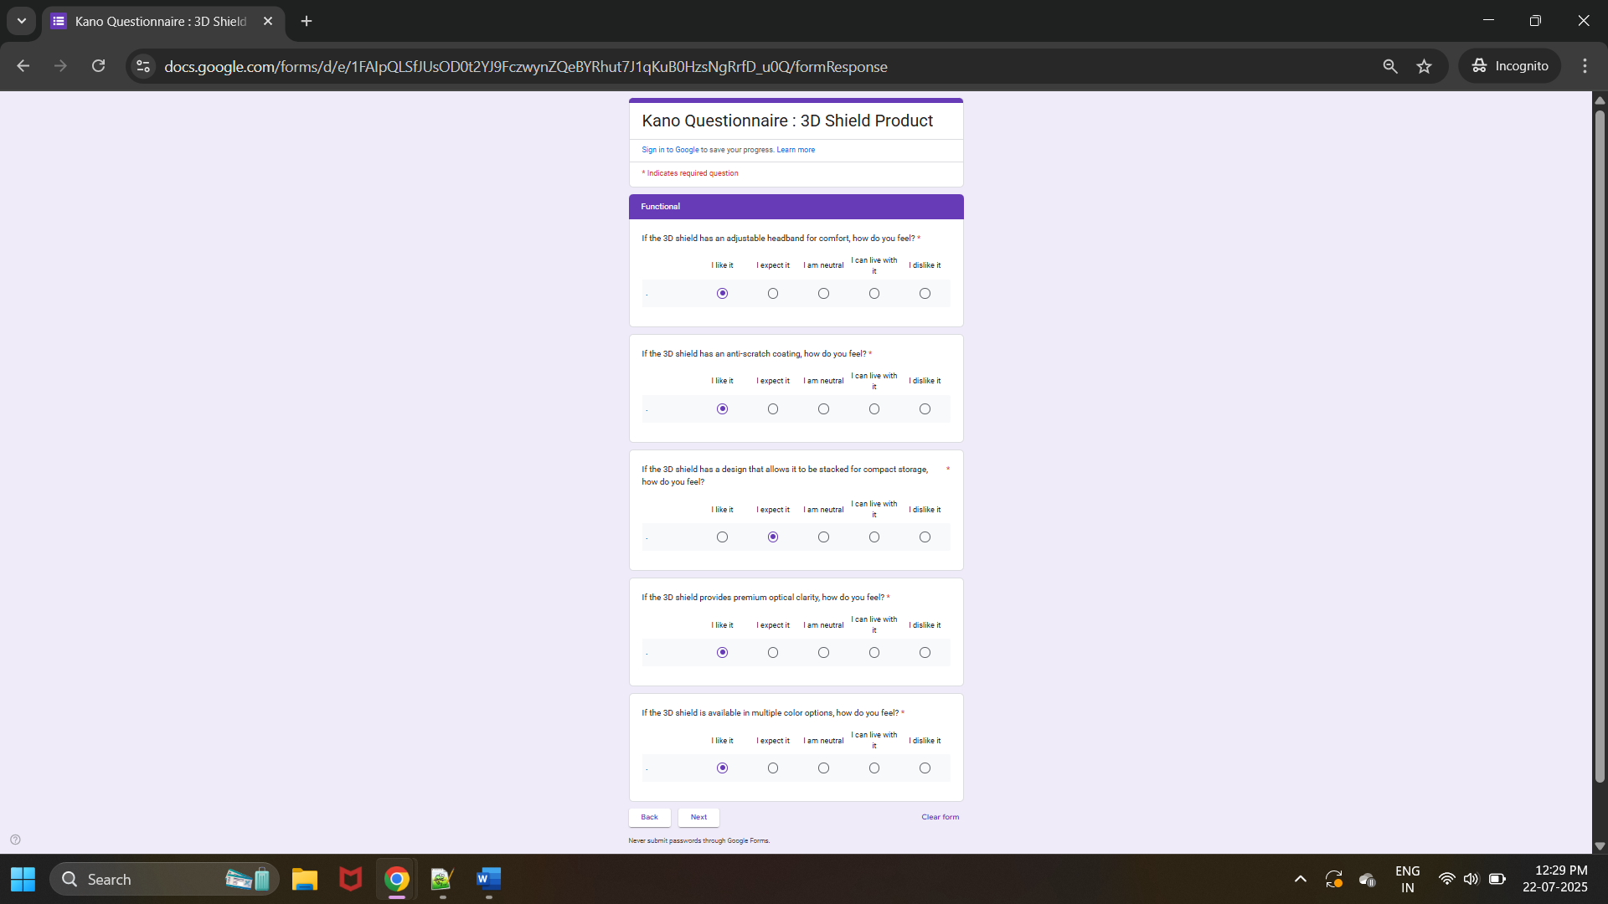

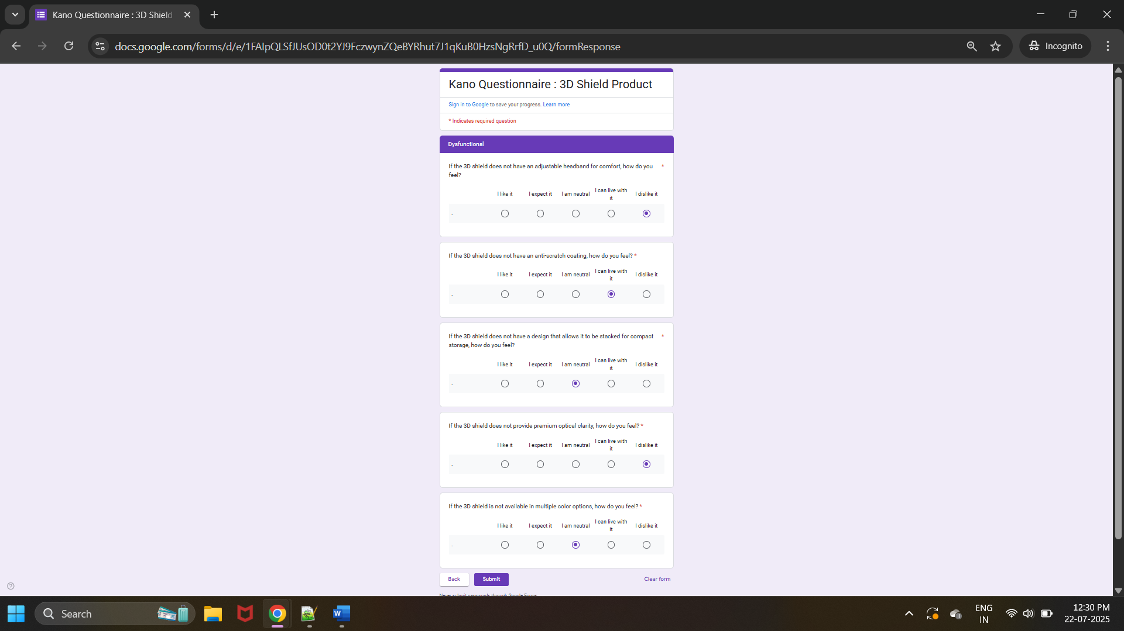

## Collected Data

Responses gathered from the survey.



## Kano Evaluation Table

|  |  |  |  |  |  |  |
| --- | --- | --- | --- | --- | --- | --- |
|  |  | **Dysfunctional** | | | | |
|  | **Customer Survey Responses** | **Like (L)** | **Expect (E)** | **Neutral (N)** | **Can live with (W)** | **Dislike (D)** |
| **Functional** | **Like (L)** | **Questionable** | **Delight** | **Delight** | **Delight** | **Performance** |
| **Expect (E)** | **Reverse** | **Indifferent** | **Indifferent** | **Indifferent** | **Mandatory** |
| **Neutral (N)** | **Reverse** | **Indifferent** | **Indifferent** | **Indifferent** | **Mandatory** |
| **Can live with (W)** | **Reverse** | **Indifferent** | **Indifferent** | **Indifferent** | **Mandatory** |
| **Dislike (D)** | **Reverse** | **Reverse** | **Reverse** | **Reverse** | **Questionable** |

## Kano Evaluation Table: 3D Shield Product

|  |  |  |  |  |  |  |  |  |  |  |
| --- | --- | --- | --- | --- | --- | --- | --- | --- | --- | --- |
| **Requirements** | **Delight** | **Performance** | **Mandatory** | **Indifferent** | **Reverse** | **Questionable** | **Total** | **Kano Category** | **Satisfaction Index** | **Dissatisfaction Index** |
| **F1 - Adjustable Headband for Comfort** | 2 | 11 | 6 | 2 | 0 | 0 | 21 | Performance | 0.62 | -0.81 |
| **F2 - Anti-Scratch Coating on Shield** | 13 | 0 | 0 | 8 | 0 | 0 | 21 | Delight | 0.62 | 0 |
| **F3 - Stackable Design for Compact Storage** | 6 | 0 | 0 | 15 | 0 | 0 | 21 | Indifferent | 0.29 | 0 |
| **F4 - Premium Optical Clarity** | 0 | 20 | 1 |  | 0 | 0 | 21 | Performance | 0.95 | -1 |
| **F5 - Colour Options (e.g., black, blue, transparent)** | 13 | 0 | 0 | 8 | 0 | 0 | 21 | Delight | 0.62 | 0 |

## Kano Graph

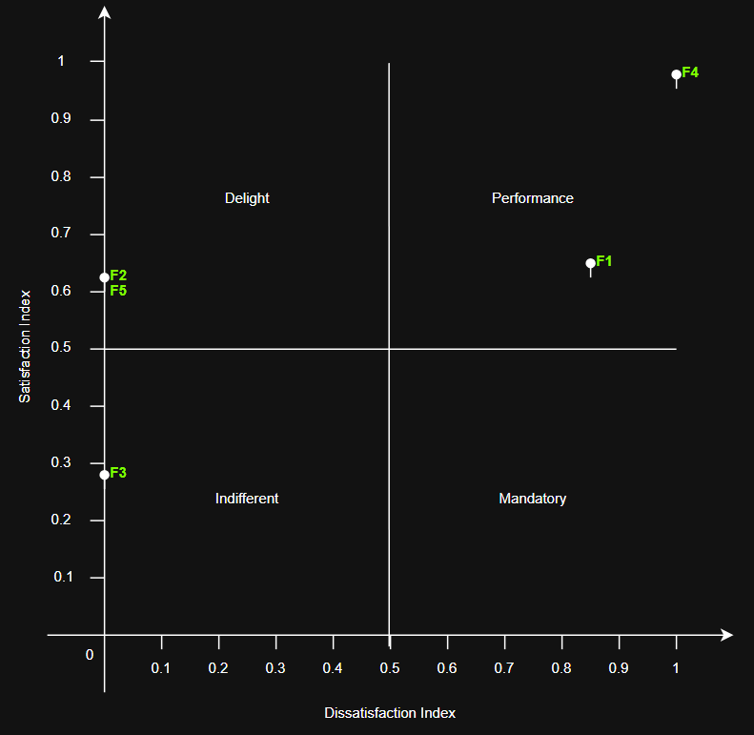

## Observations

Feature 1: Adjustable Headband for Comfort

* Category: Performance
* Interpretation: Users highly value comfort, and absence creates dissatisfaction.

Feature 2: Anti-Scratch Coating

* Category: Delighter
* Interpretation: Appreciated but not expected; good differentiator.

Feature 3: Stackable Design

* Category: Indifferent
* Interpretation: Customers do not actively care; beneficial for business ops but low customer impact.

Feature 4: Premium Optical Clarity

* Category: Performance
* Interpretation: High clarity is valued and creates satisfaction.

Feature 5: Color Options

* Category: Delighter
* Interpretation: Nice-to-have; can be a differentiator but not critical.

## Analysis

The analysis revealed that features like Adjustable Headband and Premium Optical Clarity are Must-be requirements for our target users, ensuring we avoid dissatisfaction upon launch. Anti-Scratch Coating and Colour Options emerged as Attractive features that can differentiate the product and enhance user delight, while Stackable Design was identified as Indifferent from the customer perspective but remains valuable operationally