# Van Westendorp Price Sensitivity Meter: 3D Shield Product

## The product

**New Product Concept**

*Nowadays, watching a movie in a theatre is very common in the urban population in India. Among these movie lovers, almost 20 to 30% population wear glasses. Due to technological advancements, nowadays, many 3D movies are being released. During the 3D movies, the spectators have to wear special 3D glasses. This is a major pain point for movie lovers who already have their specs. Wearing 3D glasses on top of specs is highly uncomfortable. There is a clear gap for this product in the market, as there are no other products that are easily available or are too expensive.*

*This presents an opportunity to position a lightweight, curved 3D shield as a comfortable, universal alternative for glasses and non-glasses users. A lightweight, curved 3D shield designed for use in movie theatres, worn like a face shield but positioned comfortably away from the face, allowing spectacle wearers to watch 3D movies without discomfort. The shield uses high-quality polarized film compatible with existing 3D cinema systems, offering clear visuals, comfort, and universal usability for all customers.*

## The Process

Step 1: Identify the optimal price range and acceptable “too cheap”/“too expensive” thresholds for 3D shield.

Step 2: Draft the Four Van Westendorp Questions:

* At what price would you consider the 3D shield so inexpensive that you would question its quality?
* At what price would you consider the 3D shield a great buy for the money?
* At what price would you consider the 3D shield starting to get expensive, but you might still consider buying it?
* At what price would you consider the 3D shield so expensive that you would not consider buying it?

Step 3: Collect at least 100–200 responses from representative users.

Step 4: Remove outlier entries.

Step 5: Plot the Price Sensitivity Curves.

Step 6: Identify Key Intersection Points

* Point of Marginal Cheapness (PMC)
* Optimal Price Point (OPP)
* Point of Marginal Expensiveness (PME)

Step 7: Identify a reasonable price to launch for the 3D shield.

## The Findings

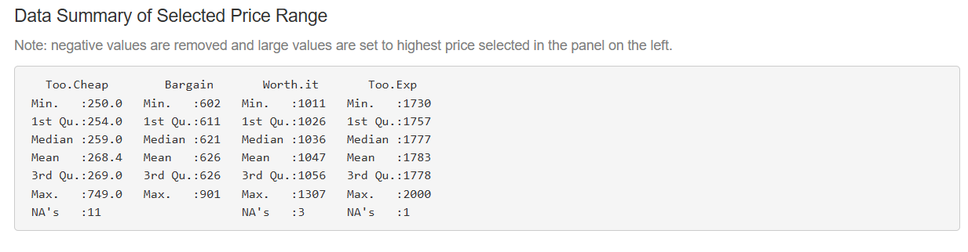

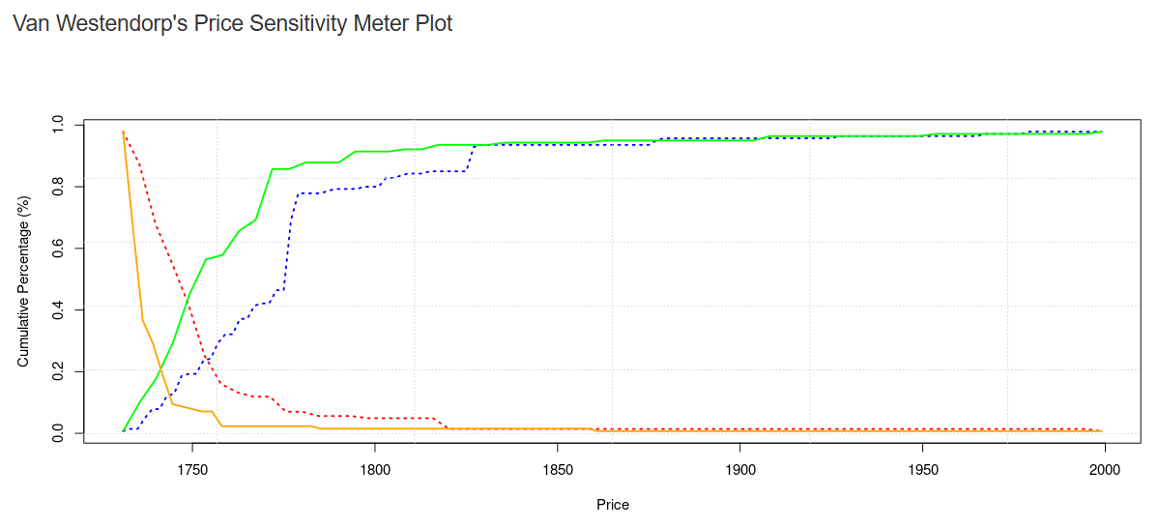

## The conclusions

Point of Marginal Cheapness (PMC): 621

Optimal Price Point (OPP): 1036

Point of Marginal Expensiveness (PME): 1777

The reasonable price to launch for the 3D shield is between 621 to 1777