Required Assignment 5.2: Comparative Positioning Analysis: Tesla Roadster vs. Hyundai Ioniq

**Shridhar Dhuri**

**Suggested time:** 90 minutes

**Inferences from Positioning Statements**

1. Tesla Roadster:

* Target Market: Rich consumers looking for an electric sports car with high speed and high performance, but environment friendly. They are ready to pay a high cost and can afford to use only a two-seater car.
* Unique Selling Proposition (USP): First production all-electric car to travel more than 244 miles per charge, and the car accelerates from 0 to 60 mph in 3.7 seconds.
* Brand Messaging: "To accelerate the world's transition to sustainable energy". The Tesla Roadster's brand messaging focused on high performance, luxury, and sustainability.

1. Hyundai Ioniq:

* Target Market: Budget-conscious consumers looking for a fuel-efficient compact car. Ready to buy any of the variants (hybrid, plug-in hybrid, electric) as per suitable to their need.
* Unique Selling Proposition (USP): EPA's (Environmental Protection Agency, USA) most efficient vehicle with a rated fuel economy of 136 miles.
* Brand Messaging: "I'm in Charge". This slogan emphasizes the brand's focus on empowering individuals to make sustainable choices and take control of their impact on the world. It's a call to action for conscious living and responsible mobility, highlighting the brand's commitment to electric vehicles and eco-friendly practices.

**Framework Application**

1. Market/Firm Newness Matrix:

* Tesla Roadster Placement:
  1. Visual Representation:

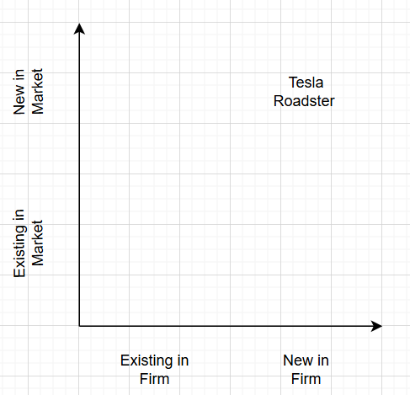

* 1. Reasoning: Tesla Roadster represents a new market segment (high-performance electric sports cars) from a relatively new firm in the automotive industry (Tesla), expanding into a new luxury EV.
* Hyundai Ioniq Placement:
  1. Visual Representation:

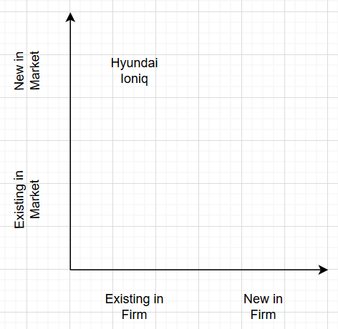

* 1. Reasoning: Hyundai Ioniq is an entry into the EV/hybrid market (new market) from an established automotive firm (Hyundai), expanding Hyundai’s portfolio into eco-friendly options for its existing customer base.

1. Opportunity Cost/Development Risk Matrix:

* Tesla Roadster Placement:
  1. Visual Representation:

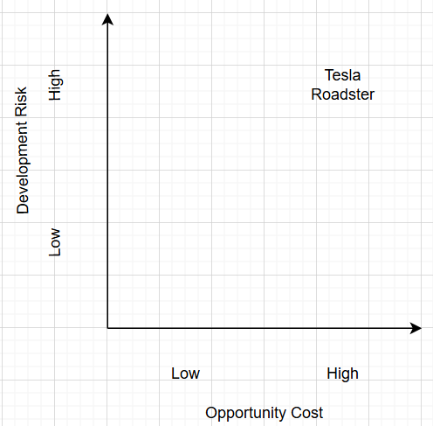

* 1. Reasoning: The Roadster has high development risk (new design, latest technology) and high opportunity cost as Tesla is using significant R&D, engineering, and capital resources for low low-volume product.
* Hyundai Ioniq Placement:
  1. Visual Representation:

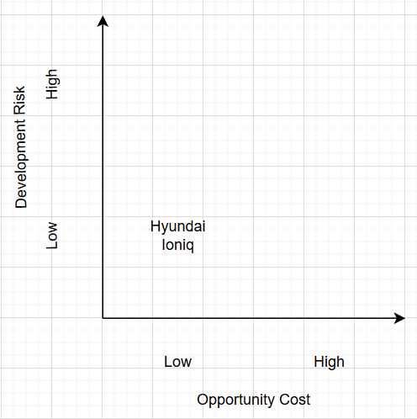

* 1. Reasoning: The Ioniq involves low development risk (leveraging existing EV/hybrid technologies) and lower opportunity cost, aligning with Hyundai’s mass production strategy.

**Comparative Analysis**

* Strengths of Tesla Roadster's Strategy:
  + Strengths:
    - Creates Tesla’s brand as a market leader in electric sports cars.
    - Creates EV car's image equivalent to the regular sports cars, shifting perceptions.
  + Challenges:
* Tesla is investing high in R&D for a low-volume segment.
* There is a risk of non-acceptance of EV sports cars by traditional sports car fans.
* Hyundai Ioniq's Strategy:
  + Strengths:
* Appeals to the mass market with affordability and practicality.
* Builds Hyundai’s green and sustainable image.
* Flexible approach (hybrid, plug-in, full EV) attracts all types of consumers.
  + Challenges:
* Faces intense competition from other budget EVs.
* Does not create any special brand image like Tesla.
* Insights into Positioning Effectiveness:

Tesla Roadster’s positioning as a high-performance electric sports car aligns with Tesla’s mission to accelerate the world’s transition to sustainable energy. They are willing to take high risks and absorb high costs to develop cutting-edge technology. At the same time, they are creating a unique brand image, demonstrating the superiority of electric vehicles, attracting significant attention, and leading innovation in the automotive industry. Due to their aggressive positioning in this ultra-high-performance EV segment, they currently face very limited direct competition.

The Hyundai Ioniq’s positioning effectively addresses the cost issues with EV cars, providing practical, reliable, and accessible electric/hybrid cars. It aligns with Hyundai’s strategy to do mass production and capture a large volume of customers while establishing its presence in the EV market.