Required Assignment 7.2: Developing a Product Roadmap

**Shridhar Dhuri**

**Suggested time:** 90 minutes

**Roadmap Type**

theme-based

**Key Milestones**

1.

Theme: Comfort and Usability Validation

Milestone: Prototype Design & Development

Create low-quality and functional prototypes focusing on comfort, fitting over spectacles, and lightweight.

2.

Theme: Feasibility and Quality Testing

Milestone: Visual Quality Testing

Test compatibility with Standard and IMAX 3D systems for clarity and visual quality.

3.

Theme: Market Validation and Customer Feedback

Milestone: Customer Testing in Controlled Environments

Test shields with spectacle wearers in cinema environments, gathering feedback on comfort and user experience.

4.

Theme: Go-to-Market Readiness

Milestone: Manufacturing and Cleaning Process Finalization

Identify lightweight, durable materials, cleaning procedures, and vendor partnerships for pilot scale.

5.

Theme: Pilot Launch and Feedback Iteration

Milestone: Pilot Launch in Select Theaters

Deploy shields in 2–3 multiplexes for real-world use, collect customer and cinema staff feedback, and refine.

**Timeline**

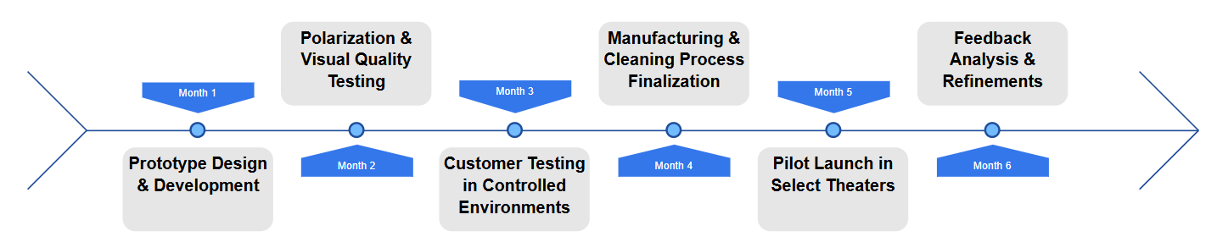

**Strategic Alignment**

* Prototype Development aligns with customer comfort, a core strategic goal for differentiation from standard 3D glasses.
* Quality Testing aligns with ensuring cinema compatibility and building trust with B2B partners.
* Customer Testing ensures product-market fit before large investments.

**Risk Assessment**

1.

Risk: Inconsistent visual quality.

Mitigation: Test multiple film vendors with different theater setups.

2.

Risk: Low customer adoption due to hygiene concerns.

Mitigation: Conduct early user testing to refine the design for better hygiene.

**Reflection**

The roadmap will be shared using a PowerPoint or Miro board in stakeholder meetings to ensure cross-functional alignment, clear milestone ownership, and early risk identification during the 6-month timeline.