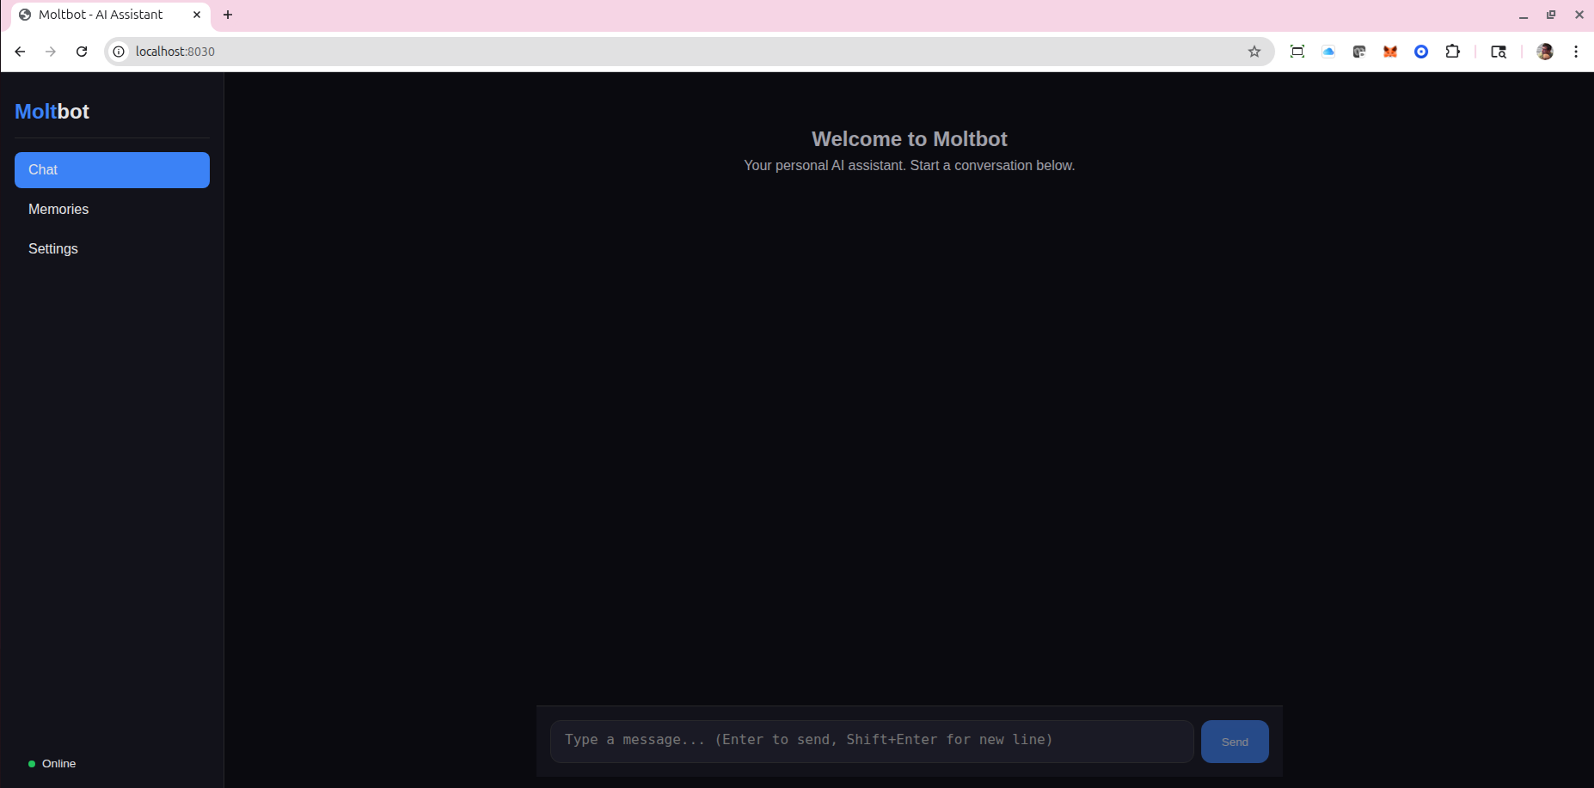

MoltBot - Personal AI Assistant
Capabilities Document
Version 2.0.0 | February 2026

Overview
MoltBot is a comprehensive self-hosted personal AI assistant—a JARVIS-style hub powered by Claude. It provides intelligent assistance through multiple communication channels including Telegram, Discord, Slack, voice commands, web dashboard, and REST API. The system features 30+ tools for shell execution, file operations, browser automation, web search, document generation, and more.

MoltBot learns from interactions through a sophisticated RAG-based memory system, supports 15 domain expert personalities, and includes enterprise features like multi-user support, SSO integration, and comprehensive security controls.

Key Features
Feature | Description
Multi-Channel Input | Telegram, Discord, Slack, Web, API, Voice
Voice Interface | Wake word detection ("Hey Molt"), continuous conversation
Tool Execution | 30+ tools including shell, browser, files, search
Memory System | RAG with pgvector, auto-extraction, importance scoring
Sub-Agent System | Research, Coding, Writing, Analysis agents
File Generation | PDF, Word, Excel, PowerPoint, charts, AI images
Personality System | 15 domain experts, mood detection, tone adaptation
Workflow Automation | IFTTT-like triggers, conditions, and actions
Enterprise Ready | Multi-user, SSO, quotas, Kubernetes support
Desktop & Browser | Electron app, Chrome/Firefox extension

Technology Stack

Core Technologies
Technology | Purpose | Version
Bun | Runtime | Latest
TypeScript | Language | 5.x
Hono | API Framework | 4.x
PostgreSQL | Database | 16
pgvector | Vector Search | Latest
Redis | Cache/Queue | 7
BullMQ | Task Queue | 5.x
Drizzle | ORM | Latest

Communication Frameworks
Technology | Purpose | Version
grammY | Telegram Bot | 1.x
discord.js | Discord Bot | 14.x
@slack/bolt | Slack Bot | 3.x
Playwright | Browser Automation | 1.x
React | UI Framework | 18
Electron | Desktop App | Latest

AI Models
AI Model | Status | Purpose
Claude (Anthropic) | ✅ Active | Primary AI Brain
OpenAI GPT-4 | ✅ Active | Embeddings, Vision
OpenAI Whisper | ✅ Active | Speech-to-Text
ElevenLabs | ✅ Active | Text-to-Speech (JARVIS voice)
DALL-E | ✅ Active | AI Image Generation
Ollama | ✅ Ready | Local LLM Fallback
faster-whisper | ✅ Ready | Local STT (GPU)
Piper | ✅ Ready | Local TTS

Input Channels
Channel | Status | Features
Telegram | ✅ Active | Text, voice, images, documents, inline keyboards
Discord | ✅ Active | Slash commands, DMs, voice channels, mentions
Slack | ✅ Ready | App mentions, threads, file attachments
Web Dashboard | ✅ Active | Chat, memory explorer, settings, task monitor
REST API | ✅ Active | Full programmatic control
Voice | ✅ Active | Wake word, VAD, speaker diarization
Desktop App | ✅ Active | System tray, global hotkeys (Ctrl+Shift+M)
Browser Extension | ✅ Active | Popup chat, context menu, page summarization

Integrations

Communication & Productivity
Integration | Status | Capabilities
Email (IMAP/SMTP) | ✅ Active | Read, send, AI inbox summarization
Twilio | ✅ Active | SMS, phone calls, voice messages
GitHub | ✅ Active | Repos, issues, PRs, AI code review
Notion | ✅ Active | Pages, databases, search, sync
Google Calendar | ✅ Active | Events, reminders, triggers
Outlook Calendar | ✅ Active | Events, reminders, triggers

Smart Home, Entertainment & Cloud
Integration | Status | Capabilities
Home Assistant | ✅ Active | Device control, automation
Spotify | ✅ Active | Playback, playlists, search
Google Drive | ✅ Active | Upload, download, search
Dropbox | ✅ Active | Upload, download, sync

Finance
Integration | Status | Capabilities
Crypto (CoinGecko) | ✅ Active | Prices, portfolio tracking
Stocks (Yahoo/Alpha Vantage) | ✅ Active | Prices, charts, alerts
Currency Exchange | ✅ Active | Real-time conversion

Security Features
Feature | Status | Description
2FA Authentication | ✅ Active | TOTP for sensitive operations
Biometric Verification | ✅ Active | Mobile biometric support
Memory Vault | ✅ Active | Encrypted sensitive storage
Audit Logging | ✅ Active | Complete action history
GDPR Compliance | ✅ Active | Data export, deletion tools
Rate Limiting | ✅ Active | Per-user, per-operation limits
Command Sandboxing | ✅ Active | Allowlist/blocklist for shell
Plugin Isolation | ✅ Active | Sandboxed plugin execution

Sub-Agent System
Agent | Purpose
Research Agent | Web search, information synthesis
Coding Agent | Implementation, debugging, code review
Writing Agent | Drafts, editing, content creation
Analysis Agent | Data processing, insights

Domain Experts (15)
Expert | Specialty
Coding Expert | Software development
Legal Expert | Legal advice and analysis
Medical Expert | Health information
Finance Expert | Financial guidance
Writing Expert | Content and copywriting
Research Expert | Deep research and synthesis
Teaching Expert | Education and explanations
Business Expert | Strategy and operations
Marketing Expert | Marketing and promotion
Design Expert | UI/UX and visual design
Data Expert | Data analysis and visualization
Security Expert | Cybersecurity guidance
DevOps Expert | Infrastructure and deployment
Product Expert | Product management
Career Expert | Career guidance

Statistics
Metric | Value
Total Features | 250+
Tools | 30+
Integrations | 15+
Domain Experts | 15
Sub-Agents | 4
Source Files | 150+
Lines of Code | ~52,000
Unit Tests | 1,733

GoGreen Paperless Initiative
MoltBot - Personal AI Assistant | Version 2.0.0 | February 2026

