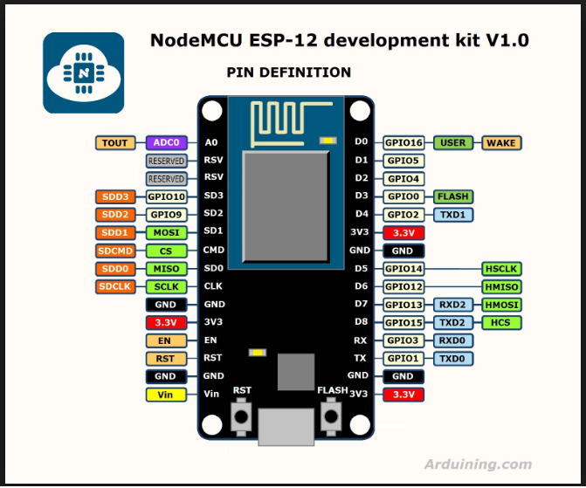

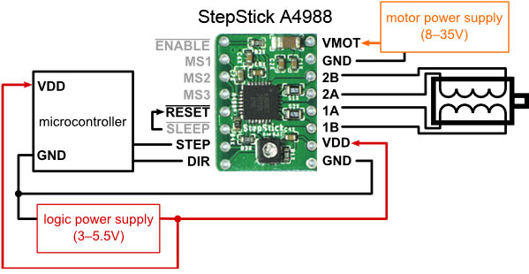

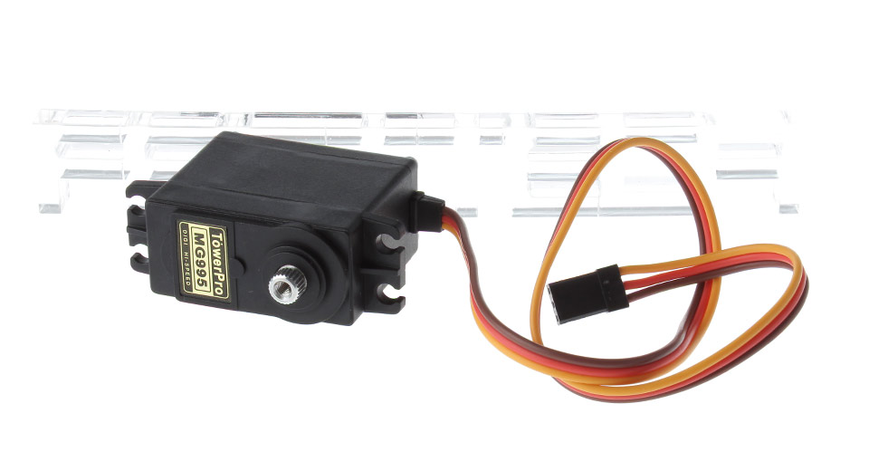
BROWN – GND
RED - +5V
ORANGE - D4 (NodeMCU)

NodeMCU configuration procedure

1. In Arduino IDE load sketch:

https://raw.githubusercontent.com/dsikar/iot-graffiti/master/arduino/iot-graffiti/iot-graffiti.ino

2. Edit network SSID and password in void setup() e.g.

WiFiMulti.addAP("Makerversity_2G", "mak3rv3rs1ty");

3. Edit http request address (in case server is not responding) in void loop() e.g.

String httpReq = "http://34.251.26.97/graffiti.php";

4. Connect NodeMCU board with USB micro cable.

5. Select Tools > Board > NodeMCU 1.0 (ESP-12 Module)

6. Select Tools > Port > (COM Port) *beware of other USB devices*

7. Upload sketch to NodeMCU (CTRL+U).

8. Remove USB Cable and power NodeMCU with jumper wire from breadboard to pin VIN (bottom left).

Web access

Access canvas.php on the same IP address as configured in NodeMCU e.g.

http://34.251.26.97/canvas.php

Start up procedure

1. Reset NodeMCU (reset button to left of USB connector).

2. Ajust weight heights as per photo:



