**Memorandum**

To: Deborah Sills, Ph. D.

From: Jared Fallt

Date: 9/24/2013

Re: Chlordane Concentration Fit



**Objective**

The objective was to fit the chlordane concentration data to either a linear of a Freundlich model in order to determine the parameters for the sorption isotherm of chlordane on GAC. The model parameters will be used to design a bench-scale treatment unit that will be further tested.

**Methods**

The data set was analyzed using Kaleidagraph in order to fit the data set to both the linear and the Freundlich models. This was done to avoid transforming non-linear data to fit a linear model. Visual inspection was used to determine the proper model for the data set.

**Results & Discussion**

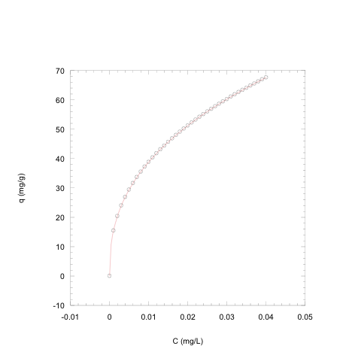

K= 245 n=2.5

Figure 1. Measured dissolved chlordane concentration, Caw (mg/L) vs absorbed chlordane concentration, Cabsorbed (mg/g). The circles are the plotted data points and the line is the fitted curve to the Freundlich equation.

q = KC1/n (1)

where q = mass of adsorbate adsorbed per mass of adsorbent at equilibrium (mg/g), C = concentration of adsorbate in the aqueous phase at equilibrium (mg/L), K = Freundlich isotherm soil-water partition coefficient((mg/g)(L/mg)), and 1/n = Freundlich isotherm intensity parameter (unitless).

By visual inspection, the Freundlich fit of the data appeared to fit well based on points proximity to the fitted curve. The linear fit had a significant proximity difference and therefore did not fit the data.