Revision History:
Version | Created/Updated By | Created/Updated Date | Comments
1.0 | Alvin Chettiar SSO()  Sheru Shaikh (502544158)  Sanchi (502619581) | 10 Feb 2016  26 April 2016  21 July 2017 | Created Standard Job template for PeS job

1. Purpose
Banking is a program for sending the home/host bank account and other bank details to pes(PeopleSoft) for active US GME’s. PeopleSoft then compares the data in the file with the data in their system and will update it at their end. In case of any queries, they will contact GMS payroll Team

Precheck for this Program is executed during PeS Precheck Run program every Wednesday and Main Run is carried out automatically when Consolidated Program is executed every week on Thursday.

tbl_peoplesoft_master has program id’s for each job. Program ID 10 is for Banking File.

Days/Dates and time on which these jobs are executed is predefined in the database tables.

PeS Preliminary Precheck internally calls Consolidated program executable with an identifier(@isPrecheck=1) which tells the program that the Precheck Run is to be processed. For main run, no identifier is passed to the respective stored procedure.

Program ID | Description | Table | Procedure | File Name
10 | Banking File | tbl_peoplesoft_banking | stp_peoplesoft_feed_banking | GMS.DIRECT.DEPOSITS (Flat File)
29 | Banking Precheck |  | stp_peoplesoft_feed_banking_precheck | Banking_Error_Report.xls

2. Scope
This SOP should be referred by the team members responsible for executing and maintaining the PeopleSoft (PeS) payroll processes. This SOP is limited to execution of PeS – Precheck and Main Run.

3. Prerequisites
- Production Windows server access. Server IP: 3.239.34.151/ Server Name: CISCIHPWEB810v.
- Access to Link_GE database.
- Cross Reference (XRef) file.

4. Other Details
- PeS Precheck Run – runs usually on Wednesday (may change depending on PeS payroll calendar) – 8:00am EST
- On Precheck Run day we do not transmit files to PeS.
- Job Execution – Automatic
- Email correspondence, upload file to support Central.

5. Procedure
As we have all the prerequisites in place, let’s begin the process.

- Precheck Run :

- PeS Precheck Run is scheduled to run at 8am EST/5:30 or 6:30 pm IST.
- Check email from ‘link.alert@ge.com’ with subject line as Bank Precheck File’. Open the attached file named ‘Banking_Error_Report.xls’ and check for errors. Take appropriate troubleshooting steps if errors are found.

Step 2 – Check PeS program Job logs and Job History table to check for failure/success :

- Check PeS Preliminary Precheck Job program log at “E:\Interfaces_Payroll\Peoplesoft\consolidated program\Peoplesoft2.log” if all the PeS programs executed successfully/failed.
- Check tbl_job_run_history_master table of Link_GE Database for PeS Program ID 29,10 if it has a success
- There should be a record for each job program id. Check for ‘run_status’ column for each program. If value is “Success” then it means job procedure has executed successfully. If status is “Started” then it means that job procedure has started but not executed completely and if the status is “Failure” then the job has failed. Check the sql_error_message column for more details on the failure.

Step 3 – Check job table and file counts:
- Verify table data counts and flat files data counts if they match.
- Open the generated flat file and match the record count of flat file with the records inserted in the Banking table.
- Table name: Link_GE..tbl_peoplesoft_banking
- Query: select count (*) from Link_GE..tbl_peoplesoft_banking

Step 4 – Send Precheck excel reports to functional users:
- In case of any errors in the Banking Precheck Error Report, we will send Banking Error report to the users for review
  - Error Report File Name : Banking_Error_Report.xls

- Banking flat file and error report location - E:\Interfaces_Payroll\Peoplesoft\banking folder
- Copy the file from application server to local machine for sending them as email attachment.
- Functional users verify and correct any errors recorded in the error report excel file.
  - Email :
    - Email subject is ‘PeopleSoft Run Precheck’.
    - Please refer previous emails for TO, CC and BCC addresses.
    - Email body for Precheck run:

Hi,

Please find the attached Precheck errors and flat files for today's run.
Please let us know if any of the records in Precheck needs to be updated.

Regards,
Sender Name

- If there are no Precheck errors in the error report excel files, we don’t send the banking error file to the functional users. If error exists, functional users fix those errors from KPMGLINK application and reply, asking us to perform the necessary steps to rectify the error at our end.
- In case of error, the same email procedure is carried out again until the functional users reply ‘Files are Okay’.

- File is NOT transmitted after Precheck Run.

In case the job is to be re-ran:

- If the user requests for the re-run of the process for that we need to make the completed flag as zero at following link by unchecking the checkbox for program id 29,10 from the UI
https://gmsapps.corporate.ge.com/Customer_Service/Payments/PeoplesoftFlag/main.asp
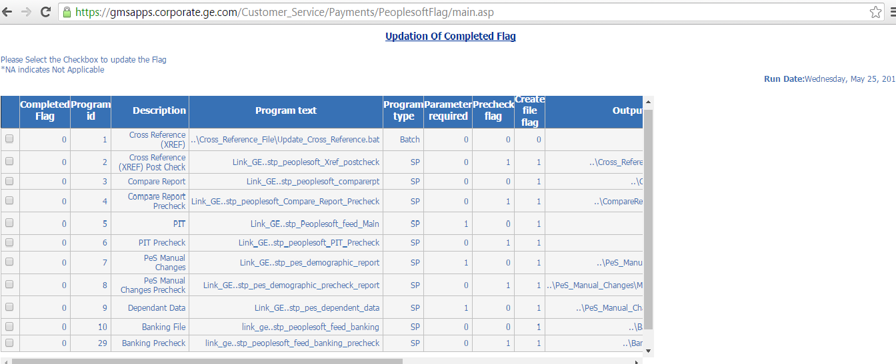

- We can check whether the link is made zero or not by using the query :
select pd.Program_id,pm.description,pm.program_text,completed_flag,payroll_date,fiscal_week,run_type,pd.parameter_from_date,pd.parameter_to_date
from Link_GE..tbl_peoplesoft_dates pd
inner join link_ge..tbl_peoplesoft_master pm on pm.program_id= pd.program_id
where pd.Payroll_date = 'YYYY-MM-DD’

- If the completed flag is zero
- Run the peoplesoft preliminary exe in case of Precheck run at
E:\Interfaces_Payroll\peoplesoft\peoplesoft preliminary.exe

- Main Run

- PeS Consolidated Program (Main Run) is scheduled to run at 12:30 am EST.
- If the user requests for the re-run of the process for that we need to make the completed flag as zero at following link by unchecking the checkbox
https://gmsapps.corporate.ge.com/Customer_Service/Payments/PeoplesoftFlag/main.asp

- We can check whether the link is made zero or not by using the query :
select pd.Program_id,pm.description,pm.program_text,completed_flag,payroll_date,fiscal_week,run_type,pd.parameter_from_date,pd.parameter_to_date
from Link_GE..tbl_peoplesoft_dates pd
inner join link_ge..tbl_peoplesoft_master pm on pm.program_id= pd.program_id
where pd.Payroll_date = 'YYYY-MM-DD’

- If the flag is made zero, then we need to again run the consolidated by double clicking on the peoplesoft exe.
- Banking Process is executed as part of the PeS Consolidated Program for Main Run at 10:03 EST.
- Check email from ‘link.alert@ge.com’ with subject line as ‘Banking Precheck File’. Open the attached file named ‘Banking_Error_Report.xls’ and check for any errors.
- One flat file is generated during the main run. Path of flat file is E:/Interfaces_Payroll/PeopleSoft/Banking/GMS.DIRECT.DEPOSITS
- Email is send only if we have any error in the Precheck file
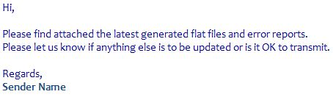
- After the main run, we need check if the checking_or_saving_code is ‘c’ or ‘C’.
- Similarly, check if the checking_or_saving_code is ‘s’ or ‘S’
- If it is ‘c’ then update the value to ‘C’ in banking table .
- Similarly, for ‘s’ update to ‘S’

Step 7 – Screenshots for Main Run:

- Verify if the Banking Transmit job transmitted the file successfully to the specified location.

- We need to run an FTP command which is saved in FTP_screenshot.txt. Path for this txt file is E:\Interfaces_Payroll\Peoplesoft\Banking\FTP_screenshot.txt

- Open the above txt file, copy the commands using Ctrl+A, Ctrl+C.

- Open a new command prompt (cmd) window, and paste the above copied commands by right-clicking in the cmd window, click on paste and hit enter.

- The generic naming convention for saving the above file is:
Filename_YYYY-MM-DD.jpg

- Now take the screenshot of the output in the terminal (cmd) window and save it in E:\Interfaces_Payroll\Peoplesoft \Peoplesoft_Screenshots\Banking\

- The above screenshot name should always be ‘Banking_YYYY-MM-DD’.

Note : Since this job is scheduled on Autosys, we need to moniter the job whether it ran successfully and take the screenshot

