Revision History:
Version | Created/Updated By | Created/Updated Date | Comments
1.0 | Alvin Chettiar SSO()  Sheru Shaikh (502544158)  Sanchi (502619581) | 10 Feb 2016  26 April 2016  20 May 2016 | Created Standard Job template for PeS job

1. Purpose
Link to PES is a program in which transactions are picked up by Cendant and sent to payroll was set by offweek process.

The Cartus Link to PES batch Job is executed after the Offweek process which sets the sent to payroll date after we run the link to pes.

The Cartus to Link Pes Job gives us output, which is further subdived to gross up and no gross up.

The Program executes in Main Mode every Tuesday after the Offweek process and Wednesday manually at any time.

Offweek Main Run will set the sent to payroll date for the Transactions and only those are picked up by the Cartus to Pes Program

S. No | Batch File/ Stored Procedure | Database/FileLocation
1 | ##stp_CartusToPeS | Link_GE
2 | CartustoPes.bat | E:\Interfaces_Payroll\Peoplesoft\Cartus

2. Scope
This SOP should be referred by the team members responsible for executing and maintaining the PeopleSoft (PeS) payroll processes. This SOP is limited to execution of PeS – Precheck and Main Run.

3. Procedure
As we have all the prerequisites in place, let’s begin the process.

Step 1 – Standard Operating Practices for running the Batch Job for the Gross Up /No Gross up Run:
- After the Main Run of Offweek Program (Tuesday 12:30 AM EST) run the following procedure :
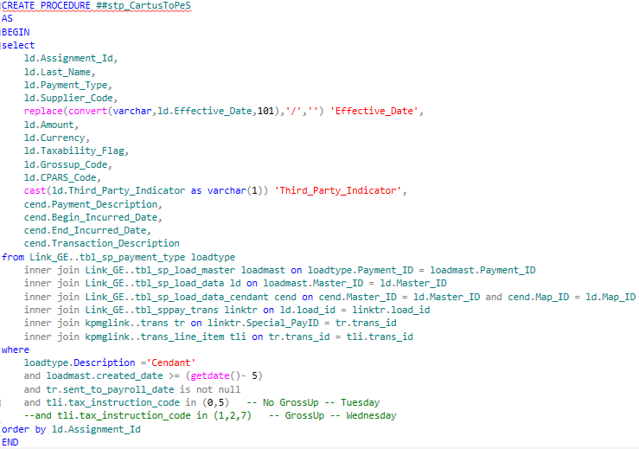

The Procedure is present on the path: E:\Interfaces_Payroll\Peoplesoft\Cartus
File name: TempProc_CartusToPes.txt

- Make sure to comment the and tli.tax_instruction_code in (1,2,7) when executing the procedure for Gross Up as Cartus to PeS No Gross Up file is sent on Tuesday and Gross Up file is sent on Wednesday after the Cartus to PeS Gross Up run.
- After executing the procedure, run the CartustoPes .bat file available on the location E:\Interfaces_Payroll\Peoplesoft\Cartus
- Bat file populates the data from the file to the table.
- To check the count of the file and the table we use the check query.
- The batch file will create the mmddyyyyCartus_LINKtoPeS.txt file
- Encrypt this file with the EDI.DEPT encryption key. For this you need to configure the key in the GnuPGK key manager (import the EDI.DEPT key)
- Transmit the encrypted key to the Cartus to PeS FTP location /home/500100249//tovan/cartuspayroll
- While Transmission select the binary mode in transfer setting option upon dialog box for uploading the file on the FTP server FTP Credentials for Cartus to PeS
- We take the backup of file on path E:\linktoPes
- We take the screenshot of the transmitted file and save it on path E:\peoplesoft\Peoplesoftscreenshot

Step 2 – Email :
- Email is send in the following format
Hi,
Please note that the Cartus to Link PES (1st File) for Fiscal Week 22, 2016 is sftp'd to 'ToCartus\Link' folder on Cartus FTP server.
File Name: 05242016Cartus_LINKtoPeS.txt.pgp
Count: 78

Regards,
Sender name

