Revision History:
Version | Created/Updated By | Created/Updated Date | Comments
1.0 | Alvin Chettiar SSO()  Sheru Shaikh (502544158)  Sanchi (502619581) | 10 Feb 2016  26 April 2016  17 May 2016 | Created Standard Job template for PeS job

1. Purpose
Dependent is a program that sends Foreign to Foreign, US inbound and US outbound internationalist GMEs’ dependent information. This file is sent for Global Health Coverage of the dependents

It is a program for which Precheck is executed during PeS Precheck Run program every Wednesday and Main Run is carried out automatically when Consolidated Program is executed every week on Thursday.

Days/Dates and time on which these jobs are executed is predefined in the database tables.

PeS Preliminary Precheck internally calls Consolidated program executable with an identifier(@isPrecheck=1) which tells the program that the Precheck Run is to be processed. For main run, no identifier is passed to the respective stored procedure.

Program ID | Description | Table | Procedure | File Name
9 | Dependant Data | tbl_peoplesoft_dependent_data | stp_pes_dependent_data | Dependent_data_file.xls (Excel File)

2. Scope
This SOP should be referred by the team members responsible for executing and maintaining the PeopleSoft (PeS) payroll processes. This SOP is limited to execution of PeS – Precheck and Main Run.

3. Prerequisites
- Production Windows server access. Server IP: 3.239.34.151/ Server Name: CISCIHPWEB810v.
- Access to Link_GE database.
- Cross Reference (XRef) file.

4. Other Details
- PeS Precheck Run – runs usually on Wednesday (may change depending on PeS payroll calendar) – 8:00am EST
- On Precheck Run day we do not transmit files to PeS.
- Job Execution – Automatic
- Email correspondence, File upload in support Central – Manual.

5. Procedure
As we have all the prerequisites in place, let’s begin the process.

Step 1 – Flat file generation:

- Precheck Run :

- PeS Precheck Run is scheduled to run at 8am EST.
- 1 excel file is generated during the precheck.
- Path of excel file is E://Interfaces_Payroll/PeopleSoft/PES_Manual_changes/ Dependent_Data_file.xls
- Check email from ‘link.alert@ge.com’ with subject line as ‘Dependant Data File’. Open the attached file named ‘Dependent_Error_Report.xls’ and check for errors. Take appropriate troubleshooting steps if errors are found.

Check PeS program Job logs and Job History table to check for failure/success :

- Check PeS Preliminary Precheck Job program log at “E:\Interfaces_Payroll\Peoplesoft\PeS Preliminary Precheck\ Peoplesoft2.log” if all the PeS programs executed successfully/failed.
- There should be a record for each job program id. Check for ‘run_status’ column for each program. If value is “Success” then it means job procedure has executed successfully. If status is “Started” then it means that job procedure has started but not executed completely and if the status is “Failure” then the job has failed. Check the sql_error_message column for more details on the failure.

- Main Run

- PeS Consolidated Program (Main Run) is scheduled to run at 12:30 am EST.
- Dependent Process is executed as part of the PeS Consolidated Program for Main Run
- Check email from ‘link.alert@ge.com’ with subject line as ‘Dependent data File’.
- If the user requests for the re-run of the process for that we need to make the completed flag as zero at following link by unchecking the checkbox

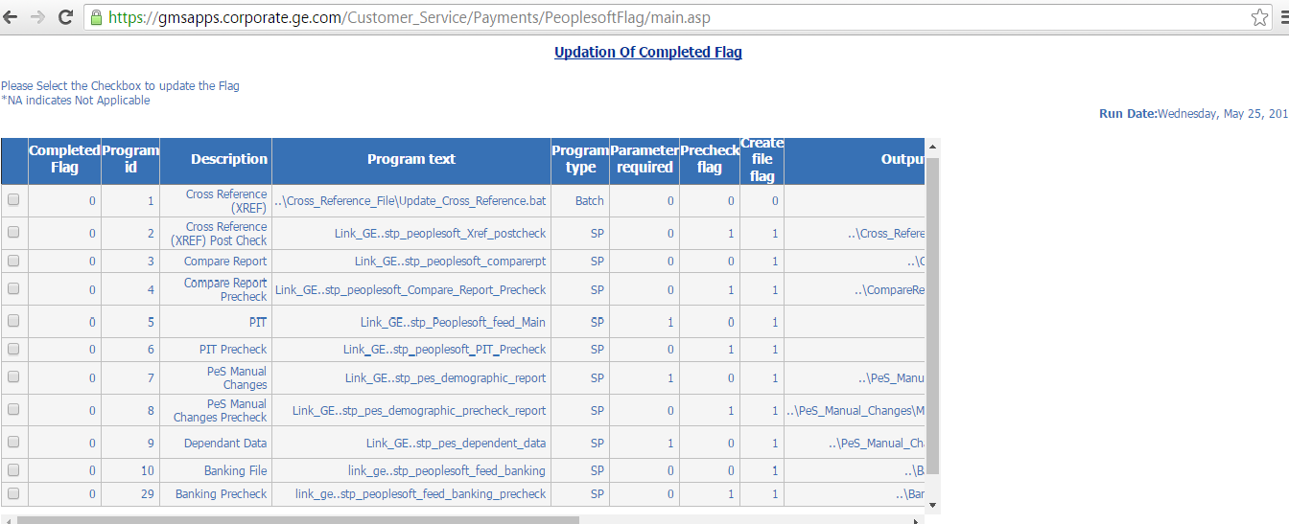

- We can check whether the link is made zero or not by using the query :
SELECT * FROM tbl_peoplesoft_dates where Payroll_date= ‘yyyy-mm-dd’
- If the flag is made zero, then we need to again run the consolidated by double clicking on the exe.
- 1 excel file is generated during the main run.
- Path of excel file is E:/Interfaces_Payroll/PeopleSoft/PES_Manual_changes/ Dependent_Data_file.xls

Step 2– Check job table and file counts:

- Open the generated excel files and match the record count excel files with the records inserted in the Dependent job/program table.

- Table name: - Link_GE..tbl_peoplesoft_dependent_data

- Query: select count(*) from Link_GE..tbl_peoplesoft_dependent_data

- If count matches, file is ready to be uploaded on support central.

Step 3 – Support Central document upload:

- Rename Dependent_Data_file.xls file to Dependent_Data_File_YYYY_MM_DD.xls

- Upload path: http://libraries.ge.com/foldersIndex.do?entity_id=3592483101&sid=101&SF=1

Step 4 – Send emails:

- Email template:

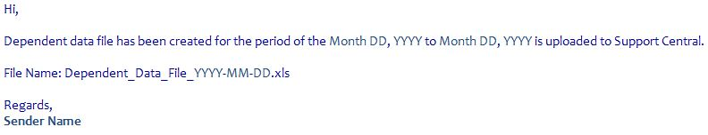

You can also refer previous emails for the above template.

- For email subject, refer previous emails.

- Email recipients:

Refer previous emails for Dependent Data to get TO, CC and BCC addresses.

