PBL SECONDARY RESEARCH REPORT

(FPGA Implementation of Hamming Code for Increasing the Frame Rate of CAN Communication)

TEAM MEMBERS DETAILS
TEAM LEADER | Macquen Joysten Dsilva(4S024EC062)
MEMBER 1 | Melisha Iyana Lobo(4S024EC069)
MEMBER 2 | Marwin Carvallo(4S024EC067)
MEMBER 3 | Joel Pinto(4S024EC054)

CHAPTER 1: INTRODUCTION
  - Background:
Digital communication is used in satellite systems, wireless networks, and many other applications. While sending data, noise in the channel can create errors and change the transmitted information.
To solve this problem, error correction techniques are used. The Hamming Code is a simple and effective method that can detect and correct single-bit errors.
In this project, an FPGA-based Hamming Syndrome Decoder is designed to improve reliable communication by detecting and correcting errors during data transmission.

Problem Statement :
Reliable digital communication is critical for applications such as disaster management systems, satellite communication, automotive networks, and rural connectivity. In CAN-based communication systems, noisy channels may introduce transmission errors that reduce data accuracy and communication reliability. Existing software-based error correction techniques increase computational complexity and processing delay. Therefore, an FPGA-based CAN communication system integrated with a Hamming Syndrome Decoder is proposed to efficiently detect and correct single-bit transmission errors with reduced latency and improved reliability.
  - Objectives:
- To understand the basics of CAN Protocol, Error Control Coding, and Hamming Code. To design a CAN transmitter and receiver architecture using Verilog HDL.
• To design a Hamming Syndrome Decoder for detecting and correcting single-bit errors in CAN data frames.
• To implement the complete CAN + Hamming Decoder system on FPGA.
• To generate syndrome bits for error identification and correction.
• To simulate and test the design using AMD Vivado tools.
• To improve reliable digital communication over noisy CAN channels with reduced hardware complexity and delay.
CHAPTER 2: Literature review (Secondary Research)
Paper 1
This work uses a Hamming Code-based ECC system for CAN communication. It improves frame rate and communication speed using FPGA implementation. However, the design supports only single-bit error correction and is mainly suitable for CAN applications.
Paper 2
This paper presents an improved Hamming Encoder and Decoder with syndrome-based error correction. The design reduces area and power consumption while improving transmission performance. Its limitation is that it mainly handles single-bit errors and is less effective in highly noisy channels.
Paper 3
This work focuses on improving reliability in radiation environments using Hamming coding and decoding techniques. The design improves protection against errors, but it does not provide detailed FPGA performance or hardware utilization analysis.

2.2: Comparison Table:
Feature | Paper 1 | Paper 2 | Paper 3
Main Focus | CAN Frame Rate | Improved CAN Reliability | Radiation Hardening
ECC Technique | Hamming Code | Improved Hamming Code | Hamming Code
FPGA Used | Virtex-5 | Artix-7 | VHDL-based
Throughput | ~1050 fps | Improved frame rate | Not specified
Resource Usage | 116 LUTs | 11× lower area than CRC | Not specified
Main Limitation | Single-bit correction | Medium scalability | No throughput analysis

2.3 Research Gap Identification:
- Existing FPGA-based Hamming Code designs mainly focus on basic error correction.
- Many systems improve either speed or hardware usage, but not both together.
- Some works do not provide proper performance and power analysis.
- Therefore, a simple, fast, and efficient FPGA-based Hamming Syndrome Decoder is needed for reliable communication over noisy channels.
CHAPTER 3: Proposed System Design
3.1 Design Justification:
Hamming Code for CAN Communication:
A Hamming Code based syndrome decoder is used to improve reliable data transmission in CAN protocol communication.
Syndrome-Based Error Detection:
The design uses XOR-based syndrome generation to quickly detect and correct single-bit errors during CAN data transmission.
Low Hardware Complexity:
Simple correction logic is used to reduce FPGA hardware usage and make the design efficient for real-time applications.
FPGA Implementation:
FPGA technology is used to achieve fast processing, parallel operation, and reliable communication performance.
Verilog HDL Design:
The decoder is implemented using Verilog HDL for easy RTL design and efficient FPGA implementation.
Improved Communication Reliability:
Compared to existing methods, the proposed system improves CAN communication reliability with faster and efficient hardware-based error correction.

3.2 BLOCK DIAGRAM
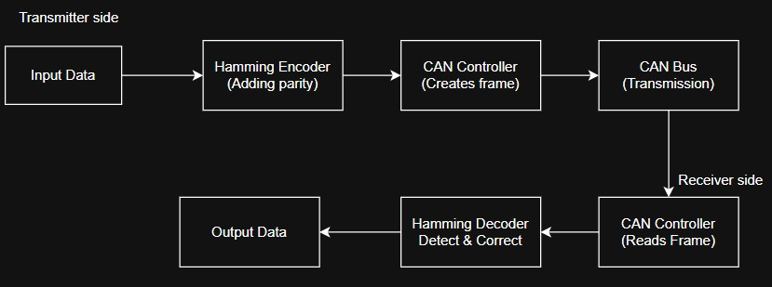

3.3 ARHITECTURE BLOCK:
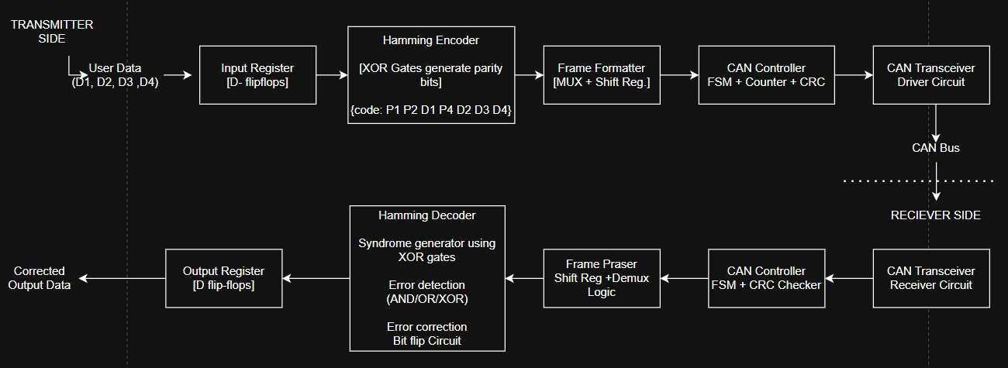
The system is an FPGA-based CAN communication design integrated with Hamming error correction for reliable data transfer.

CHAPTER 4: LEAF CELL DESIGN
1. Register:
Functionality:
Stores binary data temporarily and synchronizes input/output with the system clock.
RTL Design:
- Built using D flip-flops
- Written using always @(posedge clk) block
- Supports reset for initialization
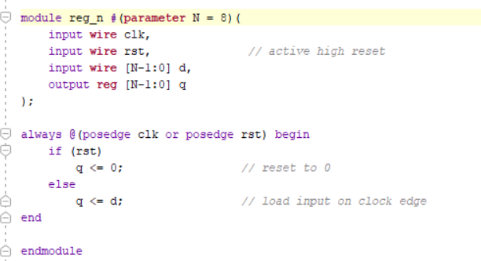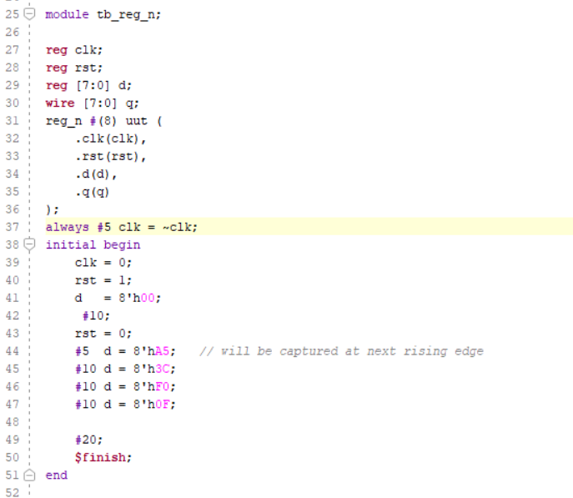
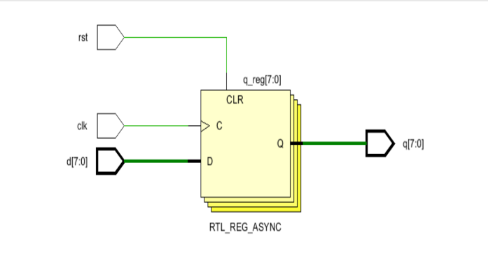

Optimization:
- Uses clock gating to reduce dynamic power
- Parameterized width for scalability
- Minimal fan-out design for timing efficiency
2. MUX (Multiplexer)
Functionality:
Selects one input from multiple inputs based on select lines.
RTL Design:
- Implemented using assign statement or case inside combinational block
- Pure combinational logic
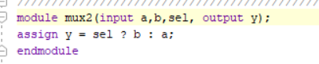
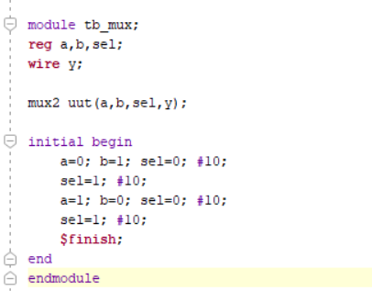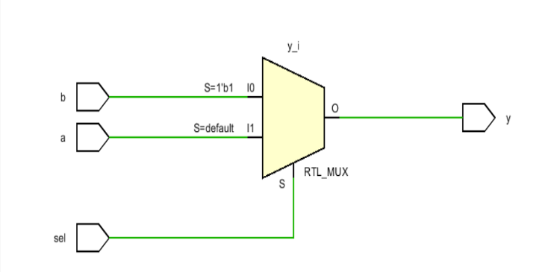

Optimization:
- Reduces hardware duplication by sharing data paths
- Implemented using logic minimization (K-map style reduction)
- Prevents unnecessary switching activity

3. XOR Logic
Functionality:
Performs exclusive-OR operation, used for parity generation and syndrome calculation.
RTL Design:
- Implemented using ^ operator
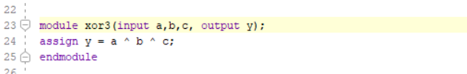
- Multi-input XOR tree structure for large bit widths

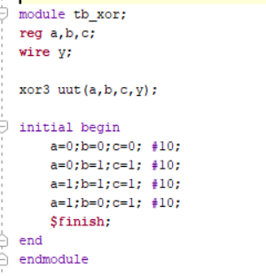
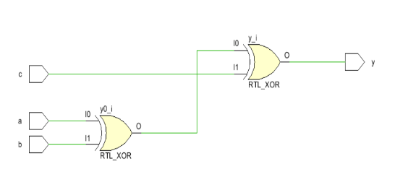
Optimization:
- Balanced XOR tree to reduce propagation delay
- Reduces critical path in Hamming and CRC logic
- Area-efficient combinational design

4. Counter
Functionality:
Counts clock cycles for sequencing, framing, and bit tracking.
RTL Design:
- Built using always @(posedge clk) with increment logic
- Resettable and parameterized
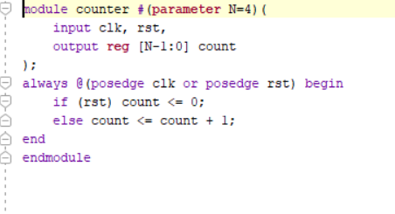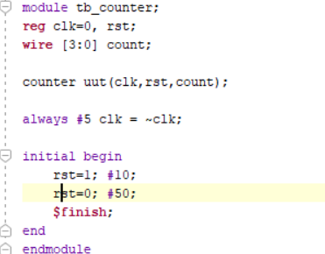
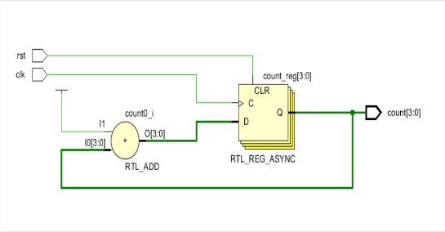
Optimization:
- Uses synchronous reset for better timing closure
- Enables or disables counting using control signal
- Can be clock-gated to save power

5. Shift Register
Functionality:
Converts parallel data to serial or vice versa for CAN transmission.
RTL Design:
- Implemented using concatenation {} operator
- Uses flip-flop chain structure 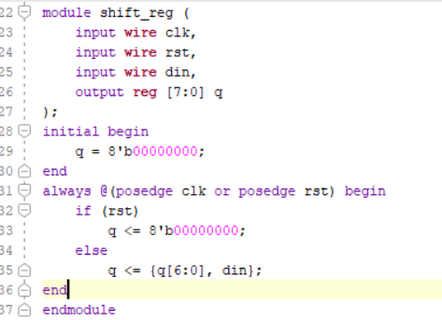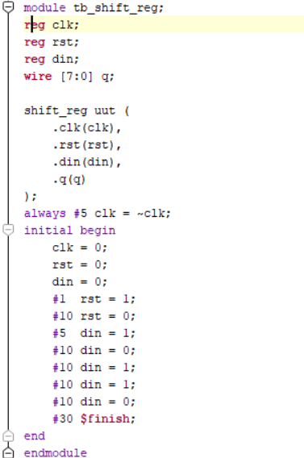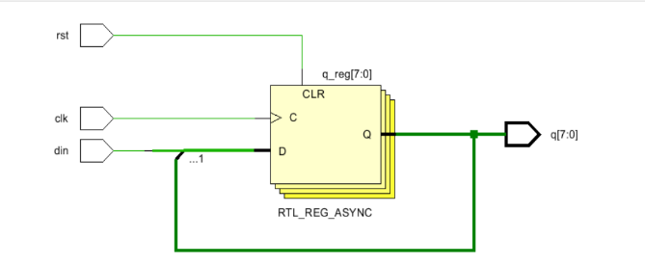
Optimization:
- Reduces I/O pin usage by serializing data
- Pipeline-friendly architecture
- Supports high-speed data shifting in FPGA

6. FSM (Finite State Machine)
Functionality: Controls sequence of operations in CAN controller and encoder/decoder flow.

RTL Design:
- Two-process model:
  - State register (sequential block)
  - Next-state logic (combinational block)
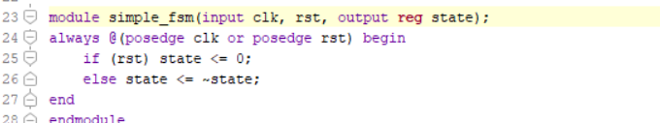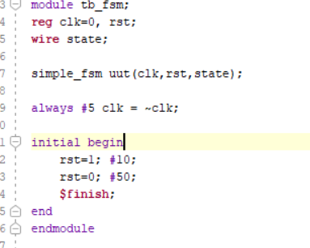
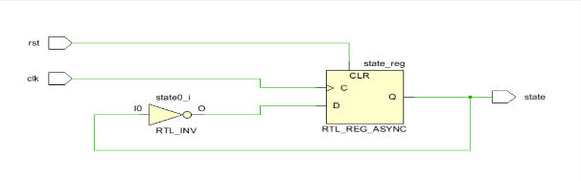

Optimization:
- State encoding: one-hot or binary encoding based on speed vs area trade-off
- Reduces glitching using registered outputs
- Improves timing predictability

7. Parity Generator
Functionality:
Generates parity bits for Hamming code to enable error detection.
RTL Design:
- Built using XOR network of selected input bits
- Combinational logic block
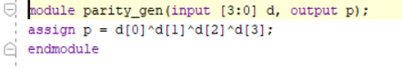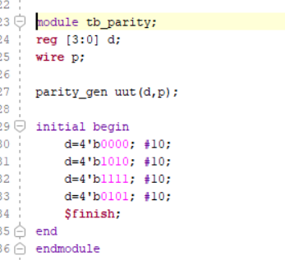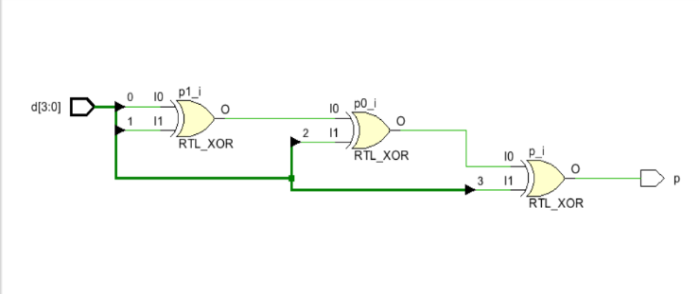

Optimization:
- Uses structured XOR grouping to reduce delay
- Minimizes logic depth (tree-based XOR reduction)
- Can be reused across multiple parity equations

8. Syndrome Calculator
Functionality:
Detects error location in received Hamming codeword.
RTL Design:
- XOR-based parity check matrix implementation
- Produces syndrome vector output
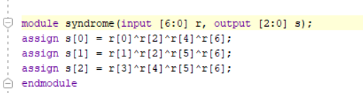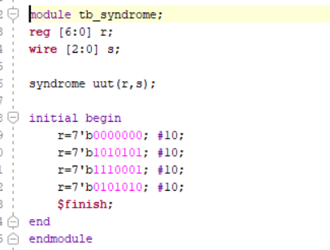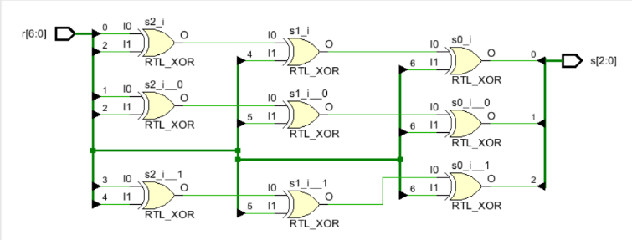
Optimization:
- Parallel XOR computation for faster detection
- Optimized H-matrix mapping to reduce redundant logic
- Critical path reduction for real-time correction

FORMULA USED:
R(x)=H^(−1)(C(T(H(D))))
D= Input Data
H(D)= Hamming Encoding
T= CAN Transmission
C= CAN Reception and CRC checking
H^(-1)= Hamming Decoding and Error Correction
R(x)= Corrected Received Data

A.1 Simulation results:
A.1.1 Simulation Result of Register cell:
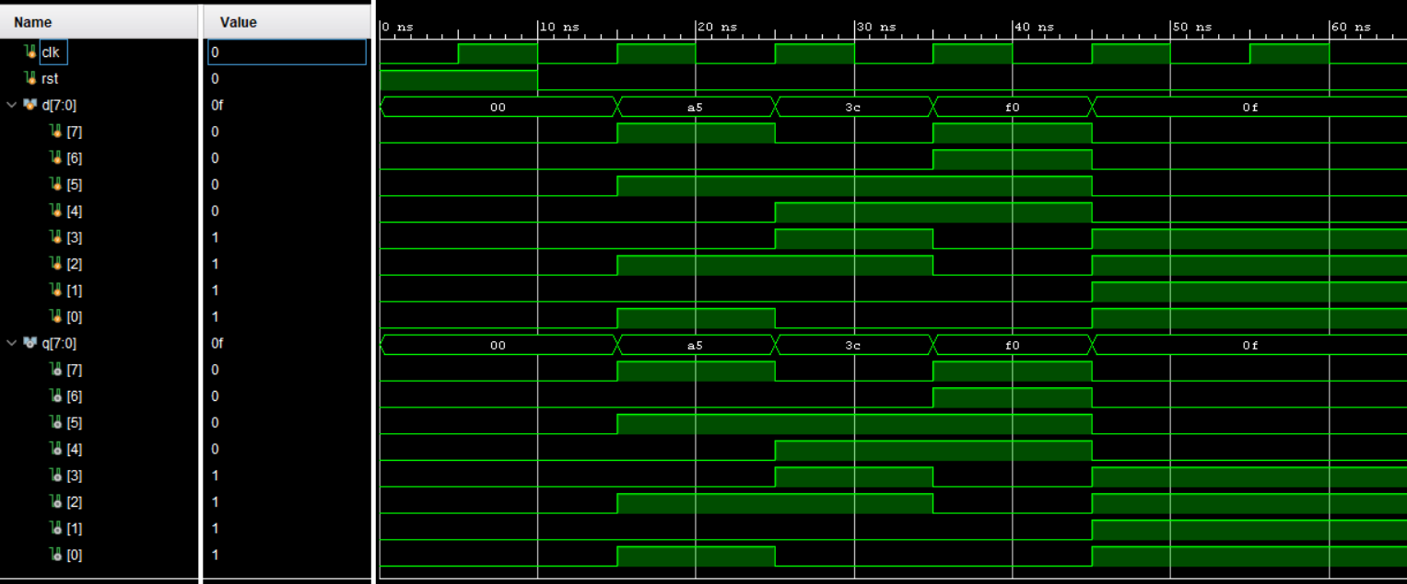
A.1.2 Simulation Result of Mux Cell:
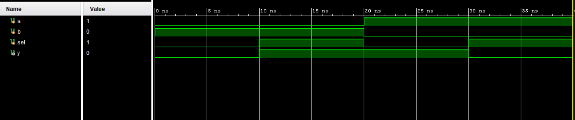
A.1.3 Simulation Result of Xor gate Cell:
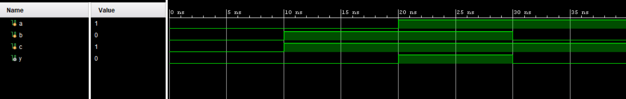

A.1.4 Simulation Result of Counter cell:
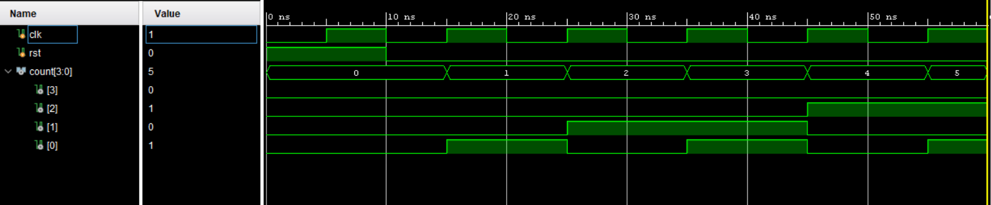

A.1.5 Simulation Result of Shift Register cell:
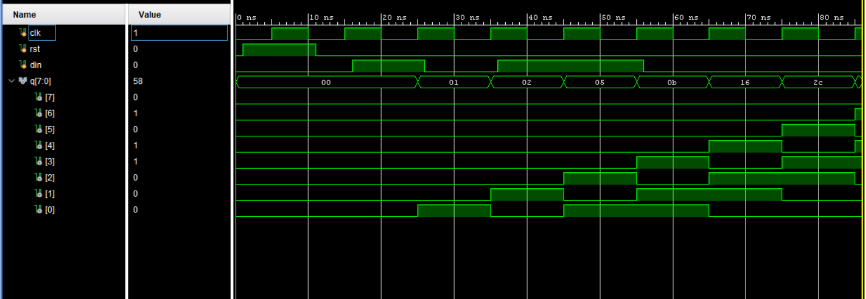
A.1.6 Simulation Result of Parity Generator:
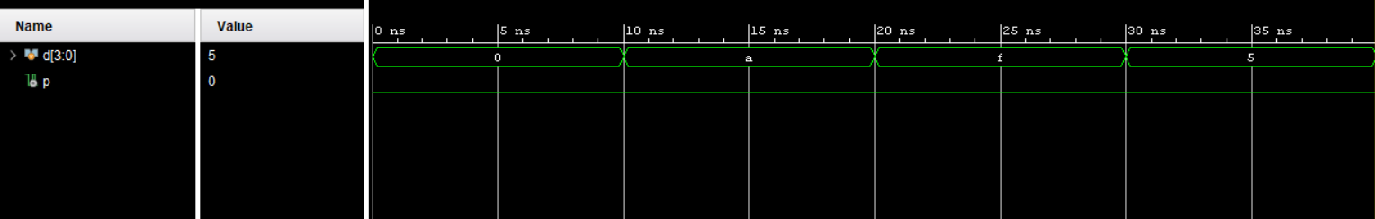
A.1.7 Simulation Result of Syndrome Calculator:
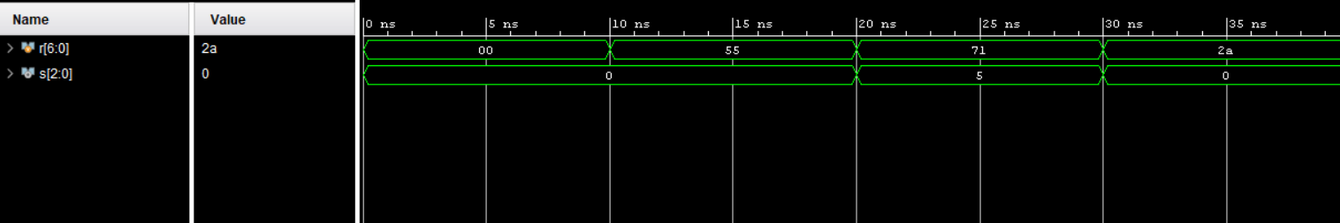

A.1.8 Simulation Result of FSM:
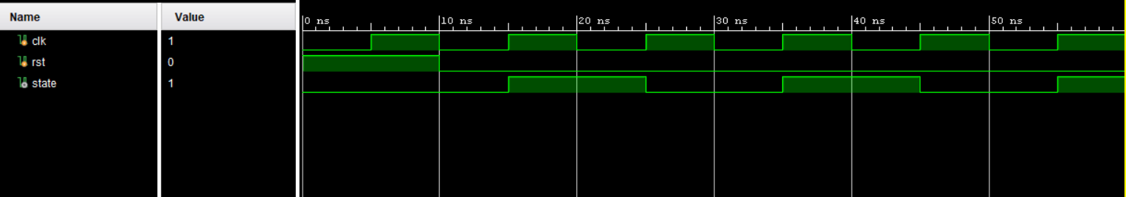
APPENDIX:
Tools Used:
1.Xilinix Vivado 2018.2 for Simulation Design
2.draw.io for block diagram and architecture diagram
3.IEEE Papers for Reference.
References:
1.Title: “FPGA Implementation of Hamming Code for CAN Communication”
R. O. S. Juan, M. W. Jeong, H. W. Cha and H. S. Kim, "FPGA implementation of hamming code for increasing the frame rate of CAN communication," 2016 IEEE Asia Pacific Conference on Circuits and Systems (APCCAS), Jeju, Korea (South), 2016, pp. 684-687, doi: 10.1109/APCCAS.2016.7804065.
URL: https://ieeexplore.ieee.org/stamp/stamp.jsp?tp=&arnumber=7804065&isnumber=7803879
2.Title:” Implementation of Improved Hamming Code for Reliable CAN Protocol on FPGA”Nagarathna, H., Ramesh Kumar, K. Implementation of improved hamming code for reliable CAN protocol on FPGA. Discov Electron 3, 57 (2026).
URL: https://link.springer.com/article/10.1007/s44291-026-00206-x?utm_source=chatgpt.com
3.Title: “CAN Bus Communication System Design and Error Handling”
Y. He and J. Li, "Observability of a temporal Boolean network," Proceedings of the 33rd Chinese Control Conference, Nanjing, China, 2014, pp. 4142-4147, doi: 10.1109/ChiCC.2014.6895632.
URL: https://ieeexplore.ieee.org/stamp/stamp.jsp?tp=&arnumber=6895632&isnumber=6895198

