Diana Silvas

Final Project

Write Up

Web Site Development

My application is for a Dentist Office. I recently have been going to the dentist. The way my dentist office works currently is I would have to call to make an appointment and for my first visit when I got there they gave me a form I had to fill out to add myself as a patient to their files. So my idea for this app is to create the front end and back end of a dentist office so they can store their patients, dentist, and appointments to make in an efficient way. I have three routes in my DentistAPI that will handle the backend, these are appointments, dentist, and patients. For patients it will store the patient’s information into the system. For dentist it will store all the dentist information and availability. For appointment it will store the appointment information. All of these js files have appropriate response codes such as 200 for success, 201 for when something like a patient has been created, 404 when something is not found, and 500 for internal server error. One thing I would like to note is that my 404 does not work. I am using 404 when I am trying to load the patient information with the appointment information. My goal was to search to make sure the patient exists before creating the appointment. Below is a screenshot of how the code is and the error I receive from Postman. I am trying to create a new appointment with a patient that does not exist in the patient DB. I am supposed to get a 404 for not found but I receive a 500 Internal Server Error. I did see in class you mentioned a solution but mine still had an error.

Appt_model.js

 patientID: {type: mongoose.Schema.Types.ObjectId,

    ref: 'Patient', required: true},

Appointment.js

Patient.findById(req.body.patientID)

        .then(patient => {

            if (!patient){

                return res.status(404).json({

                    message: 'Patient not found'

                });

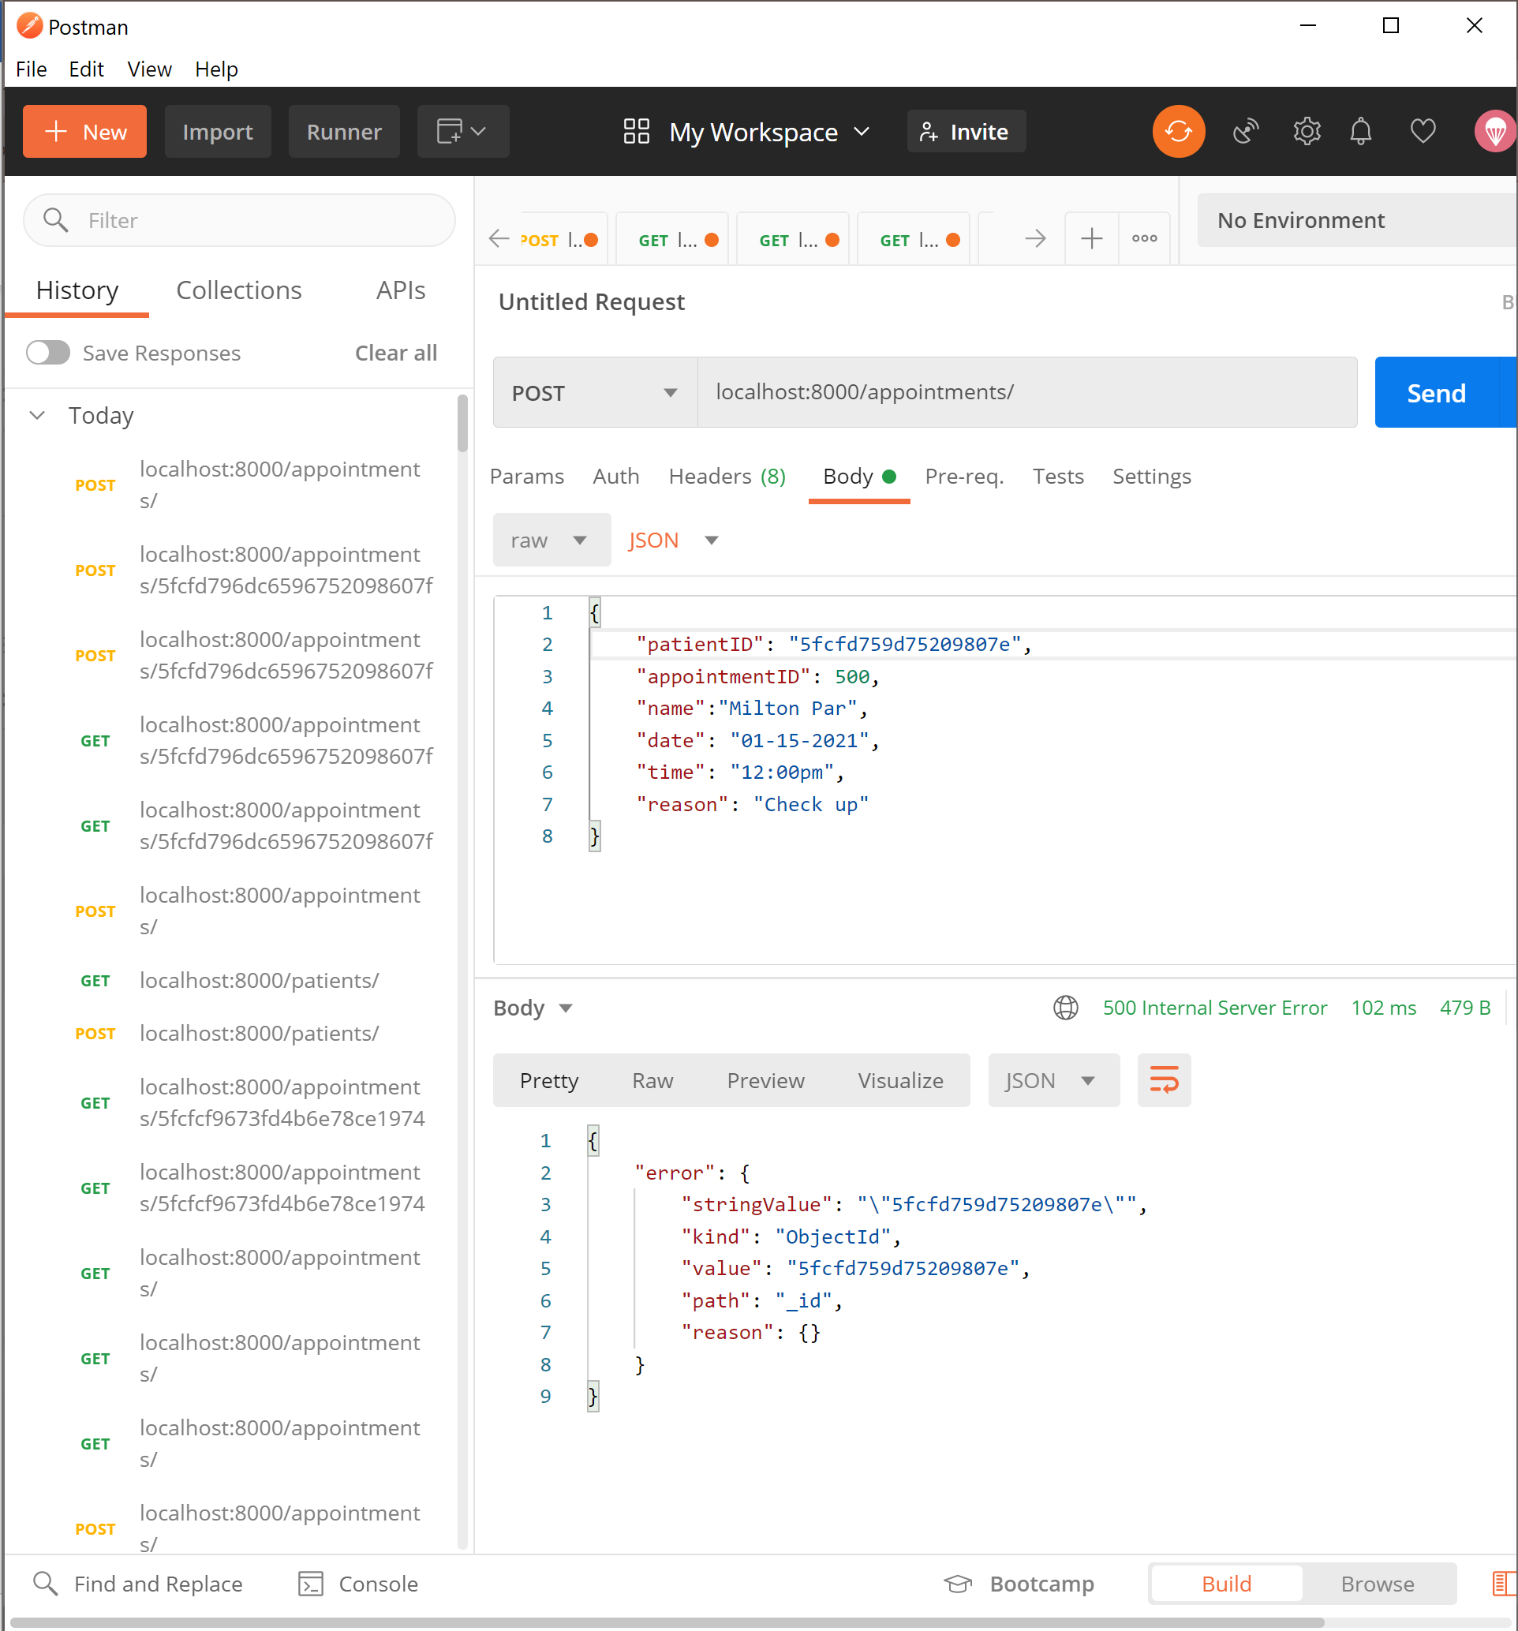

Unfortunately, I did not have time to connect the front end and back end but I did code how I would like the front end to look and function.

This is how the page to make an appointment would look. It would ask for all the details that we submitted in POSTMAN. At the bottom it would have multiple buttons like submit, Show data that was submitted, cancel appointment, add patient, update patient, and delete patient.

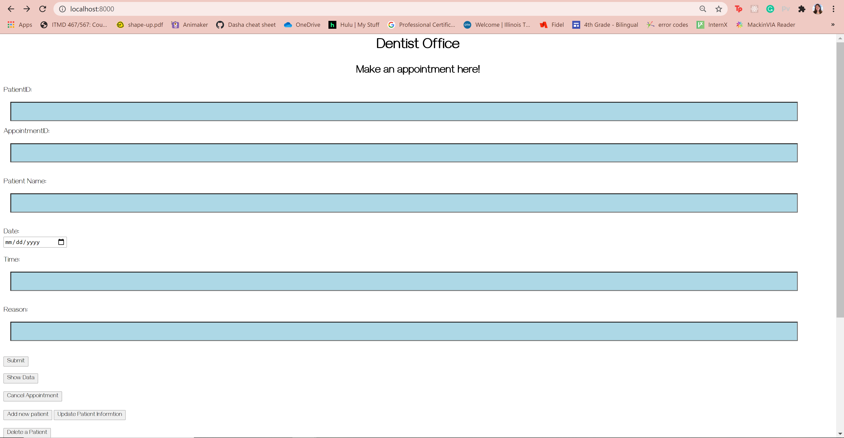

Another html page I code was the patient.html

This form would have a POST method to create a new patient in the system.

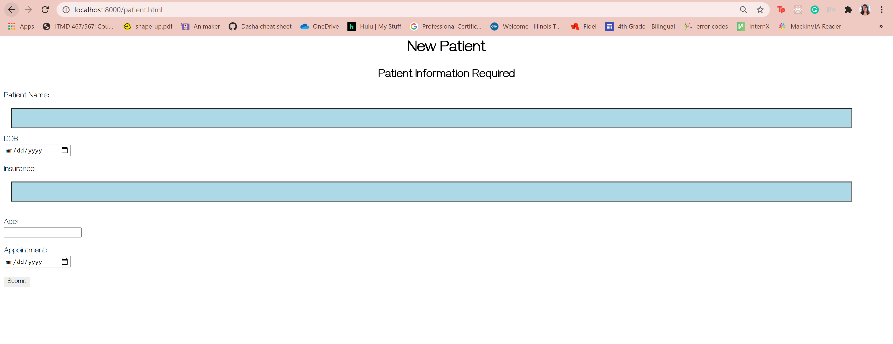

All the input of the user will be stored in MongoDB. In the video I will show how we can add patients, dentist, and appointment to the DB.

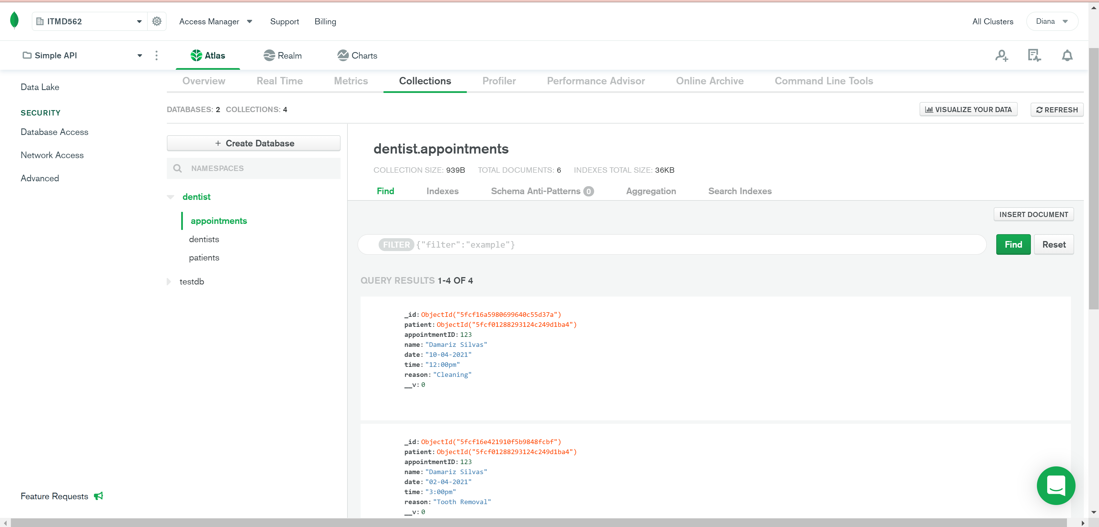

I was able to connect/populate all the information into the appointment route. For example this screenshot shows the patient information, the dentist ID, and the appointment details all in one request

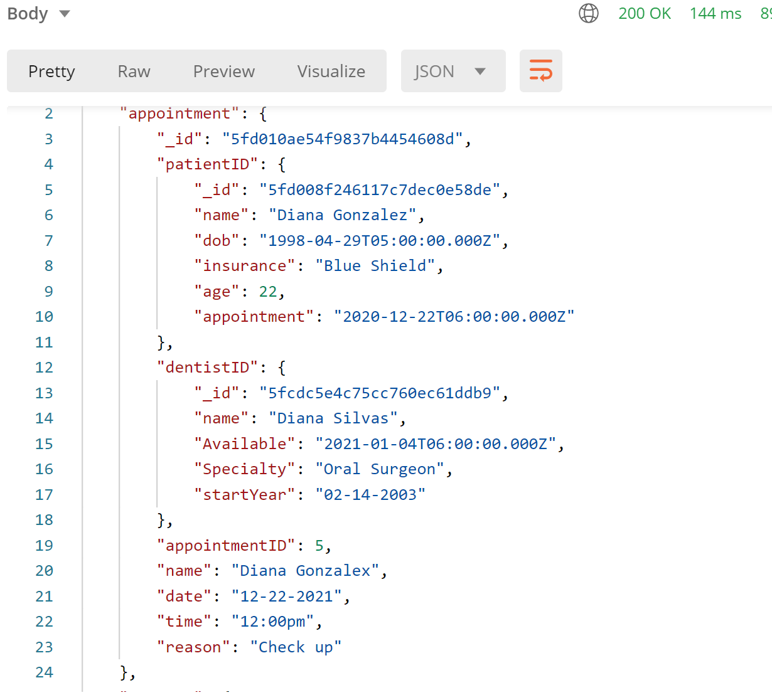

Video demo: POST, PATCH, DELETE, GET in video for patients

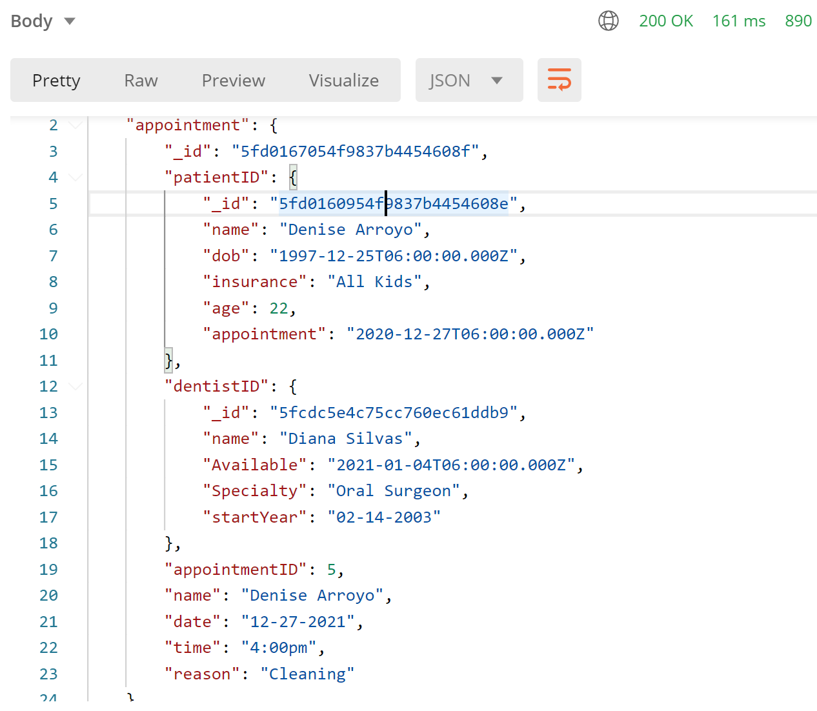

MongoDB for this (sorry I forgot to show it)

