Crew Link MVP

Technical Approach Document

February 20, 2019  
Version 0.1

**DOCUMENT CONTROL**

|  |  |  |  |
| --- | --- | --- | --- |
| **Prepared by** | Dharmendra Kumar Singh | **Designation** | Associate Architect |
| **Date** | Feb 20, 2019 | **Signature** |  |

|  |  |  |  |
| --- | --- | --- | --- |
| **Reviewed by** | Kiran Chakravarthy | **Designation** |  |
| **Date** |  | **Signature** |  |

|  |  |  |  |
| --- | --- | --- | --- |
| **Approved by** |  | **Designation** |  |
| **Date** |  | **Signature** |  |

**DOCUMENT CHANGE HISTORY**

|  |  |  |  |  |  |  |
| --- | --- | --- | --- | --- | --- | --- |
| **Date** | **Version** | **Section** | **Description** | **Author** | **Reviewer** | **Approver** |
| Feb 20, 2019 | 0.1 | NA | Created Draft | Dharmendra Kumar Singh | Kiran Chakravarthy |  |
|  |  |  |  |  |  |  |

**TABLE OF CONTENTS**

1 Introduction 6

2 Why Transforming? 7

3 Purpose 8

4 Definitions, Acronyms and Abbreviations 9

4.1 Definitions 9

4.2 Acronyms and Abbreviations 9

5 Architectural Representation 10

5.1 Proposed technical architecture – ATPI application framework 10

5.2 Proposed functional Architecture 10

5.3 Technical – Functional relationship 10

5.4 Component level Technical – Functional relationship 11

5.5 Frontend (Angular) Architecture 11

5.6 Customer Process Flow 13

5.7 Agent Process Flow 13

6 Scope 13

6.1 Scope of work 13

6.2 Assumption 14

7 Proposed Technology Stack 14

8 Development Tool 14

8.1 Front End Development 14

8.2 Middleware Development 15

8.3 Backend Development 15

8.4 Source Control 15

9 Non Functional Requirement 15

10 Pre-requisites 15

11 Features 16

11.1 Login 16

11.2 Authorization 18

11.3 Customer - Landing Page 18

11.4 Agent - Landing Page 19

11.5 Customer – Raise Travel Request 19

11.6 Customer – Approve Travel Request 19

11.7 Agent – Search Travel Request 20

11.8 Agent – Submit Travel Request 20

11.9 Notification 20

12 Third party integration 20

13 Risks, Constraints, Limitations & Issues 21

13.1 Risks 21

*13.2* Constraints 21

*13.3* Limitations 21

13.4 Issues 21

13.5 Dependencies 21

14 Appendix 21

14.1 Project Standards and Conventions 21

14.2 Development Environment Parameters 21

15 Packaging and Installation Considerations 21

16 Supplementary Information 21

# Introduction

ATPI CrewLink™ is a travel workflow management tool, specifically designed for the international Shipping and Energy industries. ATPI CrewLink™ will integrate with internal or third-party crew management tools and enables you to manage the entire travel life cycle from scheduling, via travel management to reporting. All in one global platform.

Using ATPI CrewLink™ leads to better control, greater process compliance and optimised traveler safety. With incremental cost savings as a result.

* Operational efficiencies around labor intensive, manual processes and double work
* Cost efficiencies by eliminating disparity of systems and enhanced quality control
* Optimized travel policy compliance
* Visibility of crew or traveler whereabouts and risk control
* Transparency of total cost of travel and opportunity for savings
* Improved forecasting capabilities
* Streamlined communications
* Consolidation of multiple (3rd party) systems in one single global platform
* Automated sourcing of the lowest fare available in the market in accordance with travel policy
* Automated search for the highest possible airline seat availability

# Why Transforming?

Please find some major issues which leads to transform the existing CL to new Technology stack.

* Ticket Window
* Sync issues, Sometimes CrewLink is completely down.
* Synchronization calls while creating the PNR’s by using the auto & manual bookings
* Email alerts issues
* Booking alerts, E- Ticket alerts, General alerts, group email alerts
* Work flow process issues
* Sometimes status are not changed appropriate,
* When user has 1PNR,2Quotes, and when customer approves PNR the Quotes are not moving into the Reject status for flight and hotel bookings
* Search issues
* Search button is not working properly on travel Request booking page.
* Search response is very slow under travel request search booking page
* Improper search results : When user clicks on search button under travel request page, Travel request is directly getting opened instead of producing exact search result.
* In Advanced search, while adding existing passengers: Advanced search link is not working.
* Login issues
* Login page loading is taking more than expected time
* Performance issues in all the pages
* Page loading issues in almost all the web pages, Page refreshing is very slow and error pop-up displays
* Page redirection errors: When user clicks on Customer Region/When user selects Customer region from dropdown in customer setup>Getting HTTP status 500 Error
* Page renderings on big bookings
* Compatibility issues
* Drop down navigation links are overlapping on main navigation,
* Alignment issues
* Filed box is not aligned properly for “Journey Type” filed in Flight – Itinerary Details section.
* Validation issue
* While TR booking, change the customer name and try to click on “Proceed to Booking”, pop-up is displaying with Manual Mod or Semi Auto Mode, after clicking on   manual mode, it is displaying error i.e, mandatory fields to be filled.
* Actual error: Pop-up is opening to select the mode to booking
* Expected Error: Without filling the mandatory fields in the screen, it should not open the pop-up for booking mode (Without giving last name, proceed to booking pop-up is displayed)
* Improper error messages
* Error Description for the errors found is not provided in all the pages.

* Issues with the loading the pages- Hanging the system
* Map & Calendar view issues for the rig booking
* No spinners are rendering in the application.
* Menu item issues
* No significance place for enhancements, same enhancements are here and there example email configurations

# Purpose

With successful transformation of ATPI application, below things are required to achieve

* Optimize the existing operations to present better user interface
* Sort and organize the core functions in a well manner to increase user’s journey towards the application
* Establish the flexibility across the functions within the page rather prompting for new tabs.
* Provide better product support and information to customers
* Presents different interfaces as per roles
* Equip the system with new enhancements where ever required to boost up the process and increase responsiveness across all modules

**Objectives**

The key objectives for the website redesign project is to

* Systemize the application by concerning the business projections and needs in all areas.
* Improve search functions and optimize the responsiveness.
* Increase/Reduce the flows of process between components, and stream line the forms by abolishing duplicates
* Propose sample designs of “to-be” implementations.

**Target Users**

* Agents
* Customers

# Definitions, Acronyms and Abbreviations

## Definitions

|  |  |
| --- | --- |
| **Terms** | **Definition** |
|  |  |
|  |  |

## Acronyms and Abbreviations

|  |  |
| --- | --- |
| **Acronym** | **Meaning** |
| AD | Active Directory |
| API | Application Programming Interface |
| CDN | Content Delivery Network |
| UX | User Experience |
| UI | User Interface |
| GDS | Global Distribution System |
| CL | Crew Link |

# Architectural Representation

## Proposed technical architecture – ATPI application framework

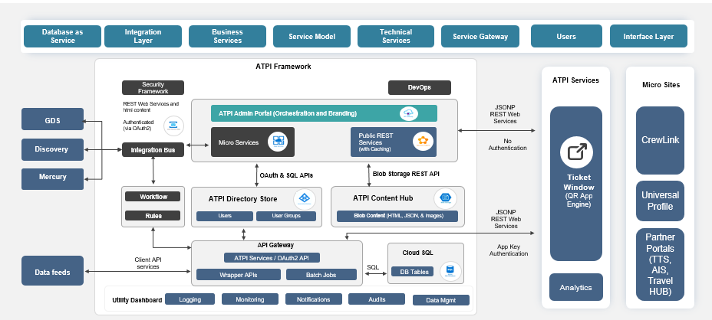

## Proposed functional Architecture

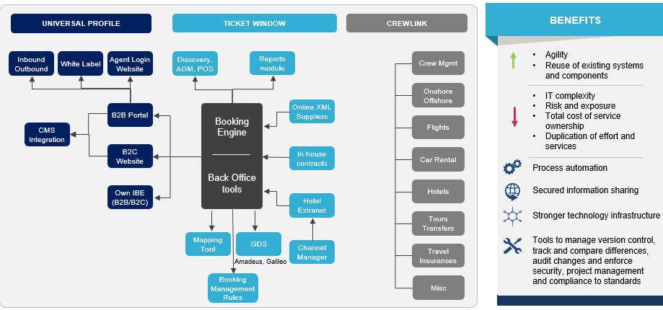

## Technical – Functional relationship

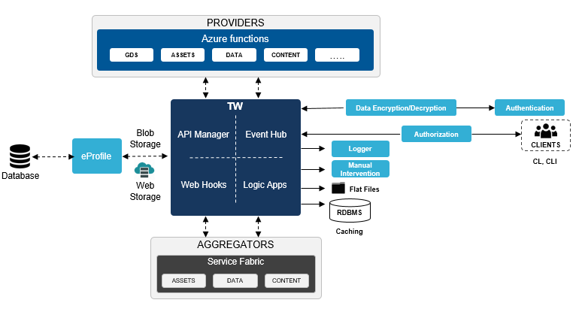

## Component level Technical – Functional relationship

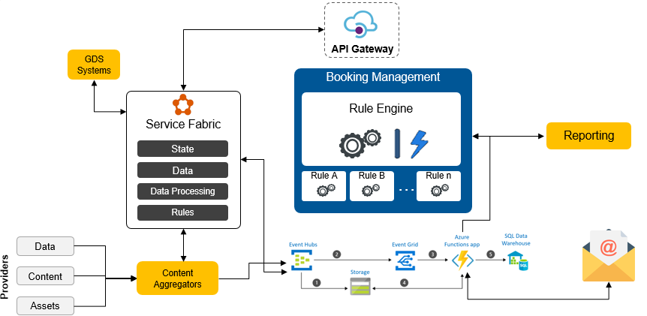

## Frontend (Angular) Architecture

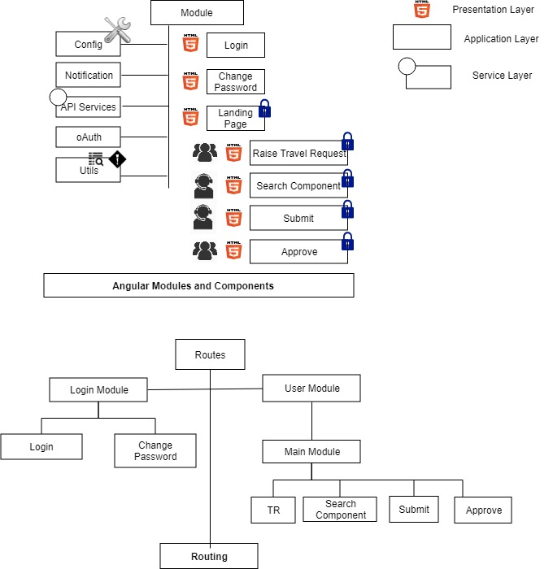

## Customer Process Flow

## Agent Process Flow

# Scope

## Scope of work

* UX and UI Development
* Authentication and Authorization
  + Customer and Agent roles one each
* Travel request generation limited to Flights
* GDS integration as provided by ATPI
* Request Processing for GDS
* Notifications via email

## Assumption

* GDS implemented services will be provided by ATPI
* CL MVP backend interacts with the above services to fetch data
* Basic Master Data required for the current scope will be implemented.
* Manual on boarding limited to user login, roles

# Proposed Technology Stack

* Hosted Blob Storage
* Service fabric Clusters
* Load balancing
* API Management
* Database implementation
* DB Schema
* Email Notifications
* Logic Apps

# Development Tool

## Front End Development

* Node.js version 8.x or 10.x
* npm packages
* npm client
* Visual Studio Code

## Middleware Development

* Visual Studio 2017 Professional
* Azure Subscription

## Backend Development

* Sql Server 2014 and above

## Source Control

* Git

# Non Functional Requirement

* Security
* Logging
* Storage
* Configuration
* Performance
* Flexibility
* Disaster recovery
* Accessibility

# Pre-requisites

* Continued support on the following
  + Requirements analysis and design
  + Understanding of production issues
  + Database architecture and reports requirements
  + Requirements gathering and scheduling
  + Access to existing servers / services (IT and Networking)
* Azure platform for SaaS
* Access to existing source code and applications
  + SQL Server Database Access
  + Mercury Web service API’s source code
  + POS Plugin Web service API src / documentation
* Documents pertaining to
  + Current architecture
  + System integration (Application, Infra, Data, DevOps)
  + GDS API Documentation
* Initial knowledge transfer from PO for transition and support until completion of transformation, for application maintenance
* Support from Delphi engineers for migration
* Dedicated availability from Product Owner and key stakeholders, for smooth execution
* Software licenses, apart from the standard list of software provided by ValueLabs

# Features

## Login

### Purpose

### Sequence Diagram

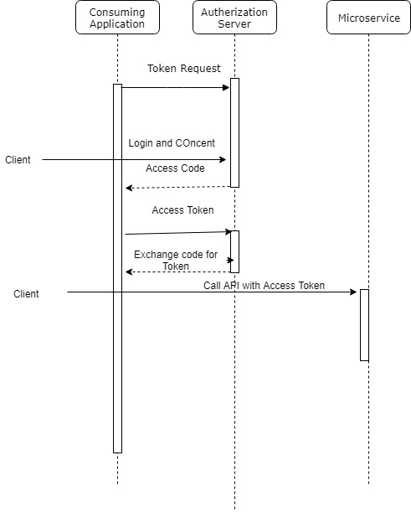

### Low level architecture

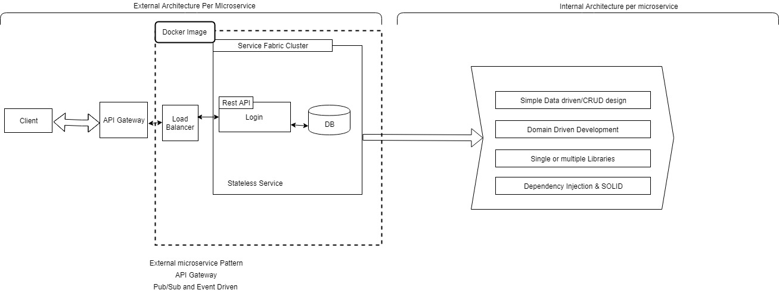

### Database Diagram

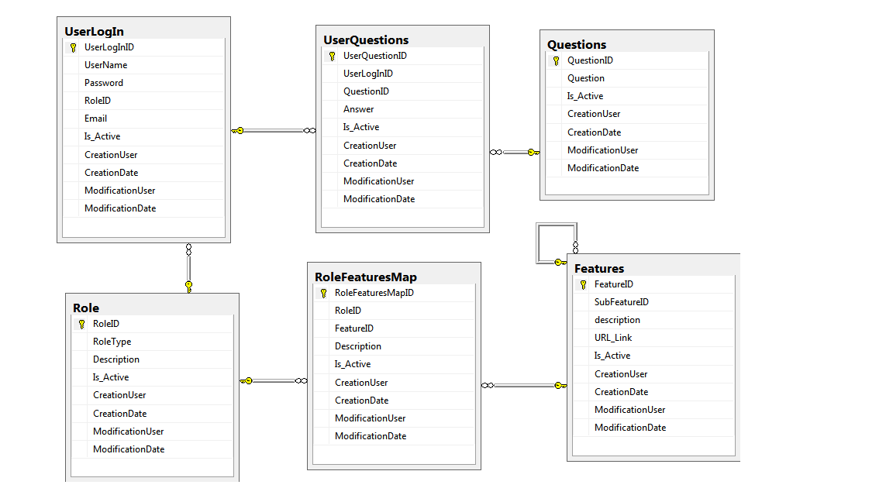

### GDPR and PbD Factor

## Authorization

### Purpose

### Approach

### Database Diagram

### GDPR and PbD Factor

## Customer - Landing Page

### Purpose

### Approach

### Database Diagram

### GDPR and PbD Factor

## Agent - Landing Page

### Purpose

### Approach

### Database Diagram

### GDPR and PbD Factor

## Customer – Raise Travel Request

### Purpose

### Approach

### Database Diagram

### GDPR and PbD Factor

## Customer – Approve Travel Request

### Purpose

### Approach

### Database Diagram

### GDPR and PbD Factor

## Agent – Search Travel Request

### Purpose

### Approach

### Database Diagram

### GDPR and PbD Factor

## Agent – Submit Travel Request

### Purpose

### Approach

### Database Diagram

### GDPR and PbD Factor

## Notification

### Purpose

### Approach

### Database Diagram

### GDPR and PbD Factor

# Third party integration

# Risks, Constraints, Limitations & Issues

## Risks

## Constraints

<Specify the Constraints>

## Limitations

<Limitations for the design need to be specified>

## Issues

## Dependencies

|  |  |
| --- | --- |
| **Item** | **Description/Reference** |
|  |  |

# Appendix

## Project Standards and Conventions

|  |  |
| --- | --- |
| **Item** | **Description/Reference** |
|  |  |

## Development Environment Parameters

|  |  |  |
| --- | --- | --- |
| **Environment** | **Parameter Name** | **Value** |
|  |  |  |

# Packaging and Installation Considerations

# Supplementary Information