Unit 7 – More Dynamic HTML

CSC 175

# Instructions

1. Download the starter zip from Cobra and extract it to a place on your computer where you can keep track of it (don’t place it on a thumb drive or network drive as those can be slow/cause problems).
2. Clone your GitHub repository that you were introduced to in class on to your local machine. Again don’t place it on a thumb drive or network drive.
3. Create a folder in your GitHub repository called “unit7assignment”. Copy the contents of the starter zip into this folder.
4. Open the index.html page in your favorite web browser, and then open your browser’s developer tools. Find the “console” feature in your developer tools window and make sure it is printing out the line in the “assignment.js” file.
5. Open the **folder** in your favorite text editor so that you can edit the “assignment.js” file and accomplish the following tasks.
6. Examine the ‘blogArticles’ array in your assignment.js file. Take note of the properties of the child objects and their child properties. Over the next few steps, you will be writing the code to place these blog articles into the HTML of the page.
7. Place a div like the following on your HTML page to be the container for your articles.

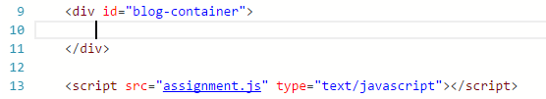

1. Write a loop that goes through the “blogArticles” array, and uses the text from each property to build out HTML with the following example structure (repeat the div.article-wrapper section for each blog article):

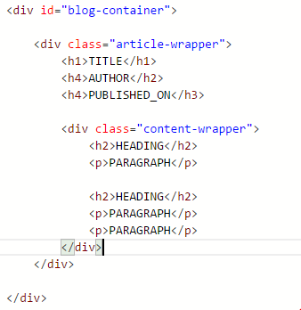

1. NOTE:
   1. Some paragraphs have headings, and others do not. If a paragraph does not have a heading, don’t include an H2 tag.
   2. It will likely be useful to put the logic for creating the HTML for a single blog article into a function and then have the loop call that function on each iteration.
2. Lastly, ensure that your browser shows all the content for the articles rendered on the screen, and that you do not have any JavaScript errors according to your browser’s development tools. Your final HTML page should look something like:



# Submitting

When you are done with the assignment, push your code to GitHub and submit a screenshot to the Cobra Dropbox