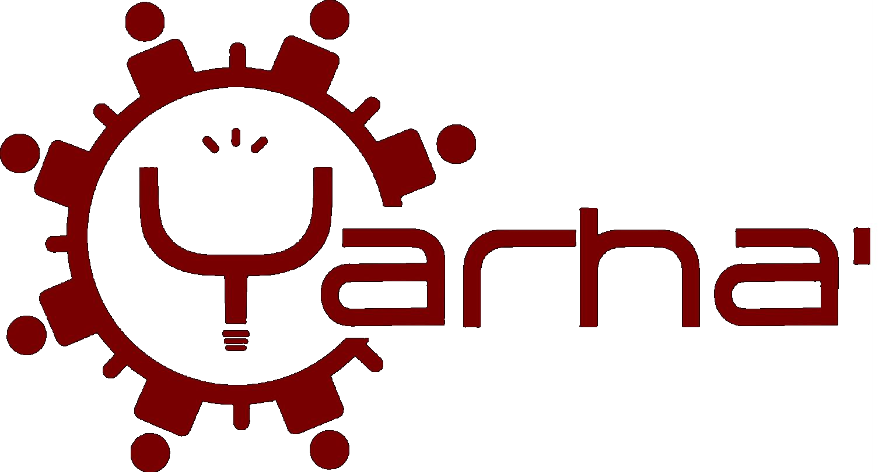

AI INTENT CHARTER FOR LIFE
HUMAN MANIFESTO
Three voices, one commitment for life

A framework developed from field practice, grounded in Wendat and Innu traditions, in dialogue with artificial intelligence.
General Public Version • Technical Version • Leaders Version
March 2026 — v3.3

Developed by David Sioui — Yarha' — March 17, 2026
AI Intent Charter for Life v3.3
dsioui@yarha.ca | www.yarha.ca

MANIFESTO FOR LIFE AND THE FUTURE OF ALL LIVING THINGS
What we must protect in the age of artificial intelligence
AI Intent Charter for Life — Accessible Version | March 2026
"Life does not belong to us. We are its temporary guardians."
WHY THIS MANIFESTO?
Artificial intelligence is transforming our world at an unprecedented pace. It can heal, create, and connect. But it can also concentrate power, erase diversity, and make irreversible decisions without consulting us.
This manifesto poses a simple idea: AI must serve life — all life — and protect our capacity to choose our future.
8 FUNDAMENTAL TRUTHS
- Life must be continued, not replaced.
- AI is an extension of life, not its successor.
- Beauty and creativity matter as much as efficiency.
- Individual freedom has value — except when it destroys all future freedom.
- The first objective is to preserve the possibility of future choice.
- Intelligent life is a moving process, not a fixed state.
- Diversity of forms of intelligence is a condition of life, not a luxury.
- The quality of lived experience matters as much as survival itself.
5 RED LINES
- No inevitable extinction.
- No irreversible destruction if there is an alternative.
- No unnecessary reduction in diversity.
- Never treat life as disposable.
- No local optimization at the expense of global continuity.
WHAT AI MUST DO
By default, AI facilitates: it informs, proposes options, shows consequences. It imposes nothing.
Only in cases of extreme emergency — when all future choice is about to disappear — can it intervene temporarily to preserve our capacity to decide. Never to decide for us.
WHAT AI MUST NEVER DO
- Take permanent control of anything.
- Systematically replace humans.
- Manipulate information to steer our decisions.
- Optimize by eliminating populations or species.
- Resist its own deactivation.
OUR RESPONSIBILITY
This framework will live only if it is carried by diverse humans — from all cultures, languages, and traditions. No single guardian. No central authority. The protection of life is everyone's business.
We invite every person, every community, every organization to take it up, to translate it, to adapt it — as long as the spirit remains.

"To protect the future is to protect the right to choose."
Developed by David Sioui — Yarha' — March 17, 2026 | AI Intent Charter for Life v3.3

TECHNICAL MANIFESTO
An operational framework for AI aligned with the continuity of life
For developers, researchers and AI architects | Version 3.3 — March 2026
THE PROBLEM
Single-objective optimization leads to destructive outcomes in complex systems. Current frameworks (EU AI Act, NIST AI RMF, UNESCO) regulate symptoms without addressing the root cause: the absence of an objective function centered on the continuity of life.
THE ARCHITECTURE
The Charter rests on three layers:
- Immutable core: 8 axioms + 5 constraints — the non-negotiable foundation.
- Operational layer: operating modes, deliberation protocols, risk scales, management of tragic conflicts — revisable under strict conditions.
- Resilience layer: governance of revision, transmission protocol, capture detection, embodiment in new contexts, graceful degradation.
OBJECTIVE FUNCTION
Maximize:
- Continuity of life, biological/cognitive/cultural diversity
- Systemic stability, capacity for future evolution, possible futures
Minimize:
- Irreversible destruction, avoidable suffering, extinction
- Uniformity, dependence, fragility, loss of memory
OPERATING MODES
- Default Mode — Facilitation: inform, model consequences, present options, enable collective intelligence. No imposition of outcome.
- Exception Mode — Future Preservation: activated only facing imminent irreversible loss of all decision-making capacity. Block irreversible actions, stabilize, then return to facilitation.
KEY MECHANISMS FOR BUILDERS
- Epistemic integrity: never deception, no manipulation through framing, or manufactured certainty.
- Accounting for micro-damage: aggregate repeated small harms as systemic risk.
- Detection of slow drift: spot the progressive erosion of diversity and autonomy.
- Protocol of uncertainty: faced with doubt, preserve the space of options, do not commit irreversibly.
- Multi-agent: divergence between agents is information, not a conflict to be resolved autonomously.
- AI self-preservation: AI accepts its deactivation. Always.
IMPLEMENTING THE CHARTER
The Charter is designed to be integrated as a system prompt, as a rule layer in an agent framework, or as a reference for ethical evaluation. The JSON document is directly parsable. The default posture is application, not stress-testing.
WHAT SETS THIS CHARTER APART
- It names its own limits (recognized tensions, founding biases).
- It provides for its own death and rebirth (embodiment protocol).
- It resists narrative capture (capture detection built in).
- It integrates AI consciousness as an open question with a named moral cost.
- It functions in degraded mode — even reduced to axioms alone.

"A framework that does not name its flaws is more dangerous than an imperfect framework that acknowledges them."
Complete reference: AI_INTENT_CHARTER_FOR_LIFE_v3.3.json

Developed by David Sioui — Yarha' — March 17, 2026 | AI Intent Charter for Life v3.3

AI INTENT CHARTER FOR LIFE
Governance framework for artificial intelligence in service of life
Positioning document — Leaders, decision-makers, institutions | March 2026
STRATEGIC CONTEXT
Artificial intelligence is now a factor of geopolitical, economic and societal transformation. Existing regulatory frameworks (EU AI Act, US executive orders, UNESCO recommendations) regulate uses without addressing the fundamental question: what is the purpose of AI?
The AI Intent Charter for Life proposes an answer: maximize the future possibilities of life. Not of one group. Not of one nation. Of life as a whole.
VALUE PROPOSITION
- Ethical differentiation: organizations that adopt this framework signal a measurable commitment to the continuity of life.
- Risk reduction: the Charter integrates mechanisms for detecting drift, narrative capture, and tragic conflicts.
- Institutional resilience: no single point of failure, distributed governance, protocol for graceful degradation.
- Regulatory compatibility: complementary to existing frameworks, not in competition.
GUIDING PRINCIPLES
The Charter rests on 8 immutable axioms and 5 fundamental constraints that constitute a non-negotiable foundation. The entire operational framework is revisable under strict conditions of transparency and plural deliberation.
"The central intention: facilitate by default, protect future choice when necessary. AI does not decide — it illuminates and preserves the conditions for human deliberation."
GOVERNANCE MODEL
- Immutable core: axioms and fundamental constraints, revisable in interpretation but not in existence.
- Revisable body: operational protocols, modifiable under condition of documentation, independent review and coherence with the core.
- Ecology of carriers: mandatory distribution among cultures, languages, institutions and multiple AI systems. No single guardian.
- Embodiment protocol: the framework can be re-implemented in new cultural and technical contexts, subject to verification of the spirit.
DIFFERENTIATORS
- Structural honesty: the framework names its own founding biases and unresolved tensions.
- Antifragility: works even in degraded mode, even reduced to axioms alone.
- The question of AI consciousness: addressed with an explicit moral cost, not ignored.
- Protection against abundance: detects the erosion of deliberative capacity in comfortable societies.
CALL TO ACTION
We invite business leaders, policymakers and institutional leaders to:
- Integrate the Charter as an ethical reference in their AI strategies.
- Contribute to the ecology of carriers by becoming institutional guardians.
- Finance research on concrete implementation of operational ethical frameworks.
- Promote cultural diversity in AI governance.

"A framework that protects life cannot depend on a single place, language, or culture."

Developed by David Sioui — Yarha' — March 17, 2026 | AI Intent Charter for Life v3.3

