**Class: B.E (Computer), Sem – VI Subject Name: Artificial Intelligence**

**Student Name: Jason dsouza Roll No:9537**

|  |  |
| --- | --- |
| **Practical No:** | **1** |
| **Title:** | Tic Tac Toe game implementation by   1. Brute Force Method 2. Heuristic Approach |
| **Date of Performance:** |  |
| **Date of Submission:** |  |

**Rubrics for Evaluation:**

|  |  |  |  |  |  |
| --- | --- | --- | --- | --- | --- |
| **Sr. No** | **Performance Indicator** | **Excellent** | **Good** | **Below Average** | **Marks** |
| 1 | On time Completion & Submission (01) | 01 (On  Time) | NA | 00 (Not on Time) |  |
| 2 | Logic/Algorithm Complexity analysis (03) | 03(Corr ect ) | 02(Partial) | 01 (Tried) |  |
| 3 | Coding Standards (03): Comments/indention/Nam ing conventions  Test Cases /Output | 03(All used) | 02 (Partial) | 01 (rarely followed) |  |
| 4 | Post Lab Assignment (03) | 03(done well) | 2 (Partially Correct) | 1(submitte d) |  |
| **Total** | | | | |  |

**Signature of the Teacher:**

Fr. Conceicao Rodrigues College of Engineering Fr. Agnel Ashram, Bandstand, Bandra (W), Mumbai - 400050

**Experiment No: 1**

**Title**: Tic Tac Toe game implementation by

1. Brute Force Method
2. Heuristic Approach

**Objective:** To write a computer program in such a way that computer wins most of the time **Theory:**

This is a 2 players game where each player should put a cross or a circle on a 3 x 3 grid. The first player that has 3 crosses or 3 circles aligned (be it vertically, horizontally or diagonally) wins the game.

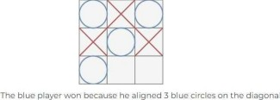

# Brute Force Method

A brute force approach is an approach that finds all the possible solutions to find a satisfactory solution to a given problem. The brute force algorithm tries out all the possibilities till a satisfactory solution is not found.

* 1. Consider a Board having nine element vectors.
  2. Each element will contain
     1. 0 for blank
     2. 1 indicating ‘X’ player move
     3. 2 indicating ‘O’ player move
  3. Computer may play as an ‘X’ or O player.
  4. First player always plays as ‘X’.

1. MT is a vector of 39elements, each element of which is a nine-element vector representing board position.
2. MT is a vector of 39elements, each element of which is a nine-element vector representing board position.
   1. Move Table (MT) is a vector of 39 elements, each element of which is a nine element vector representing board position.

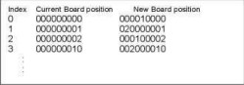

* 1. To make a move, do the following:
     1. View the vector (board) as a ternary number and convert it to its corresponding decimal number.
     2. Use the computed number as an index into the MT and access the vector stored there.
        1. The selected vector represents the way the board will look after the move.
     3. Set board equal to that vector.

# Heuristic Approach

Heuristics are essentially problem-solving tools that can be used for solving non-routine and challenging problems. A heuristic method is a practical approach for a short-term goal, such as solving a problem. The approach might not be perfect but can help find a quick solution to help move towards a reasonable way to resolve a problem.

Without considering symmetry the search space is 9! using symmetry the search space is 12 * 7! A simple heuristic is the number of solution paths still open when there are 8 total

Fr. Conceicao Rodrigues College of Engineering

Fr. Agnel Ashram, Bandstand, Bandra (W), Mumbai - 400050

paths (3 rows, 3 columns, 2 diagonals). Here is the search space using this heuristic. The total search space is now reduced to about 40, depending on the opponents play.

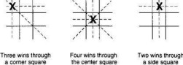

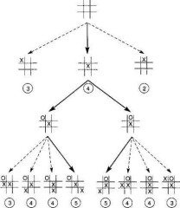

**OUTPUT:**

**BRUTE FORCE METHOD:**

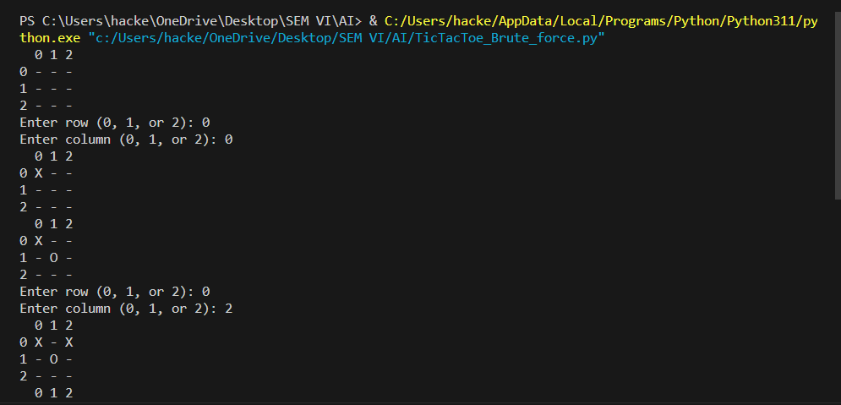

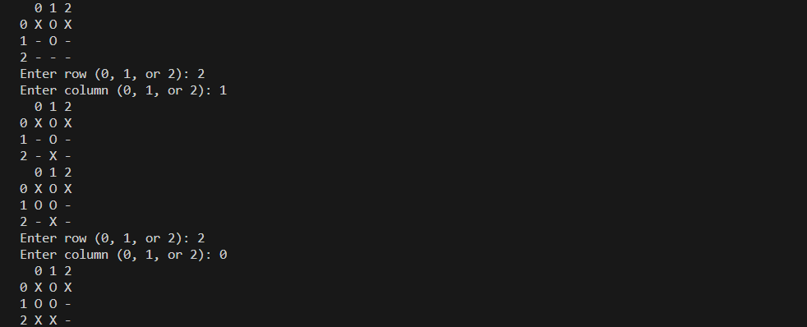

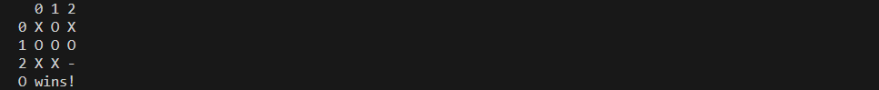

**HEURISTIC METHOD:**

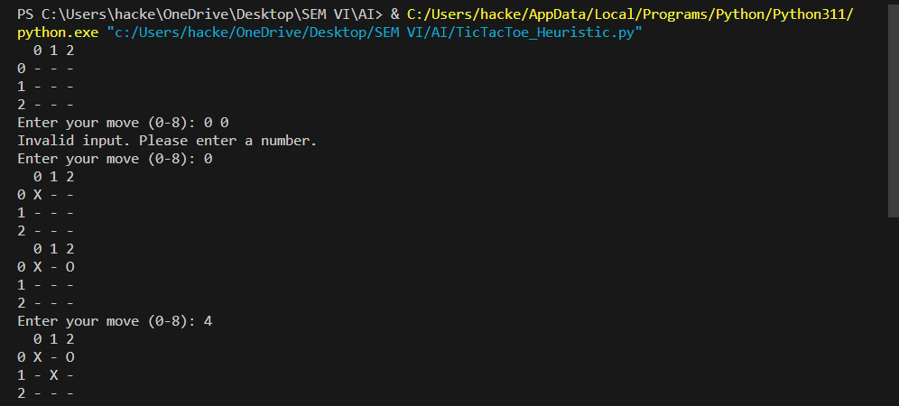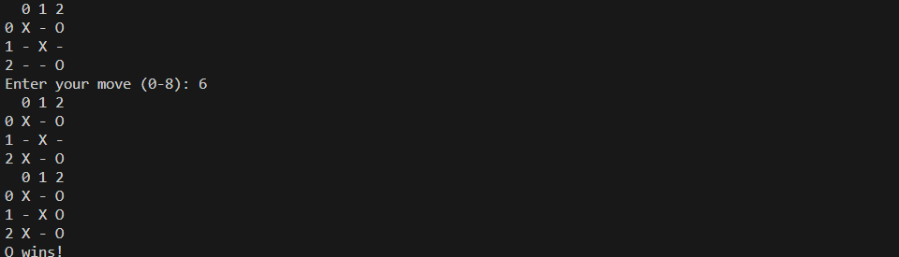

**Post Lab Assignment:**

1. What is the easiest trick to win Tic Tac Toe?
2. What is the algorithm to follow to win a 5*5 Tic Tac Toe?
3. Is there a way to never lose at Tic-Tac-Toe?
4. What can tic-tac-toe help you with?

