Fr. Conceicao Rodrigues College of Engineering Fr. Agnel Ashram, Bandstand, Bandra (W), Mumbai - 400050

**Department of Computer Engineering Academic Term II: 23-24**

**Class: B.E (Computer), Sem – VI Subject Name: Artificial Intelligence**

**Student Name: jason dsouza Roll No: 9537**

|  |  |
| --- | --- |
| **Practical No:** | **2** |
| **Title:** | Tic Tac Toe game implementation by Magic Square Method |
| **Date of Performance:** |  |
| **Date of Submission:** |  |

**Rubrics for Evaluation:**

|  |  |  |  |  |  |
| --- | --- | --- | --- | --- | --- |
| **Sr. No** | **Performance Indicator** | **Excellent** | **Good** | **Below Average** | **Marks** |
| 1 | On time Completion & Submission (01) | 01 (On  Time) | NA | 00 (Not on Time) |  |
| 2 | Logic/Algorithm Complexity analysis (03) | 03(Corr ect ) | 02(Partial) | 01 (Tried) |  |
| 3 | Coding Standards (03): Comments/indention/Nam ing conventions  Test Cases /Output | 03(All used) | 02 (Partial) | 01 (rarely followed) |  |
| 4 | Post Lab Assignment (03) | 03(done well) | 2 (Partially Correct) | 1(submitte d) |  |
| **Total** | | | | |  |

**Signature of the Teacher:**



8

Fr. Conceicao Rodrigues College of Engineering Fr. Agnel Ashram, Bandstand, Bandra (W), Mumbai - 400050

**Experiment No: 2**

**Title**: Tic Tac Toe game implementation by Magic Square Method

**Objective:** To write a computer program in such a way that computer wins most of the time using Magic Square Method

**Theory:**

A player who places his coins first across the same row or same column or same diagonal wins the game. Let us take a magic square of order 3 x 3 (for 3 coins game). The sum of the numbers across rows, columns and diagonals are the same - it is 15. That is, a player who places his coins such that he gets the perfect score of 15 takes the prize.

1. Board is considered to be a magic square of size 3 X 3 with 9 blocks numbered by numbers indicated by the magic square.
2. This representation makes the process of checking for a possible win simpler. Board Layout as magic square. Each row, column and diagonals add to 15.

|  |  |  |  |
| --- | --- | --- | --- |
| 8 | 3 | 4 | **15** |
| 1 | 5 | 9 | **15** |
| 6 | 7 | 2 | **15** |

1. Maintain the list of each player’s blocks in which he has played. Consider each pair of blocks that the player owns.

Compute difference D between 15 and the sum of the two blocks.

If D < 0 or D > 9 then

1. These two blocks are not collinear and so can be ignored.

Fr. Conceicao Rodrigues College of Engineering Fr. Agnel Ashram, Bandstand, Bandra (W), Mumbai - 400050

1. Otherwise, if the block representing difference is blank (i.e., not in either list) then a move in that block will produce a win.

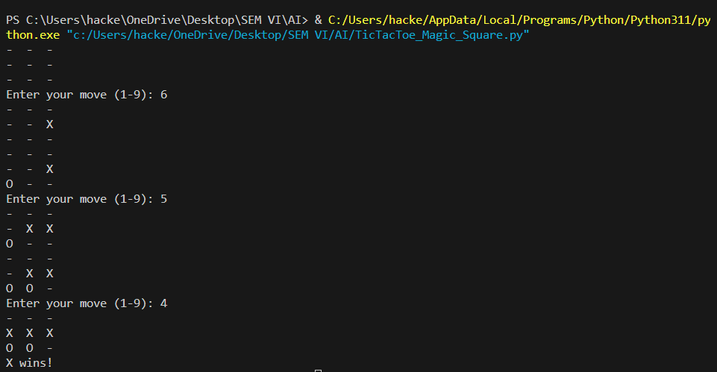**OUTPUT:**

**Post Lab Assignment:**

1. What is the relationship between tic-tac-toe and magic square?
2. What is a magic square of order n?

