**SSD – Assignment 02 Report**

By: D.S. Jiffry

IT17029896

**Structure**

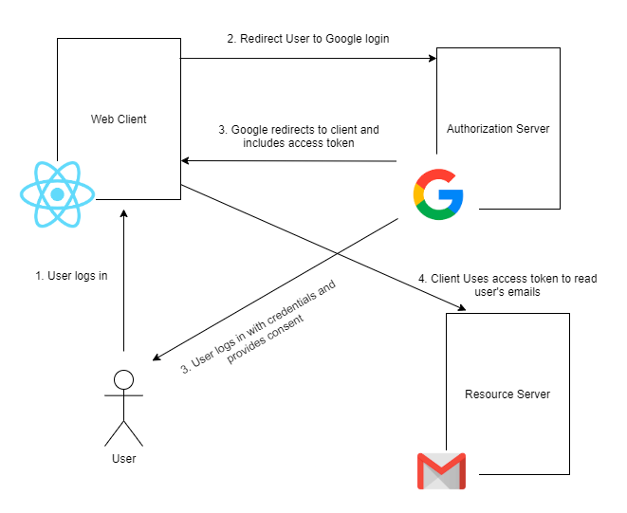

**Message Flows**

1. 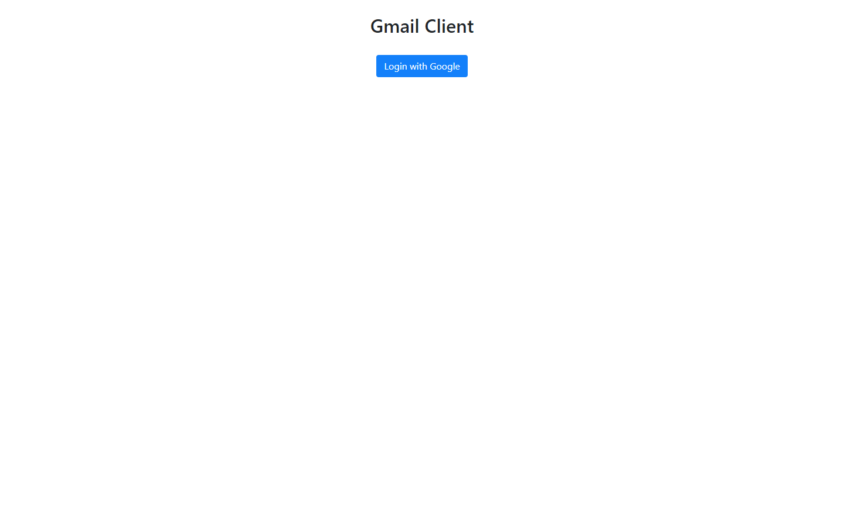Initially the user is presented with the Login with google button.
2. 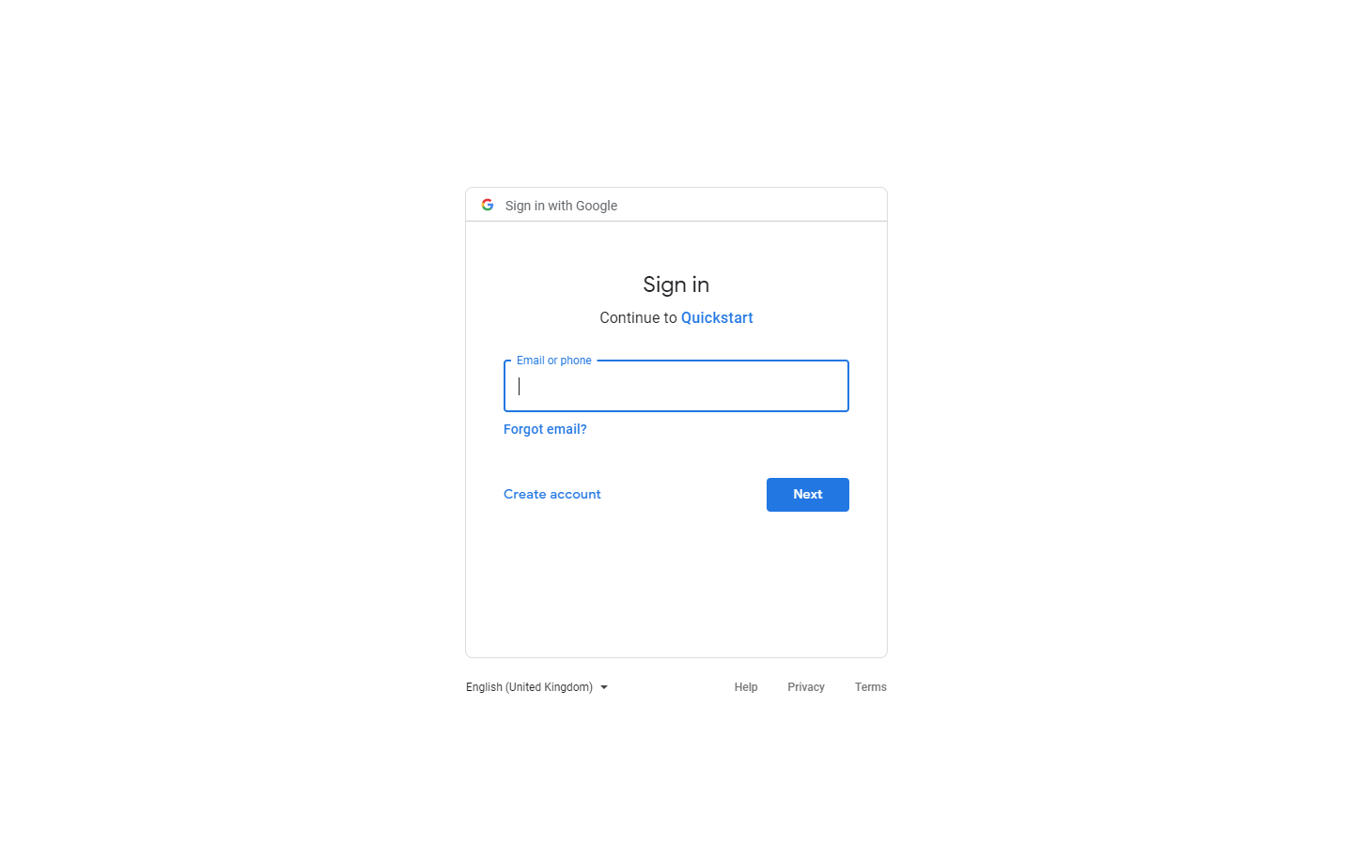Upon clicking this button, they will be redirected to the Google Login page and they need to login and provide their consent.

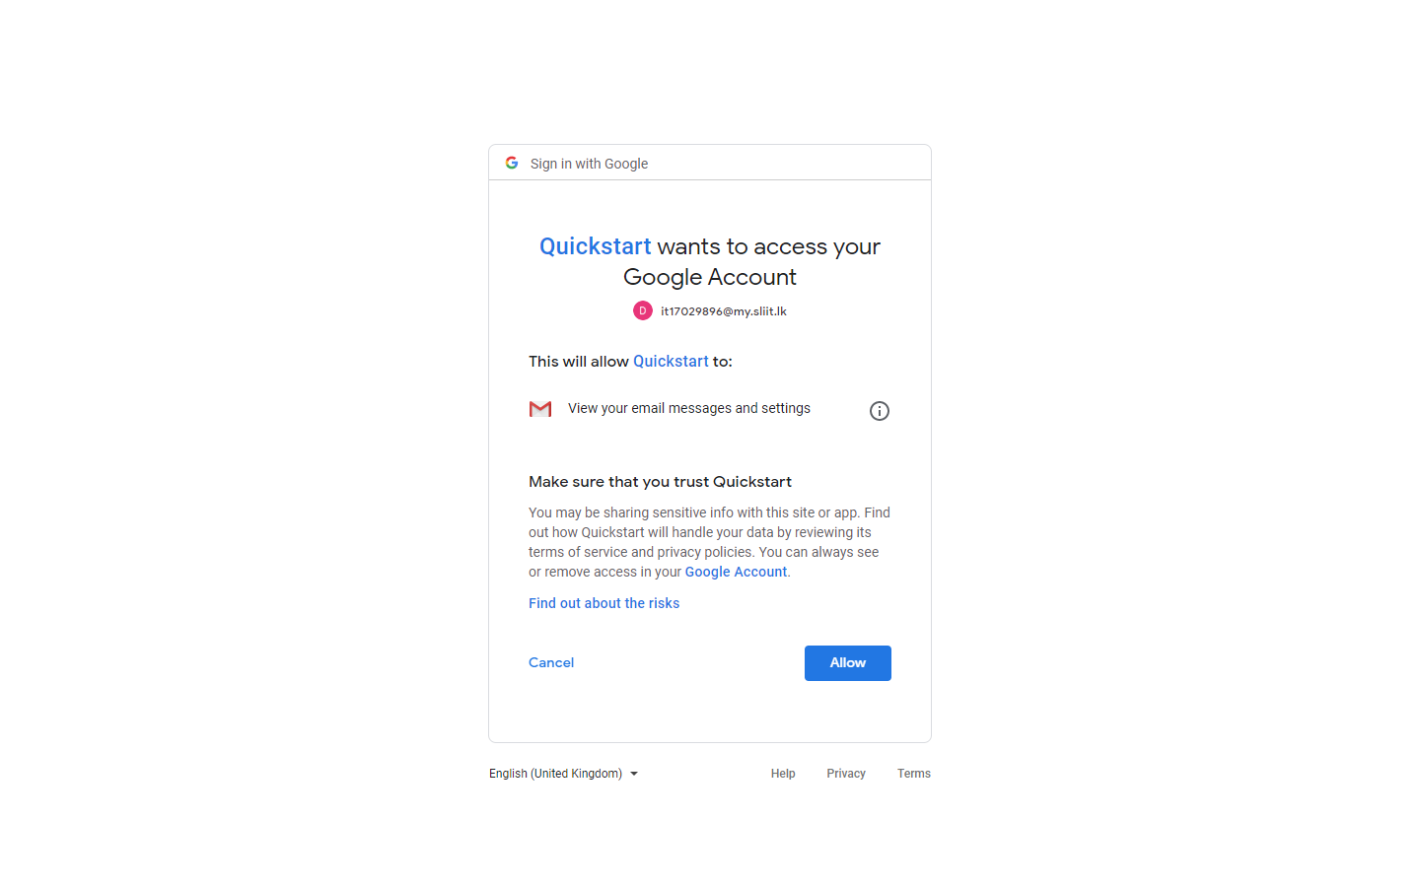

1. After they provide their consent I will get the Access token from google and then contact the Gmail resource server to get their last 10 emails and display them.

