Watchful Guardian Security System

Group Details: Q

Group Number: 61

Batch: Third Year (First Semester - Weekend)

|  |  |  |
| --- | --- | --- |
|  | Student Registration Number | Student Name |
| 1 | IT18050318 | M. A. Zeid |
| 2 | IT17029896 | D.S. Jiffry |
| 3 | It18060690 | M.R.M. Rifan |
| 4 | IT18200034 | M.A.F.Hasna |

Contents

1.0 Introduction 3

2.0 Component Diagram for the Security System 4

3.0 Manifest implementation 5

3.1 Exported and Imported Services 5

4.0 Commands of Bundle Install and Run in OSGi Framework 6

5.0 Screenshots of Its Behavior and Outputs 8

# Introduction

This is a security system for a building. When a user enters a building, their ID will be scanned and the number will be entered to the Front-Door service, this service will be checked with the Authentication service for a valid ID. If the ID is valid then the door will be opened and a log of the date & time will be made in the Reporting service. Once the user enters the building, they can use the elevator by tapping their ID, then the Elevator service will ask the authentication service what floors this user is permitted to access. Those floor buttons will be the only ones activated for that user. There will be security checks throughout the system to notify any security concerns in case someone tries to access the elevator without entering through the front door or if someone attempts to enter the building but was not logged in through the front door. As the system may evolve or change their internal authentication and authorization protocols changes and those changes can be made without downtime due to the underlying OSGi framework. Multiple versions of the front door authorization mechanisms can be implemented. Currently Two methods, one which checks the user Id and the other which checks and employee ID tag barcode has been implemented. Any other authentication and authorization mechanisms can be facilitated in the future. For clarity the console outputs in yellow color represent the reporting service and red represent authorization service.

# Component Diagram for the Security System

Figure 1 -- Component Diagram for Security System

`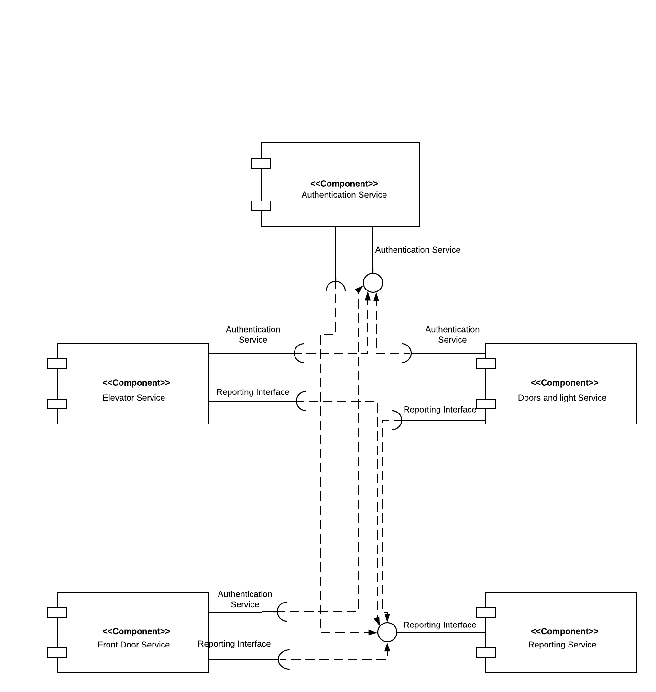

# Manifest implementation

## Exported and Imported Services

## 1. Authentication Service

#### Exported Packages:

* authentication_service
* auth_util

#### Imported Packages:

* org.osgi.framework
* org.osgi.util.tracker

## 2. Reporting Service

#### Exported Packages:

* reporting_service

#### Imported Packages:

* org.osgi.framework
* org.osgi.util.tracker

## 3. Front Door

#### Imported Packages:

* org.osgi.framework
* org.osgi.util.tracker
* authentication_service
* auth_util
* reporting_service

## 4. Elevator Service

#### Imported Packages:

* org.osgi.framework
* org.osgi.util.tracker
* authentication_service
* auth_util
* reporting_service

## 5. Barcode Reader Service

#### Imported Packages:

* org.osgi.framework
* org.osgi.util.tracker
* authentication_service
* auth_util
* reporting_service

## 6. Doors and Lights Service

#### Imported Packages:

* org.osgi.framework
* org.osgi.util.tracker
* authentication_service
* auth_util
* reporting_service

# 

# 4.0 Commands of Bundle Install and Run in OSGi Framework

|  |
| --- |
|  |
|  |  |
|  | echo "Building the jars" |
|  |  |
|  | cd "Front Door/bin/front_door" |
|  |  |
|  | jar cfm frontDoor.jar ../../META-INF/MANIFEST.MF ../front_door/ |
|  |  |
|  | mv frontDoor.jar ../../../felix-framework-4.0.3/ |
|  |  |
|  |  |
|  | cd "../../../Barcode Reader/bin/barcode_reader" |
|  |  |
|  | jar cfm barcodeReader.jar ../../META-INF/MANIFEST.MF ../barcode_reader/ |
|  |  |
|  | mv barcodeReader.jar ../../../felix-framework-4.0.3/ |
|  |  |
|  |  |
|  | cd "../../../Authentication Service/bin/authentication_service" |
|  |  |
|  | jar cfm auth.jar ../../META-INF/MANIFEST.MF ../authentication_service/ ../auth_util/ |
|  |  |
|  | mv auth.jar ../../../felix-framework-4.0.3/bundle/ |
|  |  |
|  |  |
|  |  |
|  | cd "../../../Reporting/bin/reporting_service" |
|  |  |
|  | jar cfm reporting.jar ../../META-INF/MANIFEST.MF ../reporting_service/ |
|  |  |
|  | mv reporting.jar ../../../felix-framework-4.0.3/bundle/ |
|  |  |
|  |  |
|  |  |
|  | cd "../../../Elevator Service/bin/elevator_service" |
|  |  |
|  | jar cfm elevator.jar ../../META-INF/MANIFEST.MF ../elevator_service/ |
|  |  |
|  | mv elevator.jar ../../../felix-framework-4.0.3/ |
|  |  |
|  |  |
|  |  |
|  | cd "../../../Doors And Lights/bin/doors_and_lights" |
|  |  |
|  | jar cfm doors.jar ../../META-INF/MANIFEST.MF ../doors_and_lights/ |
|  |  |
|  | mv doors.jar ../../../felix-framework-4.0.3/ |
|  |  |
|  |  |
|  |  |
|  |  |
|  | cd "../../../felix-framework-4.0.3" |
|  | rm -r "felix-cache" |
|  |  |
|  |  |
|  |  |
|  |  |
|  |  |
|  | # Running the felix framework |
|  | echo "Starting felix" |
|  |  |
|  | java -jar bin/felix.jar |

|  |
| --- |
|  |
|  |  |

# Screenshots of Its Behavior and Outputs

