Xicheng Huang

Xhuang343

**Indicators**

For technical indicators, I coded three indicators, Bollinger bands, commodity channel index, and golden cross.

For Bollinger bands, it has been taught in the course, in which I first calculate the rolling means of the stock prices, then calculate the rolling standard deviations, and at the end, using rolling standard deviations and rolling means to create the Bollinger upper and lower bands using 2 standard deviations.

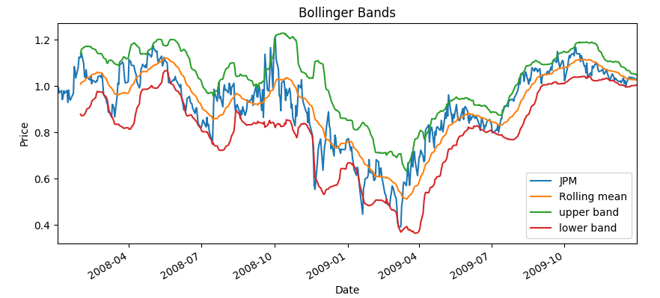

As described in the course, if the price goes over the upper band and then falls below it, there is an indicator for well. While if the price goes below the lower band and comes back later, there is an indicator for buy.

I found commodity channel index (CCI) indicator from an investment website and based on the mathematics, I wrote the python code to calculate CCI. The calculation is to first calculate rolling means, and calculate rolling standard deviations, just like Bollinger bands. Then using prices of the stock to deduct the rolling means, and then divided it by 1.5% of rolling standard deviations:

CCI = (Prices – Rolling Means) / (1.5% * Rolling Standard Deviations)

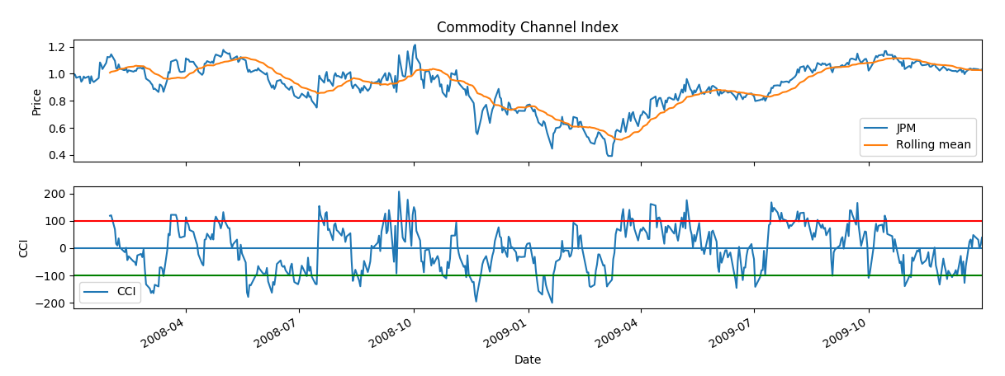

According to Stockcharts.com, CCI measures the difference between price change and its average price change. When CCI is high, especially going above 100, it indicates that the price is above average, showing strength, while CCI is low, it indicates that the price is below average, showing weakness.

Golden Cross indicator is another popular technical indicator widely used because of its ease of understanding. It uses a combination of short-term simple moving average and a long-term simple moving average, for example a 15-day and 50-day SMA. To calculate SMA, it is simply the rolling means of prices using different windows. When the short-term SMA crosses and “breaks” over long-term SMA, it shows that the price has broken the inertia to move higher. For the chart below, it uses 15-day and 50-day SMA.

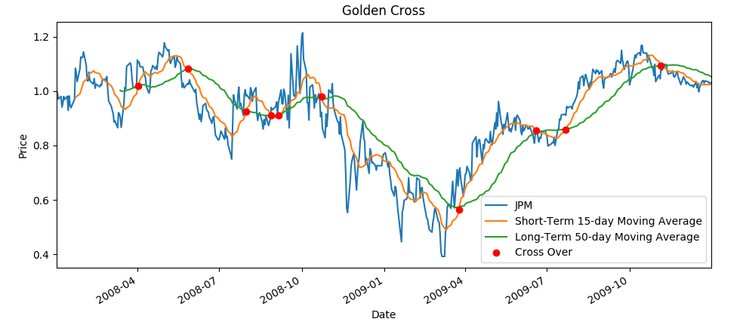

**Best Possible Strategy**

To create my best possible strategy, I calculated the price change from current day to the next day. Using that information, I determine whether I long or short for today. If tomorrow’s price is higher, I go long, otherwise, short. For the first day, it only trades 1000 shares due to the holdings constraint. Then for the rest of the days, it trades 2000 shares to either go +1000 or -1000 in holdings. Using this strategy, below is the result I got for trading JPM from 2008/1/1 to 2009/12/31.

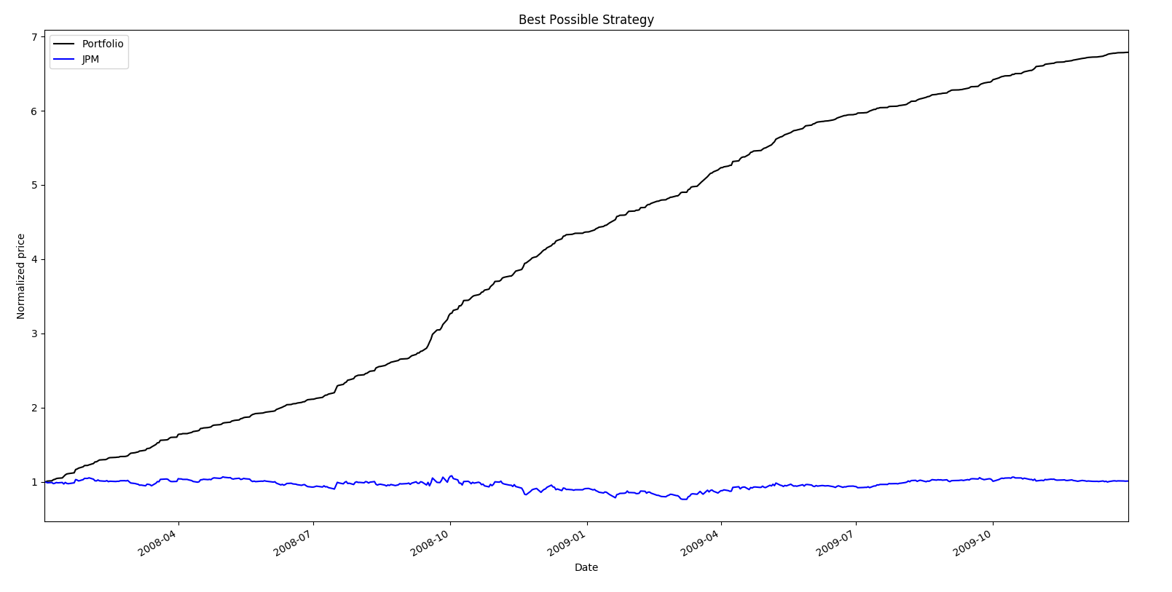

|  |  |  |
| --- | --- | --- |
|  | Best Possible Strategy Portfolio | Benchmark |
| Cumulative Return | 5.7861 | 0.012 |
| Standard Dev. of Daily Returns | 0.0045 | 0.017 |
| Mean of Daily Return | 0.0038 | 0.00017 |
| End Value | 678610 | 101230 |

**Manual Rule-Based Trader**

To create my manual strategy trader, I used all three technical indicators from my indicators.py. The indicators methods will return a list of dates and whether to long or short on those dates when called, then in manual strategy code, I combine all the dates and their positions into one trade list, then passed to market simulation to calculate the performance. For bollinger bands indicator, initially I coded so that when the price falls below upper band, it should sell, while when it rises up over the lower band, it should buy, like explained in lecture. However, when I was testing it, it did not create the best performance. In contrast, if it buys when it falls below the upper band and sells when it rises over the lower band, it performances much better for in sample period. I think it is due to that JPM’s price had a lot of downward trends in general during the period, so taking a short position actually performances better. For commodity channel index indicator, it will take a short position when it is over 100 due to overprice in stock and take a long position when it falls below -100 due to underprice. In addition, I am also using two golden cross indicators, one using a shorter window of 15-day and 50-day SMA, and another one using 50-day and 200-day SMA. Just like the common understanding of golden cross indicator, when the short-term SMA crosses over and rises higher long-term SMA, it takes a long position, and when the long-term SMA crosses over short-term SMA, it takes a short position. Below is a chart that compares portfolio and benchmark for the in-sample period. Green vertical lines indicate 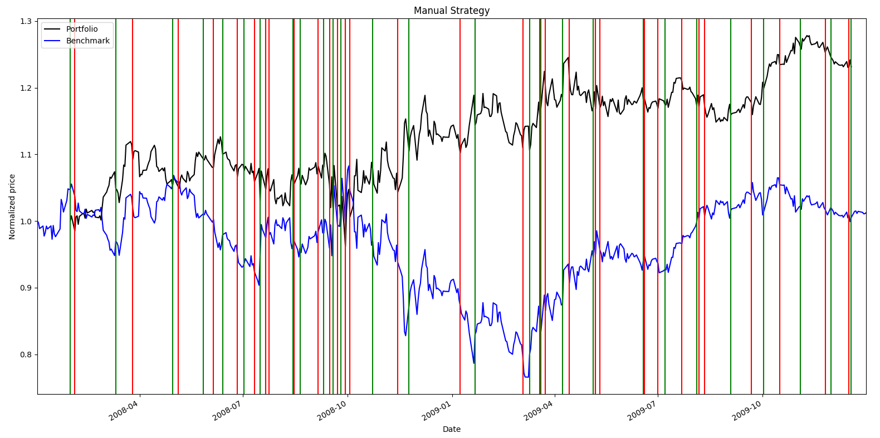long entry while red lines indicate short entry.

Here is a chart that shows the performance of the manual strategy for in-sample period.

|  |  |  |
| --- | --- | --- |
|  | Manual Portfolio | Benchmark |
| Cumulative Return | 0.2284 | 0.01027 |
| Standard Dev. of Daily Returns | 0.0152 | 0.017 |
| Mean of Daily Return | 0.00055 | 0.00017 |
| End Value | 122840.85 | 101027.7 |

**Comparative Analysis**

Using the strategy I came up with above, I applied it to out of sample time period. Here is the result I received.

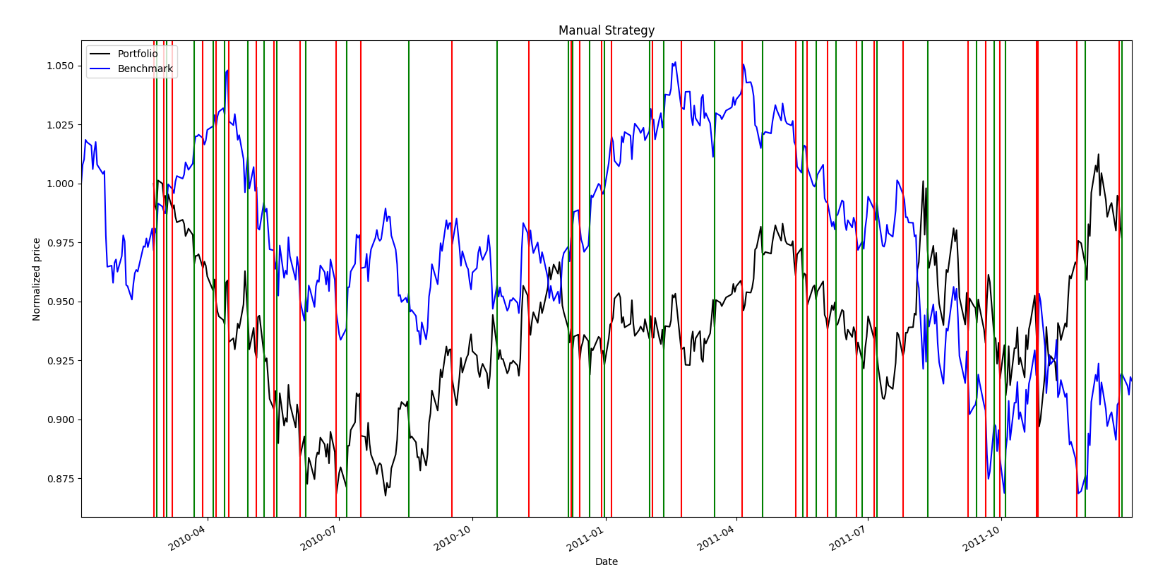

|  |  |  |  |
| --- | --- | --- | --- |
|  | In-sample | Out-of-sample | Benchmark |
| Cumulative Return | 0.2284 | -0.0229 | -0.0836 |
| Standard Dev. of Daily Returns | 0.0152 | 0.0092 | 0.0085 |
| Mean of Daily Return | 0.00055 | -7.5928e-6 | -0.00014 |
| End Value | 122840.85 | 97517.3 | 91445.7 |

From the results, it shows that out-of-sample performance did not beat the in-sample and even loses money after 2-year of trading but it is able to beat the benchmark. I think it is due to the general trend that JPM is decreasing in price, and my strategy is not reacting well in that regard. Because I did not peek at out-of-sample performance when creating the best strategy for in-sample data, I could have created overfitting and bias towards the in-sample data. I tweaked the Bollinger bands strategy to make in-sample performance better, but it might not make sense in the future. In addition, there are much more trades happening for out-of-sample period, which causes lower portfolio value.