Xicheng Huang

Xhuang343

Overview

To implement strategy learner, I used random tree learner and bag learner. Random tree learner is fast at adding evidence and updating policy which makes it amazing when there are many data points. Adding bagging technique to random tree learner to prevent any over- or underfitting when random tree does not produce the optimal result. First, I converted these two learners into classification learners so they are suitable for this problem. Then, I used the four technical indicators from manual strategy. These four indicators are Bollinger Bands, Commodity Channel Index, Golden Cross with 15/50 window, and Golden Cross with 50/200 window. The X data includes all the indicators’ value of the day. Having this information, I used the method described on the instruction about calculating n-day return to determine if the trade is a long position or a short position, a return threshold. For mine, I used 15-day window, and when the return is greater than 5%, it makes it a long position, and when the return is -5%, it makes it a short position. If the impact value is present, it will affect the return threshold by 2 times the impact value. For example, if impact value is 0.005, the 5% threshold will become 6% for both long and short positions. With these, we have our Y data for training set. For bag learner, I used 500 bags to create a more consistent result. If the bag number is low, the randomness of random tree learner will create highly inconsistent trades each time. The leaf size for random tree learner is 5. Once the model is trained, it is ready to create trades based on indicators’ data.

Experiment 1

For experiment 1, I expected that my strategy learner will perform better than manual strategy because I don’t think the indications provided by indicators are always accurate. In manual strategy, I simply put my faith into them to hope that it will indicate what I wanted it to do. Having machine learning model makes it more subjective on what indicators’ value mean. The parameter values are the same as described above when running this experiment, and the impact value is 0. I did not change any of the indicators for both learners.

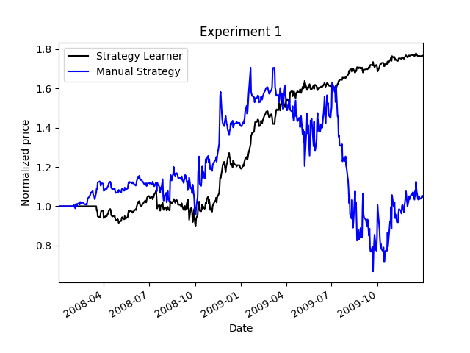

|  |  |  |
| --- | --- | --- |
|  | Strategy Learner | Manual Strategy |
| Cumulative Return | 0.7655 | .0464 |
| Standard Dev. of Daily Returns | 0.0136 | 0.041 |
| Mean of Daily Return | 0.0012 | 0.0009 |
| End Value | 176550.0 | 104640.0 |

As you can see from the chart and data above, strategy learner performs significantly better than manual strategy. It also has a more table increase in portfolio value where in manual strategy, the return varies significantly. I expect this similar result every time because for strategy learner, I set the bag size high enough that the resulting trades are very similar, and manual strategy’s resulting trades are the same every run. Therefore, this relative result should be expected all the time.

Experiment 2

Before running this experiment, I expected the that the trader will be more conservative and less risky on trading because of the increase in return threshold. This means the number of trades will decrease as well as the standard deviation of return. I did an experiment using steady increase of impact to look at three variables, number of trades, standard deviation of return, and cumulative return.

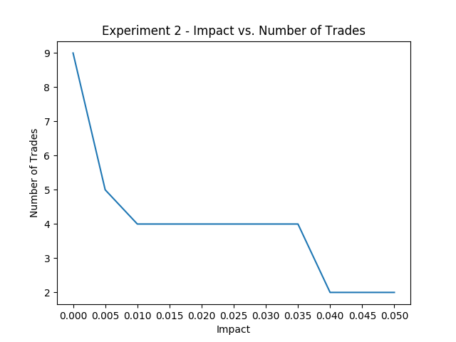

As you can see, the number of trades indeed decreases because of impact value increases.

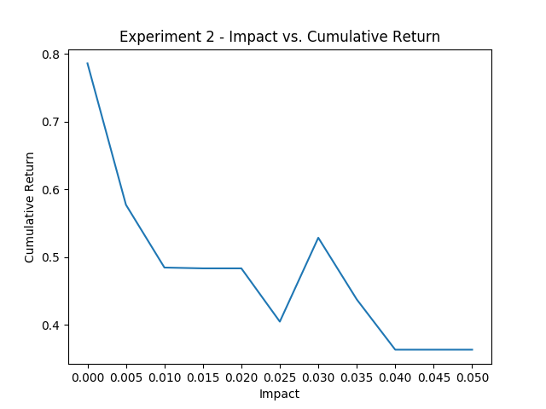

The cumulative return decreases as well.

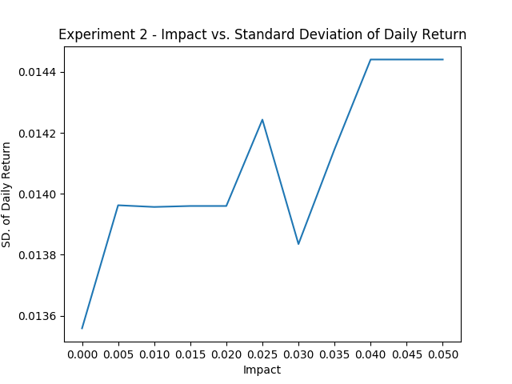

However, the standard deviation of daily returns did not decrease as expected, which made it even riskier as compared to trading without impact value.