Project 4

HTML Part 3

CSS and Forms
Complete the Following:
- Project Folder: Create a folder called “Project4_Lastname”, (using your own last name), in your
“Weekly Projects” folder, before your start the item II below. (5 Points)

2. CSS: (25 Points)
A. External: Create a CSS file similar to the one we have studied in the Class and save it as
“Proj4_CSS.css in your “Project4_Lastname” folder.
B. Inline and/or Embedded: Your Code must also contain Inline and/or Embedded CSS.

- Student Information Form A: (30 Points)
Code an application in HTML so that it provides a Form with the following controls but using your own
CSS file and Inline/Embedded ones. Save the file as “Project_4A_LastName” in your
“Project4_Lastname” folder.
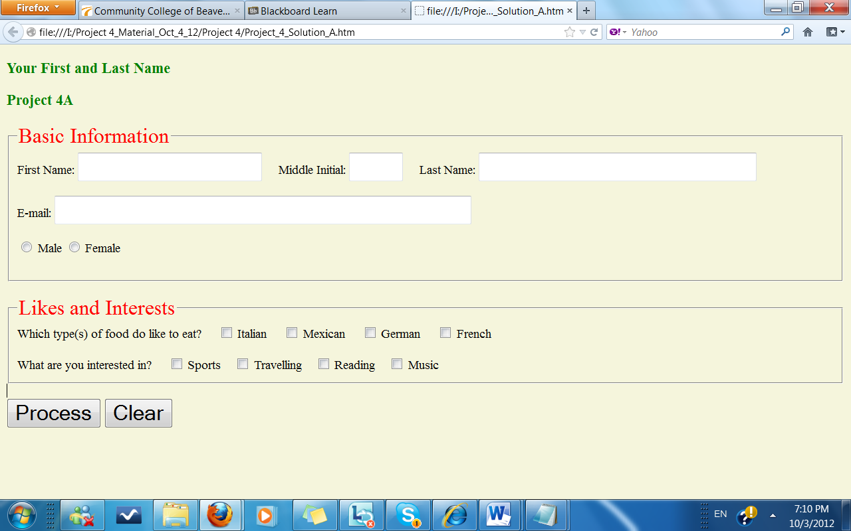

- Student Information Form B: (30 Points)
Code an application in HTML so that it provides a Form with the following controls but using your own
CSS file and Inline/Embedded ones.. Save the file as “Project_4B_LastName” in your “Project4_Lastname” folder.

The College Name dropdown list contains the following:
CCAC
CCBC
Geneva College
Penn State (default)
Pitt University

The Major dropdown list contains the following:
Accounting
Criminal Justice
Networking
Nursing
Web Programming (default)

