**SHOW YOUR BAND SPIRIT**

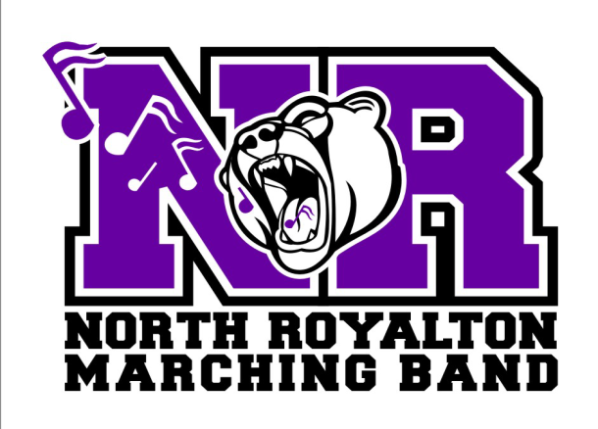**BUY A MARCHING BAND YARD SIGN**

THESE SIGNS CAN BE PERSONALIZED WITH NAME AND/OR BAND SECTION

STUDENT NAME: ______________________________________

PERSONALIZED: Name and/or Section (Please fill in what you want to appear on sign)

FIRST NAME: ________________________________

BAND SECTION: _________________________________________

(For Example: TRUMPETS, SAXOPHONES, ROYALAIRES,ETC.)

**COST: $25.00 per sign**

Make checks payable to **NRHS Band Boosters**

Place this form and check in an envelope marked **Band Boosters Yard Sign** in the white band box.

Once ordered and received students will receive signs after 6-9 practices on Wednesday evenings.

If you have any questions, call Shirley Berish at (440) 717-1532.

Office Use Only: check # __________ amount _________