Machine Learning Operations (MLOps) - AIMLCZG523
Assignment 01
End-to-End MLOps Pipeline for Heart Disease Risk Prediction
Data and EDA, MLflow tracking, CI/CD with GitHub Actions, Docker, Kubernetes, and monitoring
Student name | SRIKANTH DEVISETTY
Roll / ID number | 2025CT05053
Program | M.Tech (AI & ML), BITS Pilani
Course | MLOps (AIMLCZG523)
GitHub repository | [https://github.com/<your-username>/heart-disease-mlops]
Date | 20th October 2026

1. Introduction and objectives
Heart disease is a leading cause of death, and early risk screening from routine clinical measurements can help doctors decide who needs further tests. This assignment builds a classifier that predicts the presence of heart disease from patient health data, and, more importantly for this course, wraps it in a production-style MLOps workflow so that every step can be repeated, tested, deployed and monitored.
The work covers the full life cycle asked for in the brief:
- Data acquisition, cleaning and exploratory data analysis (EDA).
- Feature engineering and training of at least two classifiers with cross-validation.
- Experiment tracking with MLflow, with parameters, metrics, artifacts and plots logged for every run.
- Packaging of the final model together with its preprocessing so that results are reproducible.
- Automated tests and a GitHub Actions pipeline that lints, tests and trains on every push.
- A Docker container serving the model through a FastAPI /predict endpoint.
- Deployment to Kubernetes behind a LoadBalancer, and request logging with Prometheus and Grafana monitoring.
Note: this model is built for learning purposes only. It must not be used for real clinical decisions.

2. Repository structure and setup instructions

2.1 Repository layout
Path | Purpose
scripts/download_data.py | Downloads the UCI zip and writes data/processed/heart_clean.csv
src/data.py, src/features.py | Cleaning rules and the preprocessing pipeline
src/train.py | Cross-validation, tuning, MLflow logging, saving the best model
app.py | FastAPI service: /predict, /health, /metrics, request logging
tests/ | Pytest unit tests (data, model, API)
.github/workflows/ci.yml | CI pipeline: lint, test, train, Docker smoke test
Dockerfile, docker-compose.yml | API image; API with MLflow, Prometheus and Grafana
Dockerfile.mlflow, Dockerfile.train | MLflow server image and containerized training
k8s/deployment.yaml | Kubernetes Deployment and LoadBalancer Service
monitoring/ | Prometheus scrape config and Grafana data source
MLOps_Heart_Disease_End_to_End.ipynb | Single notebook: EDA, training, API test and all project files
screenshots/ | Evidence used in this report

2.2 Installation and running locally
The project needs Python 3.11 or newer, Git and Docker. From a clean clone:
python -m venv .venv
.venv\Scripts\activate # Windows; macOS/Linux: source .venv/bin/activate
pip install -r requirements.txt
python scripts/download_data.py # downloads and cleans the dataset
python src/train.py # trains, logs to MLflow, saves model/
pytest -q # unit tests
ruff check src tests scripts app.py
uvicorn app:app --port 8000 # API docs at http://localhost:8000/docs

All scripts run from a clean environment using only requirements.txt. The same steps are also available as cells of the single notebook, which writes every project file and runs the pipeline end to end.

3. Data acquisition and exploratory data analysis

3.1 Dataset
The data is the Heart Disease dataset from the UCI Machine Learning Repository, using the Cleveland subset (303 patients). Each record has 13 predictors and a target that records the degree of heart disease from 0 (none) to 4. The download script fetches the official zip file, extracts processed.cleveland.data and writes a cleaned CSV, so the data can be recreated by anyone.
Feature | Meaning | Type used in the model
age | Age in years | numeric
sex | 1 = male, 0 = female | categorical
cp | Chest pain type (1 to 4) | categorical
trestbps | Resting blood pressure | numeric
chol | Serum cholesterol (mg/dl) | numeric
fbs | Fasting blood sugar above 120 mg/dl | categorical
restecg | Resting ECG result (0 to 2) | categorical
thalach | Maximum heart rate achieved | numeric
exang | Exercise-induced angina | categorical
oldpeak | ST depression after exercise | numeric
slope | Slope of the peak ST segment | categorical
ca | Major vessels coloured by fluoroscopy (0 to 3) | categorical
thal | Thalassemia test result (3, 6, 7) | categorical

3.2 Cleaning and preprocessing
- The raw file marks missing values with "?". These appear in the ca and thal columns and are read as missing values.
- All columns are converted to numeric types. Rows without a target are dropped and duplicate rows are removed.
- The target is converted to a binary label: 0 means no disease and any value from 1 to 4 means disease present.
- Missing predictor values are kept at this stage and imputed inside the model pipeline. This avoids leaking information from the test folds into training.

3.3 Exploratory analysis
The EDA looks at the distribution of every numeric feature, the balance between the two classes and the correlation between features. The notebook saves these figures to artifacts/eda/.
[Insert screenshot]
Figure 1: Histograms of age, cholesterol and other numeric features (artifacts/eda/distributions.png)
Figure 1: Histograms of age, cholesterol and other numeric features (artifacts/eda/distributions.png)
[Insert screenshot]
Figure 2: Class balance of the binary target
Figure 2: Class balance of the binary target
[Insert screenshot]
Figure 3: Correlation heatmap of all features and the target (artifacts/eda/correlation.png)
Figure 3: Correlation heatmap of all features and the target (artifacts/eda/correlation.png)
Observations to write in your own words: [state the class balance you measured and whether it is roughly balanced; which features separate the two classes most clearly (for example chest pain type, maximum heart rate, ST depression, number of vessels); how many values were missing in ca and thal; whether outliers appear in cholesterol or blood pressure; and any pairs of features that are strongly correlated.]

4. Feature engineering and model development

4.1 Feature engineering
All preprocessing lives inside one scikit-learn ColumnTransformer that is part of the model pipeline. This means the exact same transformations are applied during training, evaluation and serving.
Feature group | Treatment
Numeric (age, trestbps, chol, thalach, oldpeak) | Median imputation, then standard scaling
Categorical (sex, cp, fbs, restecg, exang, slope, ca, thal) | Most-frequent imputation, then one-hot encoding; unseen categories at prediction time are ignored instead of causing an error

4.2 Models, tuning and evaluation protocol
Two model families were trained so that a simple, interpretable baseline can be compared with a more flexible ensemble. The data is split once into 80% training and 20% hold-out using a stratified split with a fixed seed (42). All model selection is done with 5-fold stratified cross-validation on the training part only. The hold-out part is used once, for the final report of the chosen model.
Model | Settings tried | Notes
Logistic Regression | C = 0.1, 1, 10 (3 runs) | max_iter 2000, balanced class weights; a linear baseline that is easy to interpret
Random Forest | n_estimators 200 or 400, max_depth None or 8, min_samples_leaf 1 or 2 (8 runs) | balanced class weights; captures non-linear effects and interactions

Each configuration is scored on accuracy, precision, recall and ROC-AUC. Recall is especially relevant for a screening problem, because a missed patient (false negative) is more costly than a false alarm. ROC-AUC is used as the main selection metric because it does not depend on a single decision threshold.

4.3 Results
Cross-validation results for all 11 candidate models (from artifacts/cv_results.csv):
Run | Accuracy | Precision | Recall | ROC-AUC
[run name] | [ ] | [ ] | [ ] | [ ]
[run name] | [ ] | [ ] | [ ] | [ ]
[run name] | [ ] | [ ] | [ ] | [ ]
[add rows for the best runs]

Hold-out performance of the selected model (from artifacts/final_metrics.json):
Metric | Value
Selected configuration | [from final_metrics.json]
Accuracy | [ ]
Precision | [ ]
Recall | [ ]
ROC-AUC | [ ]
[Insert screenshot]
Figure 4: Hold-out confusion matrix and ROC curve (artifacts/holdout_evaluation.png)
Figure 4: Hold-out confusion matrix and ROC curve (artifacts/holdout_evaluation.png)
Discussion to write in your own words: [explain why the selected model won, how large the gap to the other family is compared with the fold-to-fold standard deviation, which errors matter most in this setting, and the limits of a 303-row dataset.]

5. Experiment tracking with MLflow
MLflow records every training run so that results can be compared and reproduced. The tracking store is a local SQLite database (mlflow_data/mlflow.db), which can also be served by an MLflow server running in Docker.
Logged item | Details
Parameters | Model type, hyperparameters, number of CV folds, random seed
Metrics | Mean and standard deviation of accuracy, precision, recall and ROC-AUC over the 5 folds
Plots (every run) | Out-of-fold confusion matrix and ROC curve (cv_evaluation.png)
Final run | Hold-out metrics, cv_results.csv, final_metrics.json, hold-out plot, and the fitted pipeline as an MLflow model with an input example

The experiment contains 12 runs: 11 candidate models plus one final run named FINAL_<best model>. The runs can be inspected in the MLflow UI:
mlflow ui --backend-store-uri sqlite:///mlflow_data/mlflow.db # http://localhost:5000
# or inside Docker:
docker compose up -d mlflow
docker compose --profile train run --rm train

[Insert screenshot]
Figure 5: MLflow experiment page listing all runs
Figure 5: MLflow experiment page listing all runs
[Insert screenshot]
Figure 6: MLflow final run with metrics, parameters and artifacts
Figure 6: MLflow final run with metrics, parameters and artifacts
Summary to write in your own words: [how you used the run comparison view to choose the model, and what the runs showed about regularization strength (Logistic Regression) and tree depth (Random Forest).]

6. Model packaging and reproducibility
- The final model is a single scikit-learn Pipeline (preprocessing plus classifier) saved as model/heart_disease_pipeline.joblib. Because the preprocessing travels with the model, the API only needs the raw feature values.
- The same pipeline is also logged to MLflow in a reusable MLflow model format.
- requirements.txt lists the packages for development and training, and requirements-api.txt is a slimmer list for the serving image.
- Randomness is controlled by a fixed seed for the data split, the cross-validation folds and the models.
- The dataset is recreated by a script and the whole workflow can be rerun from the notebook or the command line from a clean environment.
One practical risk is a version mismatch between the environment that trained the model and the one that loads it. To avoid this, the CI pipeline trains and builds the Docker image in the same run, and the notebook is run in the same Python version that the Dockerfile uses.

7. Automated testing and CI/CD pipeline

7.1 Unit tests
There are 14 pytest tests that run on synthetic data, so they do not need the internet:
File | Tests | What is checked
test_data.py | 5 | Missing values handled, target made binary, duplicates removed, column types
test_model.py | 4 | Preprocessor handles missing values and unseen categories, probabilities are valid, the training script runs end to end and writes the model and the MLflow store
test_api.py | 5 | /health, a valid /predict call, 422 for a missing field, 422 for an out-of-range value, and the /metrics endpoint

7.2 GitHub Actions workflow
The workflow in .github/workflows/ci.yml runs on every push to main, on pull requests and on demand. Its jobs run in sequence, and a failure in any step stops the pipeline and shows the error in the logs:
- lint-and-test: installs dependencies, runs ruff (lint) and pytest, and uploads the test report as an artifact.
- train: downloads and cleans the dataset, runs the training script, prints an MLflow run table in the job summary, and uploads the model, plots and MLflow data as artifacts.
- docker: downloads the trained model, builds the image, starts the container and calls /health, /predict and /metrics as a smoke test, then prints the container logs.
[Insert screenshot]
Figure 7: GitHub Actions run with all jobs passing
Figure 7: GitHub Actions run with all jobs passing
[Insert screenshot]
Figure 8: Workflow artifacts and the MLflow run summary
Figure 8: Workflow artifacts and the MLflow run summary

8. Model containerization
The model is served by a FastAPI application inside a Docker image based on python:3.13-slim. The image contains only the runtime dependencies, the application file and the trained model, and defines a health check on /health.
Endpoint | Behaviour
POST /predict | Accepts JSON {"features": {...13 fields...}}, validates ranges, and returns prediction (0 or 1), a label, the confidence of the predicted class and the disease probability
GET /health | Returns whether the service is up and the model is loaded
GET /metrics | Prometheus metrics for requests, latency and predictions

Build and test the container locally:
docker build -t heart-disease-api:latest .
docker run --rm -p 8000:8000 heart-disease-api:latest

curl -X POST http://localhost:8000/predict -H "Content-Type: application/json" \
-d '{"features":{"age":58,"sex":1,"cp":4,"trestbps":130,"chol":250,"fbs":0,"restecg":0,
"thalach":150,"exang":0,"oldpeak":1.0,"slope":2,"ca":0,"thal":3}}'

A successful response has this shape (the values depend on your trained model):
{ "prediction": <0 or 1>, "label": "disease_present" | "disease_absent",
"confidence": <0.5 to 1.0>, "disease_probability": <0 to 1> }

[Insert screenshot]
Figure 9: docker build and docker run output
Figure 9: docker build and docker run output
[Insert screenshot]
Figure 10: /predict request and response (Swagger UI or curl)
Figure 10: /predict request and response (Swagger UI or curl)

9. Production deployment on Kubernetes
The Docker image is deployed to a local Kubernetes cluster (Docker Desktop or Minikube) with the manifest k8s/deployment.yaml. It contains:
- A Deployment with 2 replicas of heart-disease-api, with readiness and liveness probes on /health, and CPU and memory requests and limits.
- A Service of type LoadBalancer that exposes port 80 and forwards to port 8000 in the pods.
- Prometheus scrape annotations on the pods so metrics can be collected.
kubectl apply -f k8s/deployment.yaml
kubectl get pods,svc
kubectl port-forward svc/heart-disease-api 8080:80 # or use the LoadBalancer address
# Minikube: minikube image load heart-disease-api:latest ; minikube tunnel

Deployment is verified by checking that both pods are Running and that /health and /predict answer through the Service address.
[Insert screenshot]
Figure 11: kubectl get pods,svc showing 2 running pods and the LoadBalancer service
Figure 11: kubectl get pods,svc showing 2 running pods and the LoadBalancer service
[Insert screenshot]
Figure 12: API reached through the Kubernetes service (/docs or /predict)
Figure 12: API reached through the Kubernetes service (/docs or /predict)

10. Monitoring and logging

10.1 Request logging
A middleware logs every request with a request id, method, path, status code and latency. Predictions are logged with the predicted label and probability. Example of the log format:
INFO req_id=2f8833be method=GET path=/health status=200 latency_ms=1.9
INFO prediction=<label> disease_probability=<value>
INFO req_id=ca5c0bd0 method=POST path=/predict status=200 latency_ms=<value>

10.2 Metrics and dashboards
Metric | Meaning
api_requests_total | Requests by method, path and status code
api_request_latency_seconds | Latency histogram by path
api_predictions_total | Predictions by class

docker compose up --build starts the API together with Prometheus (port 9090, scraping /metrics every 5 seconds) and Grafana (port 3000, with Prometheus preconfigured as a data source). A Grafana dashboard with panels for request rate, latency and predictions per class gives a simple view of the service health.
[Insert screenshot]
Figure 13: Prometheus targets page or query result
Figure 13: Prometheus targets page or query result
[Insert screenshot]
Figure 14: Grafana dashboard with request rate, latency and predictions
Figure 14: Grafana dashboard with request rate, latency and predictions

11. Architecture
The diagram shows how data flows from the UCI source to a monitored, deployed API. The training side (top) is automated by GitHub Actions. The serving side (bottom) packages the saved model into a Docker image, which Kubernetes runs behind a LoadBalancer while Prometheus and Grafana observe it.
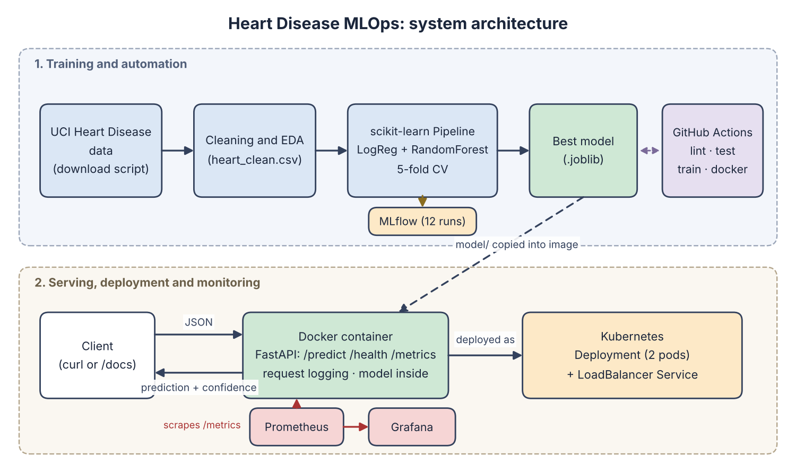
Figure 15: End-to-end system architecture

12. Challenges, limitations and future work

Challenges
- The MLflow file store is no longer accepted by recent versions, so a SQLite backend was used instead.
- MLflow rejected some scikit-learn types in its default model format, so the cloudpickle serialization was selected.
- Keeping the training and serving environments consistent required the model to be trained in the same Python version as the Docker image.
- [Add your own challenges here, for example anything unexpected in Docker, Kubernetes or GitHub Actions.]

Limitations
- The dataset is small (303 patients) and from a single source, so results may not carry over to other populations.
- The model uses default decision thresholds and has not been calibrated or clinically validated.
- Monitoring covers service health and prediction counts but not data drift or model quality over time.

Future work
- Add data drift checks and an alert rule in Prometheus.
- Add a model registry stage with promotion rules and automatic redeploys from CI.
- Use Helm and an Ingress controller, and run the deployment on a managed cloud cluster.

13. Conclusion
The project delivers a reproducible workflow from raw data to a deployed and monitored prediction service. Preprocessing and model are packaged together, every experiment is tracked in MLflow, tests and CI protect against regressions, and the Docker and Kubernetes setup runs the same artifact in any environment. [Add 2 to 3 sentences with your final model, its hold-out ROC-AUC and what you learned.]

14. Links and references
- Code repository: [https://github.com/<your-username>/heart-disease-mlops]
- Demo video: [link or file name]
- UCI Machine Learning Repository, Heart Disease dataset (Cleveland subset), archive.ics.uci.edu.
- scikit-learn, MLflow, FastAPI, Docker, Kubernetes, Prometheus and Grafana documentation.

