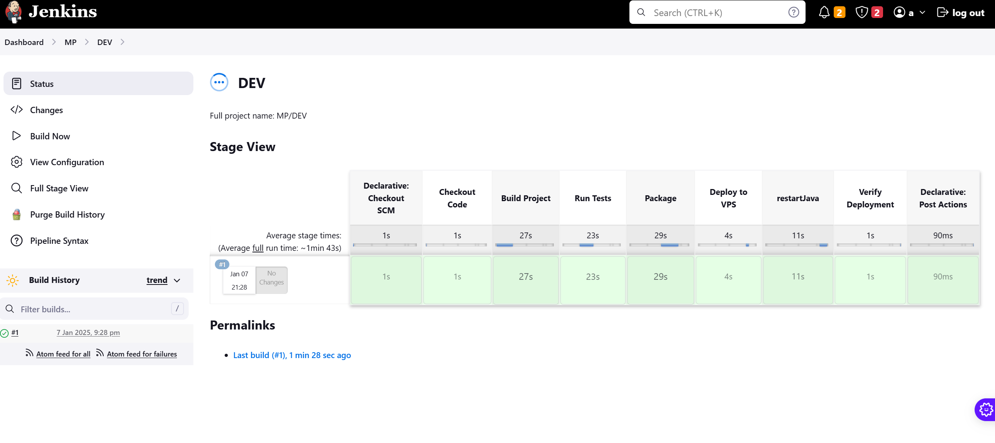

|  |
| --- |
|  |

Jenkinsfile

|  |
| --- |
| pipeline {  agent any  *// tools { // maven 'maven3.9.9' // }*  environment {  *// Define environment variables // JAVA_HOME = '/opt/java/openjdk' // Adjust if necessary  JAVA_HOME* = '/opt/jdk' *// Adjust if necessary  REMOTE_SERVER* = 'root@5.104.80.4' *// SSH user and VPS IP address  DEPLOY_DIR* = '/opt/jar' *// Directory on your VPS to deploy to  JAR_NAME* = 'demo-SpringBoot-SwaggerV3' *// Directory on your VPS to deploy to  CURRENT_TIME* = "${new Date().format('yyyy-MM-dd HH:mm:ss')}"  CURRENT_TIMVvVV = "${new Date().format('yyyy-MM-dd-HH-mm-ss')}"  *ENVENV*='dev1'  }   stages {  stage('Checkout Code') {  steps {  *// Clone the Git repository*  git 'https://github.com/dsl1888888/demo-SpringBoot-SwaggerV3.git'  }  }   stage('Build Project') {  steps {  script {  *// Run Maven to build the Spring Boot project*  sh '''#!/bin/bash  mvn clean install -DskipTests  '''  }  }  }   stage('Run Tests') {  steps {  script {  *// Optionally, run tests using Maven*  sh 'mvn test'  }  }  }   stage('Package') {  steps {  script {  *// Package the application (Spring Boot app as .jar or .war)*  sh 'mvn package'  }  }  }   stage('Deploy to VPS') {  steps {  script {  *// Copy the packaged application to the VPS using SCP*  sh '''  #!/bin/bash  scp -P 22 target/${JAR_NAME}.jar ${REMOTE_SERVER}:${DEPLOY_DIR}/${JAR_NAME}-${ENVENV}-${CURRENT_TIMVvVV}-${BUILD_NUMBER}.jar  '''  }  }  }   stage('restartJava') {  steps {  script {  sh '''  ssh -p 22 root@5.104.80.4 << EOF || true  java -version  pkill -f 'demo-SpringBoot-SwaggerV3-${ENVENV}'  nohup java -jar ${DEPLOY_DIR}/${JAR_NAME}-${ENVENV}-${CURRENT_TIMVvVV}-${BUILD_NUMBER}.jar --server.port=17001 > /dev/null 2>&1 &  sleep 10  ps aux | grep demo-SpringBoot-SwaggerV3.jar  EOF  '''  }  }  }   stage('Verify Deployment') {  steps {  script {  *// Optionally, verify if the app is running by checking the health endpoint (or any endpoint)*  echo "Verifying deployment..."  sh '''  curl -f http://5.104.80.4:17001/a2 || exit 1  '''  }  }  }       }   post {  success {  echo 'Deployment Successful!'  }  failure {  echo 'Build or Deployment Failed.'  }  } } |

Jenkinsfile1

|  |
| --- |
| pipeline {  agent any  *// tools { // maven 'maven3.9.9' // }*  environment {  *// Define environment variables // JAVA_HOME = '/opt/java/openjdk' // Adjust if necessary  JAVA_HOME* = '/opt/jdk' *// Adjust if necessary  REMOTE_SERVER* = 'root@5.104.80.4' *// SSH user and VPS IP address  DEPLOY_DIR* = '/opt/jar' *// Directory on your VPS to deploy to  JAR_NAME* = 'demo-SpringBoot-SwaggerV3' *// Directory on your VPS to deploy to  CURRENT_TIME* = "${new Date().format('yyyy-MM-dd HH:mm:ss')}"  CURRENT_TIMVvVV = "${new Date().format('yyyy-MM-dd-HH-mm-ss')}"  *ENVENV*='TEST'  }   stages {  stage('Checkout Code') {  steps {  *// Clone the Git repository*  git 'https://github.com/dsl1888888/demo-SpringBoot-SwaggerV3.git'  }  }   stage('Build Project') {  steps {  script {  *// Run Maven to build the Spring Boot project*  sh '''#!/bin/bash  mvn clean install -DskipTests  '''  }  }  }   stage('Run Tests') {  steps {  script {  *// Optionally, run tests using Maven*  sh 'mvn test'  }  }  }   stage('Package') {  steps {  script {  *// Package the application (Spring Boot app as .jar or .war)*  sh 'mvn package'  }  }  }   stage('Deploy to VPS') {  steps {  script {  *// Copy the packaged application to the VPS using SCP*  sh '''  #!/bin/bash  scp -P 22 target/${JAR_NAME}.jar ${REMOTE_SERVER}:${DEPLOY_DIR}/${JAR_NAME}-${ENVENV}-${CURRENT_TIMVvVV}-${BUILD_NUMBER}.jar  '''  }  }  }   stage('restartJava') {  steps {  script {  sh '''  ssh -p 22 root@5.104.80.4 << EOF || true  java -version  pkill -f 'demo-SpringBoot-SwaggerV3-${ENVENV}'  nohup java -jar ${DEPLOY_DIR}/${JAR_NAME}-${ENVENV}-${CURRENT_TIMVvVV}-${BUILD_NUMBER}.jar --server.port=17002 > /dev/null 2>&1 &  sleep 10  ps aux | grep demo-SpringBoot-SwaggerV3.jar  EOF  '''  }  }  }   stage('Verify Deployment') {  steps {  script {  *// Optionally, verify if the app is running by checking the health endpoint (or any endpoint)*  echo "Verifying deployment..."  sh '''  curl -f http://5.104.80.4:17002/a2 || exit 1  '''  }  }  }       }   post {  success {  echo 'Deployment Successful!'  }  failure {  echo 'Build or Deployment Failed.'  }  } } |