Graphical User Interface for S2E
Table of Contents:

1. Introduction:

My motivation behind this project lies in the conception of software for a already established program. I want to understand how to create content for an existing project and the way this content should be released. I studied and programmed compilers last semester, the subject really interested me. Hence, I wondered what the debugging paradigm of S2E is.

Currently S2E requires to have a specific knowledge on what plugin is available and what configuration option they require. The knowledge is generally acquired reading the plugin source file. Once S2E is configured, it will typically produce logs and other various files that the user has to read and fully understand.
The main goal of this project is to simplify these processes.

I choose to implement the interface using a python back end with a django framework. The front end is made using javascript (and jquery), html and css.

I made this choice because the framework is well documented and I already knew a bit of python. Also, python has a good compatibility with clang making it easier to parse c++ source code. Regarding the front end, I think it is the obvious choice for a web application, it is responsive and can be accessed by everyone.
2. Automate the generation of configuration files.

//TODO remove
Currently, on S2E, if a user wants to use a plugin, he has to go through the source code of the plugin and understand the way it works. Then the user has to write a configuration file in LUA to be able to use that plugin. The goal of the interface is such that the user can just select which plugin to enable and configure it.

As explained in the introduction, the user of S2E has to go through the plugin's source code to see what plugin is available and how to configure them.

In this part of the project, I address this problem with an annotation in every plugin's source code.

The plugin's developer must include a small annotation in his code for each attributes of the plugin. The comment looks like this:

// @s2e_plugin_option@
// attribute_name:
// type: int
// description: "attribute description."

The developer must supply the name of the attribute, the type and optionally a description for the attribute. These comment should respect the YAML format. Currently the project supports multiple types: "int", "bool", "string", "stringList", "intList" and "list". An attribute of type list describes a list of attributes, it must contain a variable named "content" assigned with every attributes included in the list.
Here is an example of a list attribute comment list:

// @s2e_plugin_option@
// list_prefix:
// type: list
// description: "this is the description of the list"
// content:
// checked:
// type: bool
// description: "this is the description of checked"

When the annotation has been written inside the plugin source, a script will generate a json file with the information inside the source files.
This as the added benefit to encourage the developer to comment their plugins code, otherwise his plugin will not work inside the GUI.
3. Configure and run S2E.

The JSON file constructed in stage 2 is used by the GUI to create a customized interface to generate the plugin configuration.

The parser on the previous step also gathered the information about plugin's dependencies. When the user enables a plugin, everyone of its dependencies get automatically enabled. Therefore, the state of each plugin inside of the interface is defined by the buttons on the left, they can be of 3 differents colors : Red for disabled, green for enabled and blue for enabled due to dependencies.

To generated the interface, the JSON file previously created gets sent to the browser, then a javascript runs and creates the plugin custom configuration page.
The plugin name, description are displayed as well as every attributes. The types of the attributes is enforced with the input fields. Each attribute type has a specific input field, if the user tries to run an analysis with a wrong value in any of the fields, an error message is display and the analysis is not launched.

When the user has finished the configuration of the plugins, he must supply a binary to execute before he can run the analysis. The interface sends the selected plugins and their configuration by the user to the server.

With these informations, the server generate a LUA file for S2E.
Every plugin gets added to the plugins list and their configuration is set to the one selected by the user. In parallel, the data from the client is checked using the JSON file generated in step one. This way, the user cannot send invalid data and still have the server accept his request.

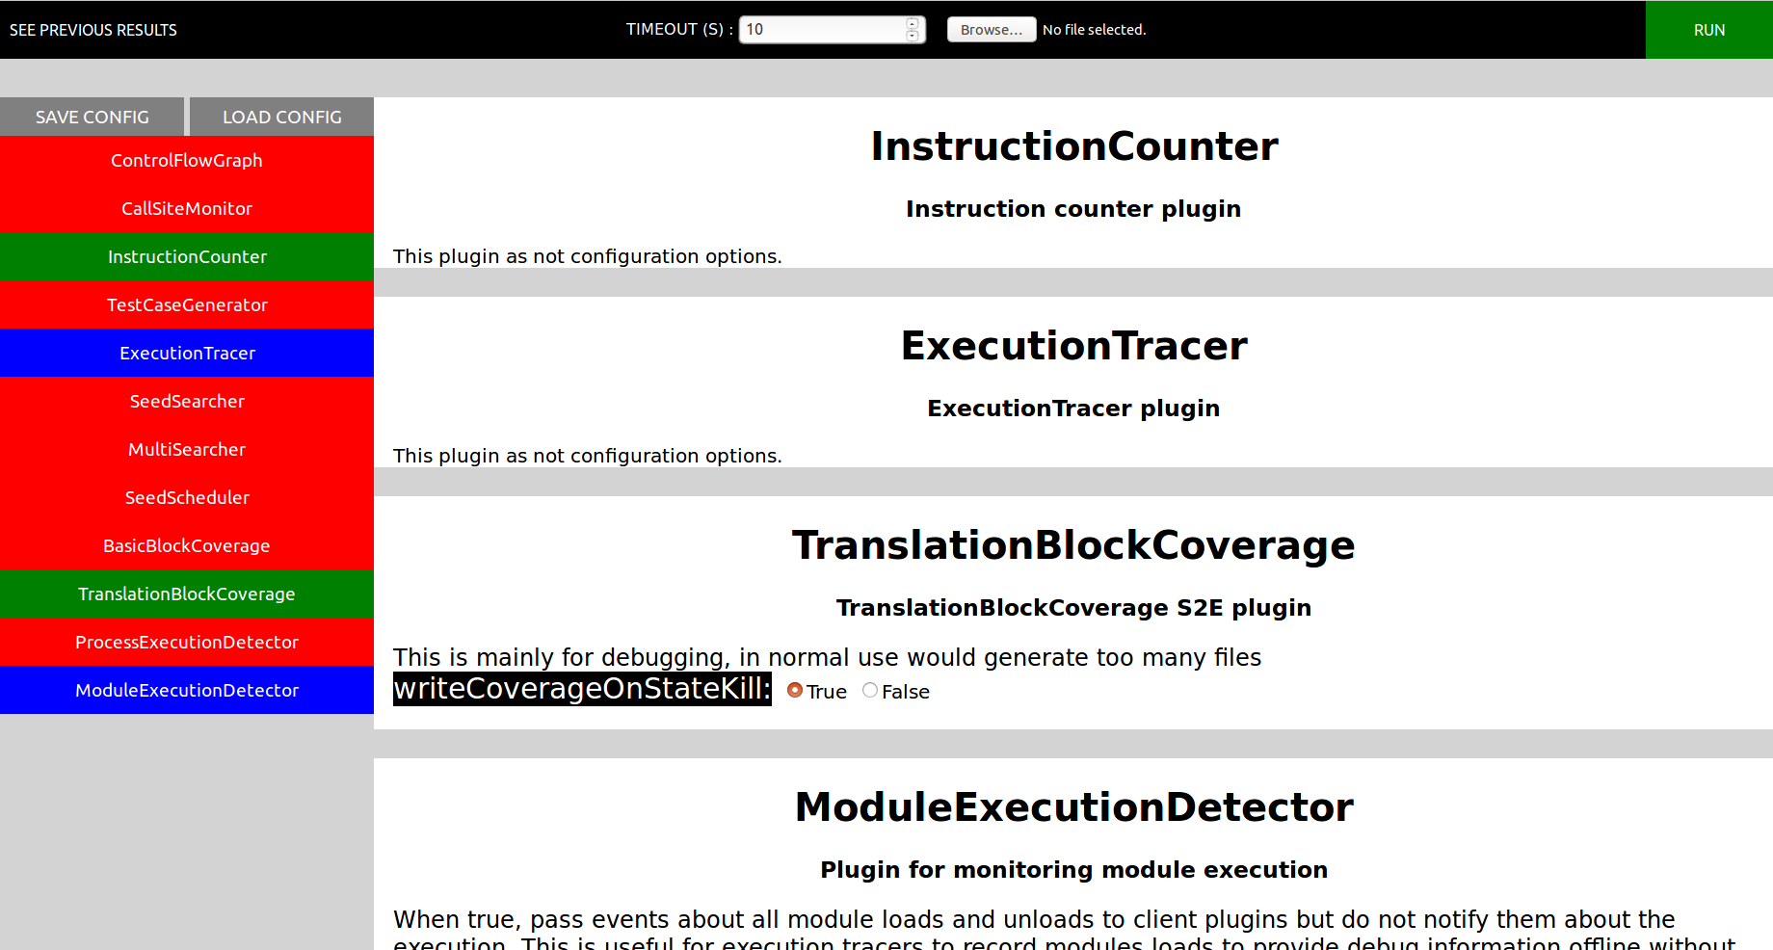
Once everything is ready, the analysis can finally be launched.

4. Extend the web interface to display plugin specific output in an easy-to-understand way

In a normal execution, S2E outputs three log files (info.txt, debug.txt, warning.txt) and files generated by plugins (e.g., ExecutionTracer.dat). The user has then to read and understand those files to debug or profile his binary file.

To make it easier for the user to read the log files, they are grouped into the S2E states, which can be selected and then read individually.
The user can also look at the analysis overview, it displays all the states that have run in the analysis as well as their termination status and message. This can be used to quickly see in which state a problem occurred.

Currently the interface displays custom data for two plugins: InstructionCounter and TranslationBlockCoverage.

If the user enables the InstructionCounter plugin, he can go to a tab that show the total instruction count on every states of the analysis.
This information is read from the ExecutionTracer.dat file and displayed inside a table on the GUI.

The plugin TranslationBlockCoverage has two different custom outputs.
The first one is the line coverage, it displays if a line has been executed and how many states ran. To generate it, I use the lcov tool.
The second one is the function's graphs, it is a set of images that describe the flow of the program. An image is generated for each function involved in the submitted binary. In the image, a green block describes a block that as been executed at least once and in contrast a block that has not been executed is colored in gray. In the graph, an arrow describes a jump from a block to another, arrows exists with three colors :

- Green arrow: jump if condition is true.
- Red arrow: jump if condition is false.
- Blue arrow: unconditional jump.

5. Implement a mechanism for storing S2E analysis results and allow the user to browse a history of S2E analysis.

In the current S2E environment, when the user creates a project, by default the project name is the same as the binary name.
The GUI uses this disposition to stay consistent with s2e-env. Everything related to an analysis is stored inside the S2E output folder. A database keeps track of the project name, s2e-number and binary checksum for later accessibility.
The checksum is calculated with SHA256.
Conclusion:

The current interface addresses the problems raised in the introduction.

I encountered some problems when I tried to generate configuration interface. At first I tried to do everything using python and it was fine until I wanted to support an attribute type of list with another list in its content. It turned out that creating nested javascript scripts inside a python string made the code unreadable and unreliable. Thus I decided to rewrite this part in javascript with a different model in mind.

Now the main problem is that each plugin's developer must add the annotation on their plugins and keep these annotation consistent with their code.
If the developer somehow changes the code but forgets to update the annotation, then the interface cannot generate the configuration for that plugin correctly. This is a problem because it breaks the fail fast principle. To fix this problem the information for the plugins attributes could be fetched directly from the source making the process more reliable but we would lose the description that could help the user to configure the plugins.

I enjoyed do work on this project because it taught me a lot on many different ends. I learned to use Linux more efficiently, to deal with many different libraries, to setup a web server, to look for multiple ….
Further improvement:

The time I could spend working on this semester project was quite limited,
Here is a list of elements I would have liked to add to the GUI :

- Add a way to run an already existing project without submitting a binary.
- Add the date of the analysis.
- Display the code coverage on the page where every analysis are listed.
- Group everything analysis overview by project name.
- Giving the possibility to the plugin developer to add a default value in the YAML annotation.
- Have a load button which displays the gui in the state depicted by the lua configuration file send by the user. (backward compatibility)
- Create a authentication system, this way, the server could be hosted somewhere and the GUI used as a service (e.g. pex for fun).
- Have a graph which show how the states gets created and how they get terminated. For example :

