## Graphing Linear Inequalities Pattern Activity

In this activity, students discover the pattern behind the four basic inequalities: y ≥ x, y ≥ -x, y ≤ -x, y ≤ x.

Materials

* 24 sheets of paper each with four grids, one in each quarter of the paper
* Interactive whiteboard or overhead projector
* File, slide, or transparency with four grids arranged 2 by 2 as in the following image
* Colored pencils

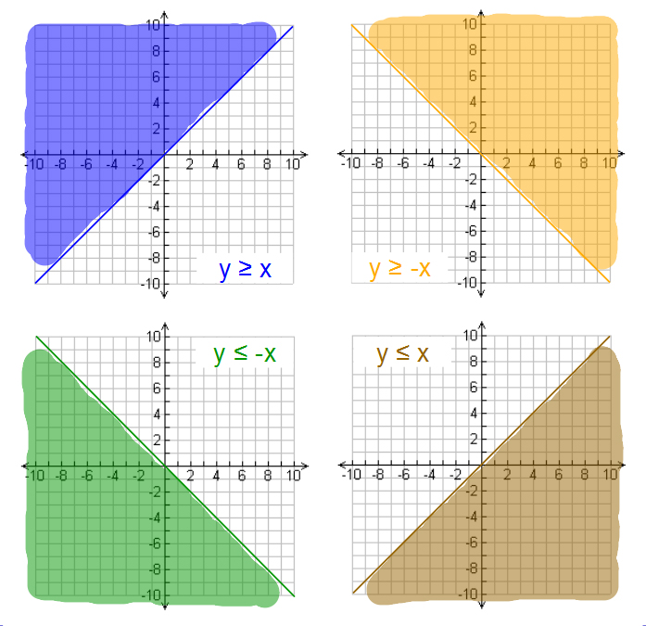

**Note:** Students can use colored pencils for this activity, but the activity can also be done with regular graphite pencils.

Procedure

Pass out graph paper and instruct students orally while demonstrating the following steps.

Part I

1. Fold your paper in half and then in half again. Unfold your paper to see that it is divided into four sections separated by creases. We are going to graph four inequalities, each in one section.
2. Refold your paper once. Orient your paper so that the folded edge is down and the open edge is up.
3. Look for the crease that splits this portion of your paper in half. At the bottom, just to the left of the crease, write y ≥ x. On the other side of the crease, also at the bottom, write y ≥ -x.
4. Graph both of these inequalities, y ≥ x in the left-hand section and y ≥ -x in the right-hand section.
5. Which direction should you shade? How did you decide which direction to shade an inequality problem on the number line?
   1. Select a point (4, 2) and check if it is a solution to the inequality. If it is, shade the area that includes the point. If it is not, shade the other portion.
   2. The point (4, 2) **is** **not** a solution for y ≥ x so shade the portion of the graph above and to the left of the line.
   3. The point (4, 2) **is** a solution for y ≥ -x so shade the portion of the graph above and to the right of the line.

You can see that the shading for both of these graphs goes up (above the line). Why do you think that is? (because these inequalities are both greater than)

You can also see that the shaded region for one of the graphs goes to the left while the shaded region for the other goes to the right. What do you think accounts for this quality? Take note in this case…When the slope is positive, the shading goes to the left. When the slope is negative, the shading goes to the right.

Part II

1. Leave the paper folded but flip it over. This time, orient it so the folded edge is up and the open edge is down.
2. Look for the crease that splits this portion of your paper in half. At the bottom, just to the left of the crease, write y ≤ -x. On the other side of the crease, also at the bottom, write y ≤ x.
3. Graph both of these inequalities, y ≤ -x in the left-hand section and y ≤ x in the right-hand section.
4. Which direction should you shade?
   1. Select a point (4, 2) and check if it is a solution to the inequality. If it is, shade the area that includes the point. If it is not, shade the other portion.
   2. The point (4, 2) **is** **not** a solution for y ≤ -x so shade the portion of the graph below and to the left of the line.
   3. The point (4, 2) **is** a solution for y ≤ x so shade the portion of the graph below and to the right of the line.

You can see that the shading for both of these graphs goes down (below the line). Why do you think that is? (because these inequalities are both less than)

You can also see that the shaded region for one of the graphs goes to the left while the shaded region for the other goes to the right. Take note in this case…When the slope is negative, the shading goes to the left. When the slope is positive, the shading goes to the right.

Open the paper up. How does the “leftness” or “rightness” of the shading in the bottom two graphs compare to the two above? Look at the graph of y ≤ -x. How does the shading compare to the graph of y ≥ -x in terms of the “leftness” or “rightness” of the shading? (the horizontal direction is opposite when considering the sign of the slope)

Is the sign of the slope the only factor that accounts for the direction of the shading? (both the sign of the slope and the sign of the inequality determine the horizontal direction of the shading)