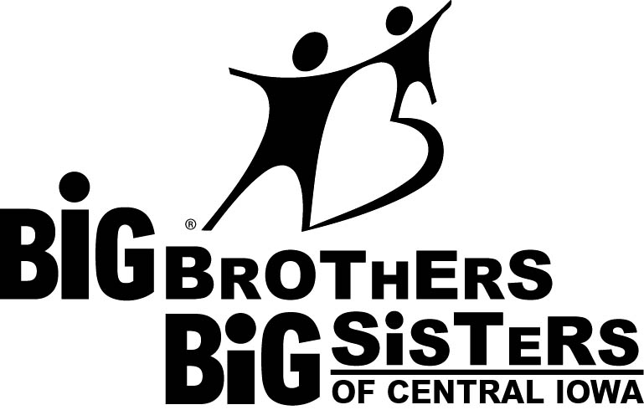
COMMUNITY VOLUNTEER AGREEMENT

Volunteer’s Name:

Big Brothers Big Sisters is a program designed to help children who have a defined need for a strong relationship with an interested adult.

‘Big Brothers Big Sisters of Central Iowa impacts youth by empowering them to discover and achieve their goals through meaningful mentoring relationships.’ – Mission Statement

The evaluation interviews are designed to establish a profile of your capacities in relating to children and your interests. Except for parents and/or guardians with a direct responsibility for a Little Brother/Sister who has been evaluated, approved for a match, and is actively being considered for a match with you, the information you provide the agency will be handled in a confidential manner.

The desires of a child’s parent or guardian and the wishes of the Big Brother or Big Sister are respected in the selection of the appropriate adult and child to be matched. Relevant information will be provided to each party in a prospective match regarding the other, but names will be withheld until the parties agree to enter into a pre-match discussion. Relevant information shall include past or present factors of health, personality, behavior of each individual and/or family that your Case Manager determines may have a significant effect on the relationship. Any party has the right to refuse to enter into the match based upon the information communicated.

Big Brothers Big Sister of Central Iowa maintains supervision after the match is made. During the supervision of the match, your Case Manager will share relevant information that, in their opinion, will be necessary to help the relationship depend and/or resolve problems.

All parties in the match, including staff members of Big Brothers Big Sisters, will handle information in a confidential and appropriate manner.

If applicable and as an agency volunteer:

- I agree that, upon notification, I will adhere to all new policies and procedures adopted by Big Brothers Big Sisters of Central Iowa.
- I understand that overnight visits are NOT allowed except in rare circumstances and only after prior approval has been given by the agency.
- I understand that outings at my home with my LB/LS are NOT allowed for the first 3 months of the match and will only be allowed thereafter once a home visit is done by a BBBSCI staff member.
- I agree to refrain from bringing any guests along to outings within the first 6 months.
- I am willing to develop a consistent and nurturing relationship with my LB/LS through time spent at least two times a month, for a minimum of two hours each meeting, for at least one year.
- I understand that the approved volunteer(s) is/are the only one(s) authorized, under the BBBS agency insurance policy to transport the little.
- I agree to spend time with my LB/LS primarily on a one-to-one basis. A guest or other family member should only be included if both parties agree and are present throughout the duration of the outing. No volunteer to ever be alone with their Little’s guest or other family member.
- I agree to be a consistent Brother/Sister role model; one the child can depend on and trust in.
- I agree to keep my Case Manager informed about the progress in my match by contacting him/her monthly during the first year and quarterly during subsequent years.
- I understand failure to maintain contact with the agency will result in the match being suspended or terminated.
- I agree to contact my Case Manager if I develop a concern about the match or need to make changes in the match.
- I agree to inform my Case Manager of any significant health changes (i.e.: hospitalization, extended treatment, or pregnancy).
- I agree to keep the parent informed how the match is going by communicating with him/her on a consistent basis.
- I agree that, in the event a match participant should marry, become involved in a live in arrangement with a significant other or bring a minor child into my home, I will notify my Case Manager.
- I agree to refrain from being under the influence of alcohol or drugs while around my LB/LS.
- I agree that the purchase price of all gifts for my Little during the first year will be less than $50 per gift; I understand when considering participating in the purchase of a gift for my Little of a significant amount I am encouraged to consult with my Case Manager after the first year.
- If under the age of 18, in a family or duo match, I agree my participation in the match will be dependent on the presence of an adult.
- I agree if active in a family or duo match all participants will be involved together, as a unit, at least 50% of the time.
- I agree and consent that Big Brothers Big Sisters of Central Iowa, its affiliates, employees, agents or media may take still or motion pictures and sound recordings by tape or otherwise of me. I agree to the use of such photographs and written information about me in connection with advertising, promotional, or other presentations on behalf of Big Brothers Big Sisters of Central Iowa. I agree to the reproductions of such on television or radio in newspapers or newsletters, or in any other medium of communication.
- I agree to allow my name, address, and phone number to be shared with other members of Big Brothers Big Sisters of Central Iowa for the sole purpose of facilitating and promoting the Big Brothers Big Sisters Program. This will include such things as planning for special events and membership drives.
- I agree to allow information about me to be shared for the purpose of program evaluation, audit, or accreditation with certain outside bodies, such as Big Brothers Big Sisters of America. I understand that outside parties shall be required to respect the agency’s policy of confidentiality and to use the information solely for the stated purpose.
- I agree to adhere to the terms of this volunteer agreement through out the time that I serve as a Big Brother/Big Sister volunteer.

Signature: |  | Date:

Signature: |  | Date:

Signature: |  | Date:

Signature: |  | Date:

Signature: |  | Date:

**Please Return This Form to the Big Brothers Big Sisters Office**

