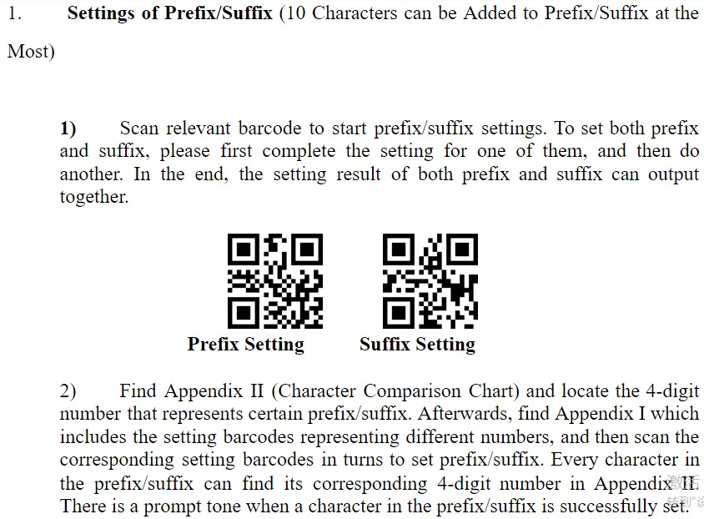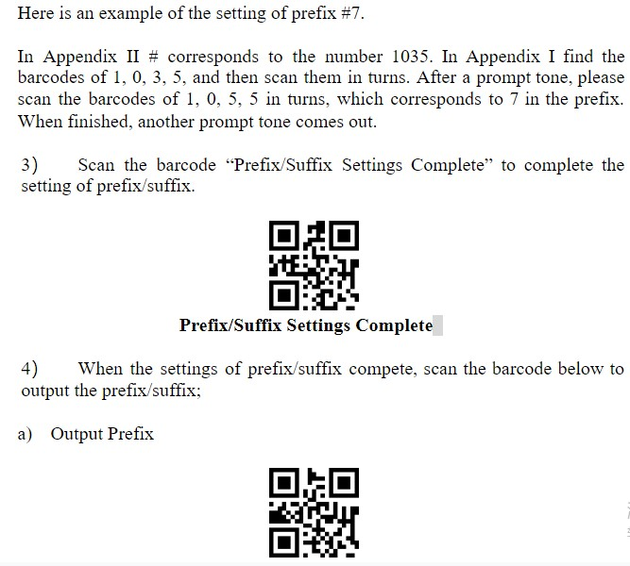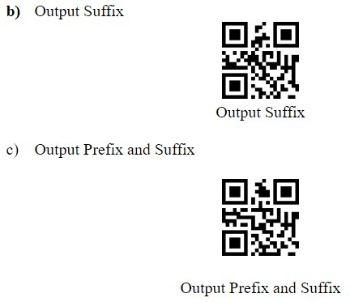

**Appendix II: Character Comparison Chart**

|  |  |
| --- | --- |
| Numbers | Corresponding Function |
| 1000 | Null |
| 1002 | Caps lock |
| 1003 | Right Arrow |
| 1004 | Up Arrow |
| 1005 | Null |
| 1006 | Null |
| 1008 | Left Arrow |
| 1009 | Tab |
| 1010 | Down Arrow |
| 1011 | VT |
| 1012 | Backspace |
| 1013 | Enter |
| 1014 | Insert |
| 1015 | Esc |
| 1016 | F11 |
| 1017 | Home |
| 1018 | Print Screen |
| 1019 | Delete |
| 1020 | tab+shift |
| 1021 | F12 |
| 1022 | F1 |
| 1023 | F2 |
| 1024 | F3 |
| 1025 | F4 |
| 1026 | F5 |
| 1027 | F6 |
| 1028 | F7 |
| 1029 | F8 |
| 1030 | F9 |
| 1031 | F10 |
| 1032 | Space |
| 1033 | ! |
| 1034 | ‘ |
| 1035 | # |
| 1036 | $ |
| 1037 | % |
| 1038 | & |
| 1039 | ‘ |
| 1040 | ( |
| 1041 | ) |
| 1042 | * |
| 1043 | + |
| 1044 | , |
| 1045 | - |
| 1046 | . |
| 1047 | / |
| 1048 | 0 |
| 1049 | 1 |
| 1050 | 2 |
| 1051 | 3 |
| 1052 | 4 |
| 1053 | 5 |
| 1054 | 6 |
| 1055 | 7 |
| 1056 | 8 |
| 1057 | 9 |
| 1058 | : |
| 1059 | ; |
| 1060 | < |
| 1061 | = |
| 1062 | > |
| 1063 | ? |
| 1064 | @ |
| 1065 | A |
| 1066 | B |
| 1067 | C |
| 1068 | D |
| 1069 | E |
| 1070 | F |
| 1071 | G |
| 1072 | H |
| 1073 | I |
| 1074 | J |
| 1075 | K |
| 1076 | L |
| 1077 | M |
| 1078 | N |
| 1079 | O |
| 1080 | P |
| 1081 | Q |
| 1082 | R |
| 1083 | S |
| 1084 | T |
| 1085 | U |
| 1086 | V |
| 1087 | W |
| 1088 | X |
| 1089 | Y |
| 1090 | Z |
| 1091 | [ |
| 1092 | \ |
| 1093 | ] |
| 1094 | ^ |
| 1095 | _ |
| 1096 | ‘ |
| 1097 | a |
| 1098 | b |
| 1099 | c |
| 1100 | d |
| 1101 | e |
| 1102 | f |
| 1103 | g |
| 1104 | h |
| 1105 | i |
| 1106 | j |
| 1107 | k |
| 1108 | l |
| 1109 | m |
| 1110 | n |
| 1111 | o |
| 1112 | p |
| 1113 | q |
| 1114 | r |
| 1115 | s |
| 1116 | t |
| 1117 | u |
| 1118 | v |
| 1119 | w |
| 1120 | x |
| 1121 | y |
| 1122 | z |
| 1123 | { |
| 1124 | | |
| 1125 | } |
| 1126 | ~ |