CONFIGURING THE SHELL

Key component of the bash shell is shell variables. Store vital system information and modify the behavior of the bash shell, as well as many commands.

A variable is a name or identifier that can be assigned a value. The shell (and other commands) reads the values of these variables, which can result in altered behavior depending on the contents (value) of the variable.

You assign a value to a variable by typing the name of the variable immediately followed by the equal sign = and then the value. For example: name="Bob Smith"

Variable names should start with a letter (alpha character) or underscore and contain only letters, numbers and the underscore character. It is important to remember that variable names are case-sensitive; a and A are different variables. Just as with arguments to commands, single or double quotes should be used when special characters are included in the value assigned to the variable to prevent shell expansion.

Valid Variable Assignments | Invalid Variable Assignments
a=1 | 1=a
_1=a | a-1=3
LONG_VARABLE='OK' | LONG-VARIABLE='WRONG'
Name='Jose Romero' | 'user name'=anything

The bash shell and many commands make extensive use of variables. One of the main uses of variables is to provide a means to configure various preferences for each user. Based upon the value of variables, the bash shell and commands can behave in different ways. For the shell, variables can affect what the prompt displays, the directories the shell will search for commands to execute and much more.

A local variable is only available to the shell in which it was created. An environment variable is available to the shell in which it was created and it is passed into all other commands/programs started by the shell.

By convention, lowercase characters are used to create local variable names and uppercase characters are used when naming an environment variable.

There are a few ways that a local variable can also be made to be an environment variable. First, an existing local variable can be "exported" with the export command:
sysadmin@localhost:~$ ENVIRONMENT=1
sysadmin@localhost:~$ export ENVIRONMENT
Second, a new variable can be "exported" and assigned a value with a single command. In the following case, we assume that the variable has not previously been set:
sysadmin@localhost:~$ export ENVIRONMENT=2
Third, the declare or typeset command can be used, to "declare" a variable to be an environment variable. These commands are synonymous and work the same way:
sysadmin@localhost:~$ declare -x ENVIRONMENT=3
sysadmin@localhost:~$ typeset -x ENVIRONMENT=3
Third, the declare or typeset command can be used, to "declare" a variable to be an environment variable. These commands are synonymous and work the same way:
sysadmin@localhost:~$ declare -x ENVIRONMENT=3
sysadmin@localhost:~$ typeset -x ENVIRONMENT=3
DISPLAYING VARIABLES

The set command by itself will display all variables (local and environment):

To display only environment variables, you can use several commands that provide nearly the same output: env, declare -x, typeset -x or export -p:

To display the value of a specific variable, use the echo command with the name of the variable prefixed by the $ (dollar sign). For example, to display the value of the PATH variable, you would execute echo $PATH
sysadmin@localhost:~$ echo $PATH
/home/sysadmin/bin:/usr/local/sbin:/usr/local/bin:/usr/sbin:/usr/bin:/sbin:/bin: /usr/games:/usr/local/games
Consider This
Variables can also be enclosed in {} (curly braces) in order to delimit them from surrounding text. While the echo ${PATH} command would produce the same result as the echo $PATH command, curly brackets set the variable apart visually making it easier to see in scripts in some contexts.
If you create a variable and then no longer want that variable to be defined, you can use the unset command to delete it:
sysadmin@localhost:~$ example=12
sysadmin@localhost:~$ echo $example
12
sysadmin@localhost:~$ unset example
sysadmin@localhost:~$ echo $example
THE PATH VARIABLES

The PATH variable contains a list of directories that are used to search for commands entered by the user. When the user types a command and then presses the Enter key, the PATH directories are searched for an executable file that matches the command name. Processing works through the list of directories from left to right; the first executable file that matches what is typed is the command the shell will try to execute.

Consider This
Before searching the PATH variable for the command, the shell will first determine if the command is an alias or function, which may result in the PATH variable not being utilized when that specific command is executed.
Additionally, if the command happens to be built-in to the shell, the PATH variable will not be utilized.
The following table illustrates the purpose of some of the directories displayed in the output of the previous command:
Directory | Contents
/home/sysadmin/bin | A directory for the current user sysadmin to place programs. Typically used by users who create their own scripts.
/usr/local/sbin | Normally empty, but may have administrative commands that have been compiled from local sources.
/usr/local/bin | Normally empty, but may have commands that have been compiled from local sources.
/usr/sbin | Contains the majority of the administrative command files.
/usr/bin | Contains the majority of the commands that are available for regular users to execute.
/sbin | Contains the essential administrative commands.
/bin | Contains the most fundamental commands that are essential for the operating system to function.

To execute commands that are not contained in the directories that are listed in the PATH variable, several options exist:
- The command may be executed by typing the absolute path to the command.
- The command may be executed with a relative path to the bid.
- The PATH variable can be set to include the directory where the command is located.
- The command can be copied to a directory that is listed in the PATH variable.
INITIALIZATION FILES

When a user opens a new shell, either during login or when they run a terminal that starts a shell, the shell is customized by files called initialization (or configuration) files. These initialization files set the value of variables, create aliases and functions, and execute other commands that are useful in starting the shell.

There are two types of initialization files: "global" initialization files which affect all users on the system and "local" initialization files that are specific to an individual user.
The global configuration files are located in the /etc directory. Local configuration files are stored in the user's home directory.
BASH INITIALIZATION FILES

Each shell uses different initialization files. Additionally, most shells execute different initialization files when the shell is started via the login process (called a login shell) versus when a shell is started by a terminal (called a non-login shell or an interactive shell).

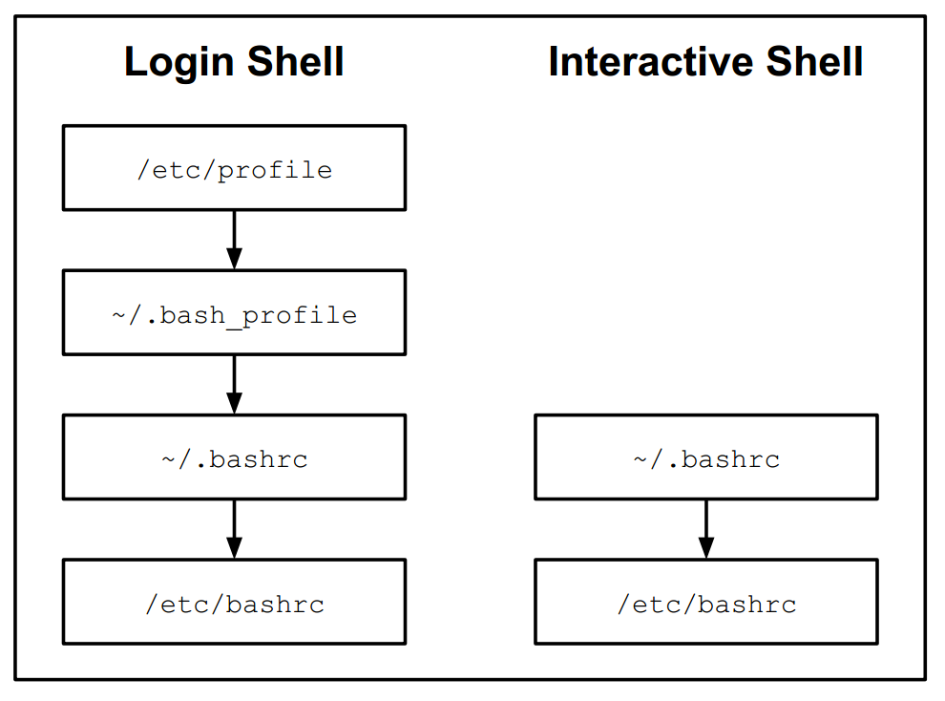

When bash is started as a login shell, the /etc/profile file is executed first. This file typically executes all files ending in .sh that are found in the /etc/profile.d directory. The next file that is executed is usually ~/.bash_profile but some users may use ~/.bash_login or ~/.profile file. The ~/.bash_profile file typically also executes the ~/.bashrc file which in turn executes the /etc/bashrc file

Note: Since the ~/.bash_profile file is under the control of the user, the execution of the ~/.bashrc and /etc/bashrc files are also controllable by the user.

When bash is started as an interactive shell, it executes the ~/.bashrc file, which may also execute the /etc/bashrc file, if it exists. Again, since the ~/.bashrc file is owned by the user who is logging in, the user can prevent execution of the /etc/bashrc file.

/etc/profile | This file can only be modified by the administrator and will be executed by every user who logs in. Administrators use this file to create key environment variables, display messages to users as they log in and set key system values.
~/.bash_profile | Each user has their own .bash_profile file in their home directory. The purpose for this file is the same as the /etc/profile file, but having this file allows a user to customize the shell to their own tastes. Normally used to create customized environment variables.
~/.bashrc | Each user has their own .bashrc file in their home directory. The purpose for this file is to generate things that need to be created for each shell, such as local variables and aliases.
/etc/bashrc | This file may affect every user on the system. Only the administrator can modify this file. Like the .bashrc file, the purpose for this file is to generate things that need to be created for each shell, such as local variables and aliases.

MODIFYING INITIALIZATION FILES

The way a user's shell operates can be changed by modifying that user's initialization files. Modifying global configuration requires administrative access to the system as the files under the /etc directory can only be modified by an administrator. A user can only modify the initialization files in their home directory.

Create backup.

The default ~/.bashrc file executes /etc/bashrc using a statement like:
./etc/bashrc
The default ~/.bash_profile shipped with CentOS 6.3 contains the following two lines which customize the PATH environment variable:
PATH=$PATH:$HOME/bin
export PATH
The . character used to source a file in order to execute it. The . character also does have a synonym command, the source command, but the use of the . character is more common than using the source command.
Sourcing can be an effective way to test changes made to initialization files, enabling you to correct any errors without having to log out and log in again. If you update the ~/.bash_profile to alter the PATH variable, you could verify that your changes are correct by executing the following:
.~/.bash_profile
echo $PATH
Just as bash executes one or more files upon starting up, it also may execute one or more files upon exiting. As bash exits, it will execute the ~/.bash_logout and /etc/bash_logout files, if they exist. Typically these files are used for "cleaning up" tactics as the user exits the shell. For example, the default ~/.bash_logout executes the clear command to remove any text present in the terminal screen.
Consider This
When a new user is created, the files from the /etc/skel directory are automatically copied into the new user's home directory. As an administrator, you can modify the files in the /etc/skel directory to provide custom features to new users.
BASH HISTORY
In a sense, the ~/.bash_history file could also be considered to be an initialization file, since bash also reads this file as it starts up. By default, this file contains a history of the commands that a user has executed within the bash shell. When a user exits the bash shell, it writes out the recent history to this file.
You can use the up and down arrow keys to review your history and select a previous command to execute again.
- You can select a previous command and modify it before executing it.
- You can do a reverse search through history to find a previous command to select, edit and execute it. To start the search, press CTRL+R and then begin typing a portion of a previous command.
- You execute a command again, based upon a number that is associated with the command.

Action | Key | Alternate Key Combination
Previous history item | ↑ | Ctrl+P
Next history item | ↓ | Ctrl+N
Reverse history search |  | Ctrl+R
Beginning of line | Home | Ctrl+A
End of line | End | Ctrl+E
Delete current character | Delete | Ctrl+D
Delete to left of cursor | Backspace | Ctrl+X
Move cursor left | ← | Ctrl+B
Move cursor right | → | Ctrl+F

EDITING KEYS

Keys that are available for editing a command are determined by the settings of a library called Readline. Keys typically set to match key assignments found within the emacs text editor.

To bind the keys to match the key assignments found with another popular text editor, the vi editor, the shell can be configured with the set -o vi command. To set the key bindings back to the emacs text editor, use the set -o emacs command.

To automatically configure the edit history options, edit the ~/.inputrc file. If this file doesn't exist, the /etc/inputrc file is used instead. Key bindings are set differently in configuration files than on the command line; for example, to enable the vi key binding mode for an individual, add the following lines to the ~/.inputrc file:

set editing-mode vi
set keymap vi
If the situation is reversed, perhaps due to the above two lines being added to the /etc/inputrc file, a user can enable the emacs mode by adding the following lines to the ~/.inputrc file:
set editing-mode emacs
set keymap emacs
HISTORY COMMAND

The history command can be used to "re-execute" previously executed commands. When used with no arguments, the history command provides a list of previously executed commands:

Note that each command is assigned a number that a user can use to re-execute the command.
The history command has numerous options, the most common of these options are listed below:

Option | Purpose
-c | Clear the list
-r | Read the history file and replace the current history
-w | Write the current history list to the history file

The history command accepts a number as an argument to indicate how many commands to list. For example, executing the history 10 command will only show the last ten commands from your history.

CONFIGURING HISTORY COMMAND

When you close the shell program, it takes commands in the history list and stores them into the history file (~/.bash_history). By default, five hundred commands will be stored in the history file. The HISTFILESIZE variable will determine how many commands to write to this file.

If a user wants to store the history commands in a file that is different from ~/.bash_history, then the user can specify an absolute path to the different file as the value for the HISTFILE local variable: HISTFILE=/path/to/file

The HISTSIZE variable will determine how many commands to keep in memory for each bash shell. If the size of HISTSIZE is greater than the size of HISTFILESIZE, then only the most recent number of commands specified by HISTFILESIZE will be written to the history file when the bash shell exits.

Although it is not normally set to anything by default, you may want to take advantage of setting a value for the HISTCONTROL variable in an initialization file like the ~/.bash_profile file. The HISTCONTROL variable could be set to any of the following features:
- HISTCONTROL=ignoredups will prevent duplicate commands that are executed consecutively.
- HISTCONTROL=ignorespace will not store any command that begins with a space. This provides the user with an easy way to execute a command that won't go into the history list.
- HISTCONTROL=ignoreboth will not store consecutive duplicates or any command that begins with a space.
- HISTCONTROL=erasedups will not store a command that is identical to another command in your history (actually, the previous entry of the command will be deleted from the history list).
- HISTCONTROL=ignorespace:erasedups will include the benefit of "erasedups" with the advantage of "ignorespace".
Another variable that will affect what gets stored in the history of commands is the HISTIGNORE variable. Most users do not want the history list cluttered with basic commands like ls, cd, exit and history. The HISTIGNORE variable can be used to tell bash to not store certain commands in the history list.

To have commands not included in the history list, include a command like the following in the ~/.bash_profile file: HISTIGNORE='ls*:cd*:history*:exit'

EXECUTING PREVIOUS COMMANDS

History Command | Meaning
!! | Repeat the last command
!-4 | Execute the command that was run four commands ago
!555 | Execute command number 555
!ec | Execute the last command that started with ec
!?joe | Execute the last command that contained joe

By pressing either Esc+. (Escape Period) or Alt+. (Alt Period), the shell will "bring back" the last argument of the previous command. Repeatedly pressing one of these key combinations will recall, in reverse order, the last argument of each previous command.

