CS 411 - Artificial Intelligence I
Fall 2025
Assignment 2
Department of Computer Science, University of Illinois at Chicago

Total Points : 25

- Explain the difference between goal-based agent and utility-based agent [4]

- Imagine environment below, in which the agent can move left, right, up and down, and pick up stars.[21]

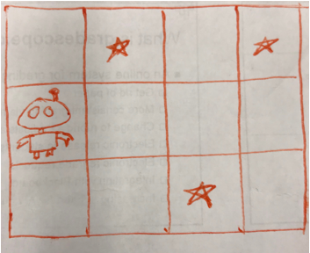

Try to specify as precisely as you can what conditions would make this environment:

- fully observable
- partially observable
- deterministic
- stochastic
- dynamic
- static
- sequential
- episodic
- known
- unknown
- continuous
- discrete
- single-agent
- multi-agent

