CS 411 - Artificial Intelligence I
Fall 2025
Assignment 1
Department of Computer Science, University of Illinois at Chicago
Total Points: 25
- Explain why the “Part-Picking robot” environment (Fig 2.6, page 47, AIMA) is characterized with following properties - partially observable, single-agent, stochastic, episodic, dynamic and continuous. [6*1]
- Give PEAS description for the robotic-soccer environment. [2*4]
- Define rational agent and autonomous agent in your own words [4]
- You have the agent program for simple reflex agent as shown below
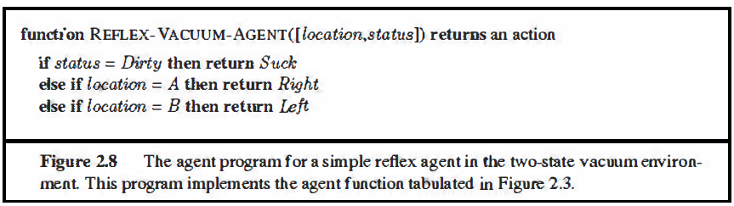
Now suppose you can use one more action “NoOp” which does nothing.
- Would it be desirable to use this action in this agent program to prevent vacuum cleaner from moving after all squares are cleaned? If yes, modify the simple reflex agent program adding “NoOp” action and if not give an argument that despite the option of “NoOp” the agent is bound to keep moving. [4]
- If you have a choice of using other type of agents, which one would you choose and how would it prevent vacuum from moving after all squares are cleaned? [3]

Use the assumptions listed below

- The performance measure awards one point for each clean square at each time step, over a “lifetime” of 1000 time steps.
- The “geography” of the environment is known a priori (Figure 2.2) but the dirt distribution and the initial location of the agent are not. Clean squares stay clean and sucking cleans the current square. The Left and Right actions move the agent left and right except when this would take the agent outside the environment, in which case the agent remains where it is.
- The only available actions are Left, Right, Suck and NoOp
- The agent correctly perceives its location and whether that location contains dirt

