Hello Arduino Uno

Getting a “Hello World” with the GNU GCC toolchain

Revision | Author | Date | Description
0.01 | D Snider | 15/11/05 | Initial Outline
0.02 | D Snider | 15/11/12 | Cleanup screenshots, updated to 115.2kbaud, added putty ref

Table of Contents
1. SW Dev Environment 3
2. HW tools 3
2.1. Atmel JTAGICE3 3
3. Hello Uno 4
3.1. Build 4
3.2. Connect ISP pod to Atmel Studio and Uno 5
Connect to ISP pod 5
Verify Pod connection to Atmega328p 7
3.3. Programming Atmega328p 8
Erase Chip 8
Fuses 8
Load hello_uno.hex 9
3.4. Verify 1sec LED 9
3.5. One-time Windows Driver Install 10
3.6. Verify Serial I/O 11
4. Design Notes - Fuses 13
5. Resources 13

Note: While this document is being refined, meta information will be in < brackets >.

SW Dev Environment

Google keywords | Description & URLs | tested versions
Cygwin | GNU file utils and make for Windows  https://www.cygwin.com/ | > make --version  GNU Make 4.1
TortoiseGit | Windows based GIT:  https://tortoisegit.org/  https://git-for-windows.github.io/ | > git --version  git version 2.6.2.windows.1
WinAvr | Windows GCC Compiler, Linker  and C libraries  http://sourceforge.net/projects/winavr/ | > avr-gcc --version  avr-gcc.exe (WinAVR 20100110) 4.3.3
Atmel Studio | Programmer Software which uses the JTAGICE3 debug pod  http://www.atmel.com/tools/atmelstudio.aspx | Version: 7
putty | A serial terminal program with reliable cut & paste.  http://www.chiark.greenend.org.uk/~sgtatham/putty/ | Version: 0.66

HW tools

Atmel JTAGICE3

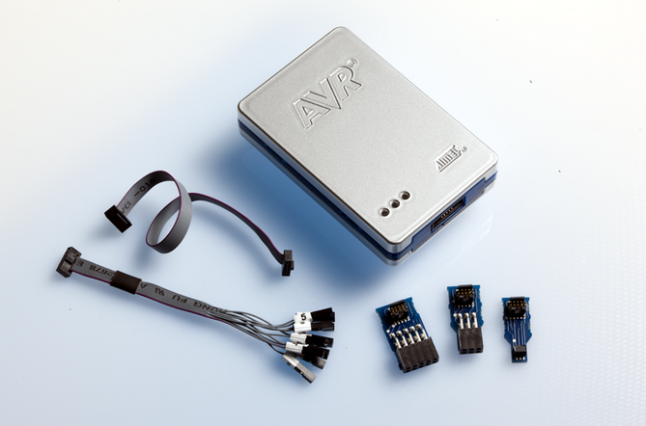

Google | “Atmel JTAGICE3”
Source | Digikey: http://www.digikey.com/product-detail/en/ATJTAGICE3/ATJTAGICE3-ND/
Support pages | http://www.atmel.com/tools/JTAGICE3.aspx  http://www.atmel.com/webdoc/jtagice3/

Hello Uno

Build

> git clone https://github.com/dsnider0909/hello_arduino.git
> cd hello_arduino/uno
> make
...
Linking: hello_uno.elf
...
Creating load file for Flash: hello_uno.hex
…
> ls hello_uno.hex
hello_uno.hex

Connect ISP pod to Atmel Studio and Uno

Connect to ISP pod

Within Atmel Studio, Select: Tools→ Device Programming

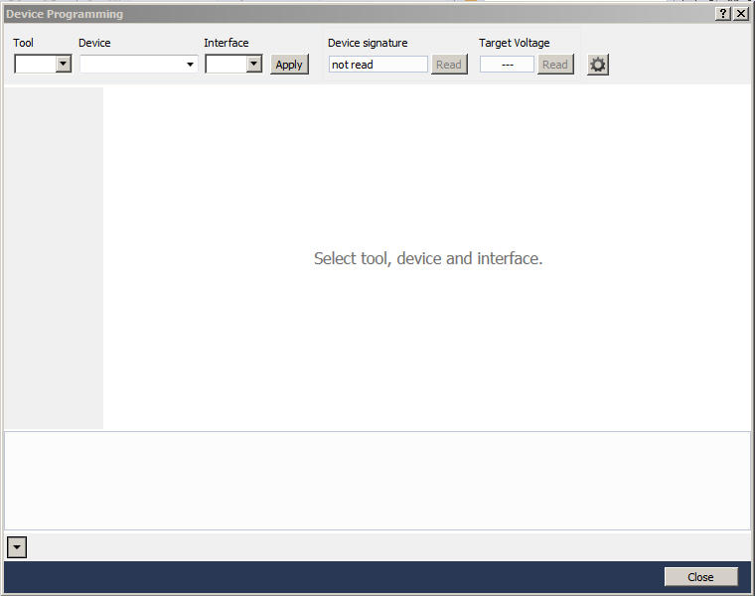

Connect the JTAGICE3 pod to a Windows PC USB port.

Configure:
Tool: JTAGICE3
Device: ATmega328P
Interface: ISP

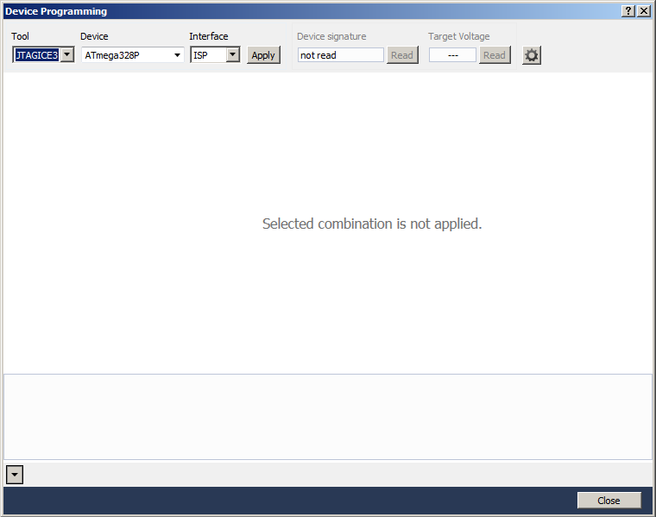
Select: Apply

If the pod is found, the following screen should show:

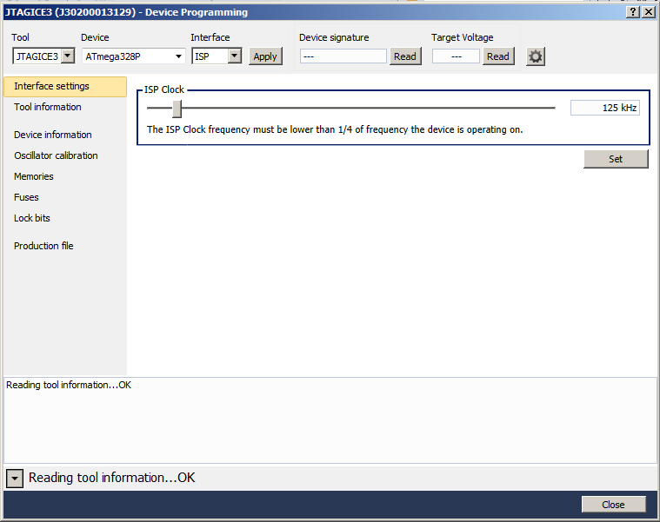

Verify Pod connection to Atmega328p
Connect the Arduino Uno board to a USB cable.
Connect this USB cable to another Windows PC for both power and serial I/O.
Connect the JTAGICE3 6pin ISP header to the UNO header: ICSP.

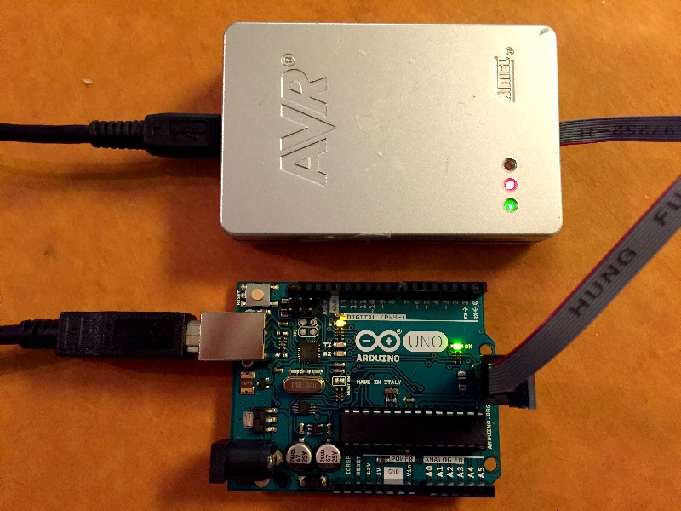

Select: Target Voltage → Read
It should return 3 to 5V.

Select: Device signature → Read
There should be no error messages of Device ID mismatch.
For the Atmega328P, the signature should be 0x1E950F.

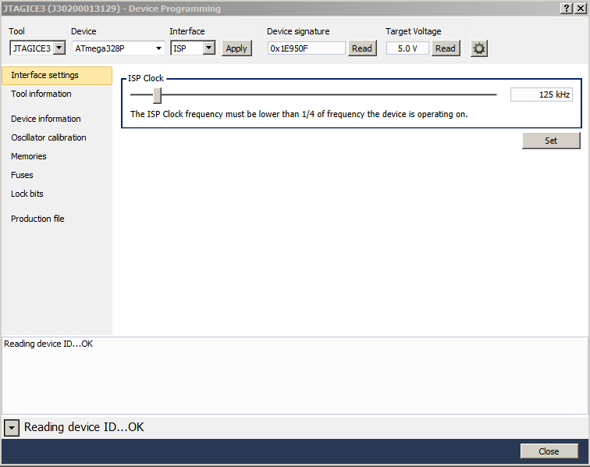

Programming Atmega328p

Erase Chip
Select: Memories → Device: Erase Chip → Erase Now
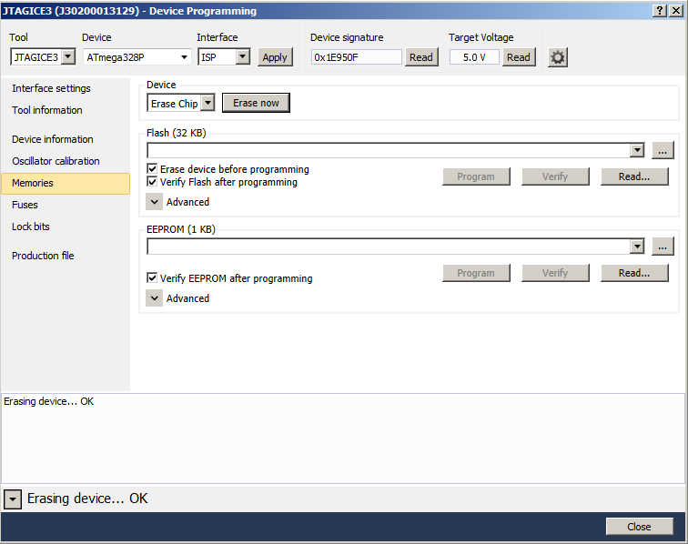

Fuses
Select: Fuses
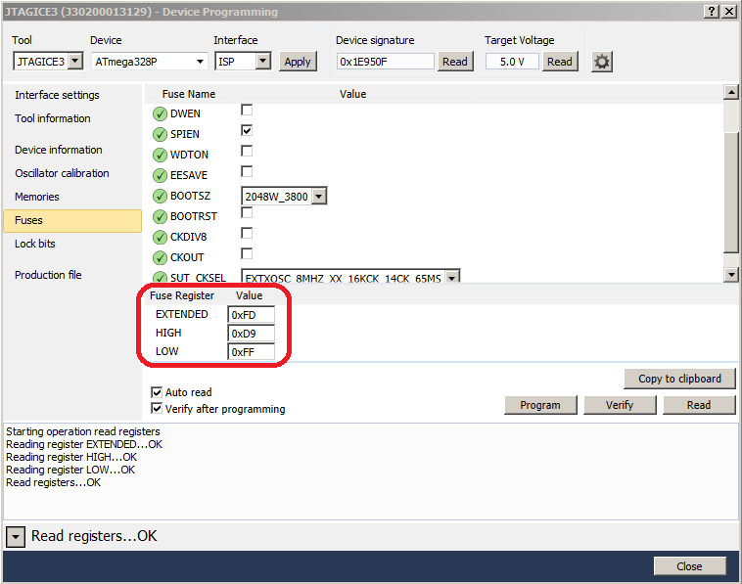

For Arduino Uno - ATmega328p:
EXTENDED: 0xFD
HIGH: 0xD9
LOW: 0xFF

Load hello_uno.hex
Select: Memories
Select: Flash: hello_arduino\uno\hello_uno.hex
Select: Program

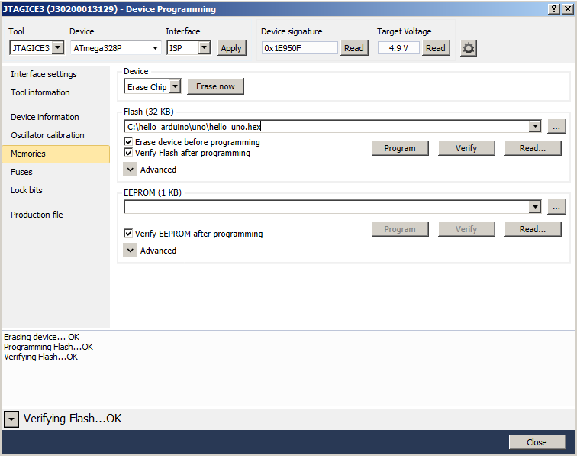

Verify 1sec LED

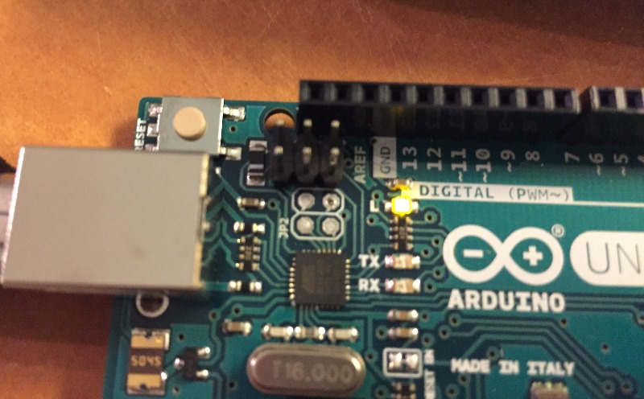
This should precisely transition once a second.

One-time Windows Driver Install
Within Windows, Open the “Device Manager”
Select: Start, at the prompt enter: devmgmt.msc

Check whether there is a “Ports – COM port” defined,
or an “Other devices/ Arduino Uno” showing?
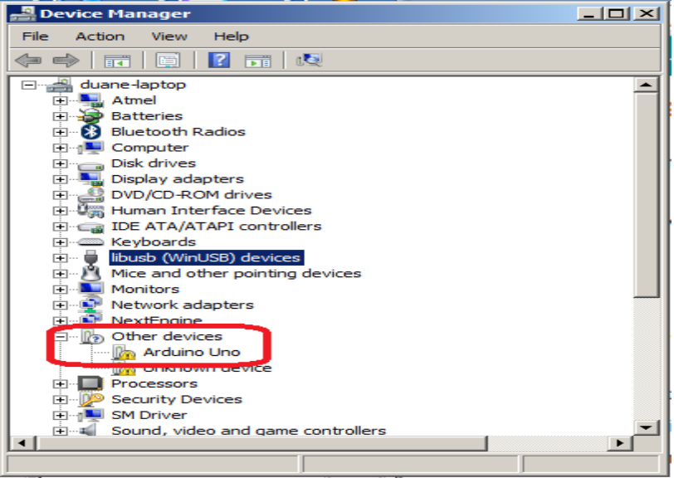

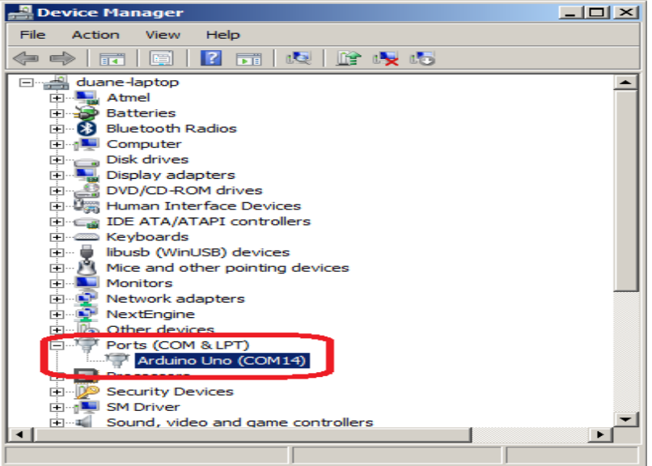

The “Other devices/ Arduino Uno” means a driver needs to be installed:
Right Click “Other Devices / Arduino Uno”
Select Driver Update and point the update to the directory:
'hello_arduino/Uno/doc' directory for the *.inf file

References:
https://www.arduino.cc/en/Main/USBSerial
https://www.arduino.cc/en/Guide/Windows#toc4

Verify Serial I/O

Open the Windows “Device Manager”
Within Windows: select Start, at the prompt enter: devmgmt.msc
Search for what COM ports are connected.

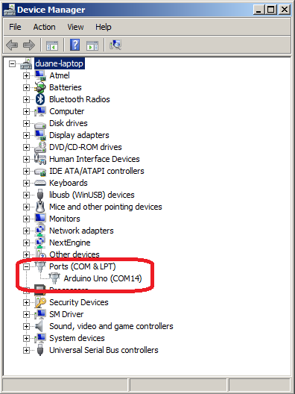
Start up a Putty Window and configure:
Connection type: serial
Serial line: COM14 (from this example)
Speed: 115200
Select: Open
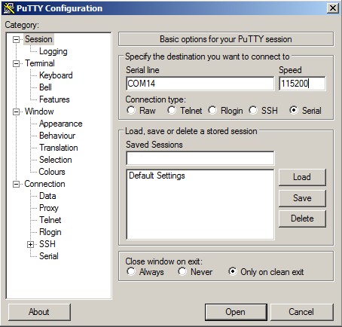

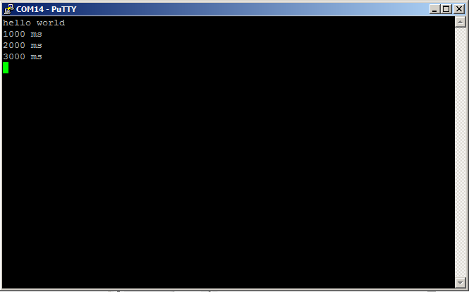

Hit a few keys to verify the Arduino is receiving serial data:

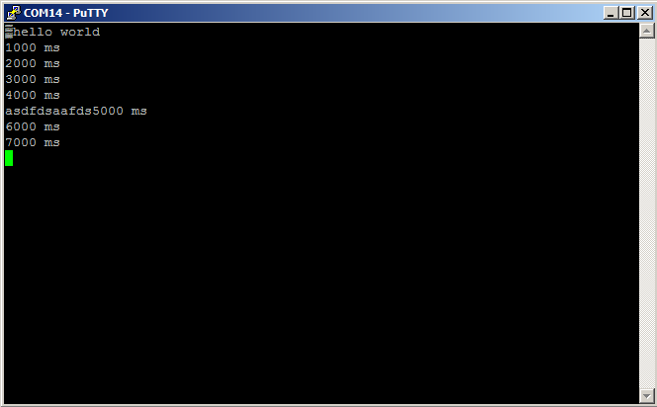

Design Notes - Fuses

Atmega328P Fuse Notes:

Extended: // 7 6 5 4 3 2 1 0
// 1 1 1 1 1 1 1 1 => Atmel factory default: FF
FD // 1 1 1 1 1 1 0 1 => Ardyino UNO setting
+--+--+-- BODLVL[2.0]: 111 – Disabled
100 – 4.3V
101 – 2.7V

High: // 7 6 5 4 3 2 1 0
//
D9 // 1 1 0 1 1 0 0 1 => Atmel factory default
// 1 1 0 1 0 1 1 0 => Ardino UNO original setting: D6
// 1 1 0 1 1 0 0 1
// | | | | | | | + BOOTRST: 1 – no Boot Loader
// | | | | | +--+--- BOOTSZ[1.0]: 00 – 2K words
// | | | | +--------- EESAVE: 1 – EEPROM not reserved
// | | | +------------ WDTON: 1 - Watchdog timer off
// | | +--------------- SPIE: 0 - SPI programming enabled
// | +------------------ DWEN: 1 - debugWire disabled
// +--------------------- RSTDISBL: 1 – External reset enabled

Low: // 7 6 5 4 3 2 1 0
//
// 0 1 1 0 0 0 1 0 => factory default: 62
// 1 1 1 0 0 0 1 0 => internal 8Mhz RC: E2 → F_CPU = 8000000
FF // 1 1 1 1 1 1 1 1 => 8-16Mhz ext crystal → F_CPU = xtal = 16000000
// | | | | | | | |
// | | | | +--+--+--+ CLKSEL[3.0]: 0010 – internal 8Mhz
// | | | | | 111x – 8-16Mhz ext crystal
// | | | | | 110x – 3–8Mhz ext crystal
// | | +--+-----------+ SUT[1.0],CLKSEL[0]: 11,1 – slowest start up
// | +------------------ CKOUT:1 – CLK not out on PB0
// +--------------------- CKDIV8: 1 – do not divide clk by 8

UNO : FD D9 FF

Resources

Google keywords | Description
Atmega 328p datasheet | The final word on register settings.  http://www.atmel.com/devices/atmega328p.aspx  http://www.atmel.com/images/Atmel-8271-8-bit-AVR-Microcontroller-ATmega48A-48PA-88A-88PA-168A-168PA-328-328P_datasheet_Complete.pdf
Arduino uno schematic r3 | https://www.arduino.cc/en/uploads/Main/Arduino_Uno_Rev3-schematic.pdf
AVR libc | WinAVR library source and documentation  http://www.nongnu.org/avr-libc/
AVR freaks | A good online community for most AVR questions  http://www.avrfreaks.net/

