Weibull Regression with R, Part One*
Comparing Two Treatments

The Pharmaco-smoking study

The purpose of this study ... was to evaluate extended duration of a triple-medication combination versus therapy with the nicotine patch alone in smokers with medical illnesses. Patients with a history of smoking were randomly assigned to the triple-combination or patch therapy and followed for up to six months. The primary outcome variable was time from randomization until relapse (return to smoking); individuals who remained non-smokers for six months were censored. The data set, “pharmacoSmoking”, is available in the “asaur” package.
The variable “ttr” is the number of days without smoking (“time to relapse”), and “relapse=1” indicates that the subject started smoking again at the given time. The variable “grp” is the treatment indicator, and “employment” can take the values “ft” (full time), “pt” (part time), or “other”.
This material is quoted from Applied Survival Analysis Using R, pages 18-19.

> rm(list=ls()); # options(scipen=999)
> # install.packages("survival",dependencies=TRUE) # Only need to do this once
> library(survival) # Do this every time
> # install.packages("asaur",dependencies=TRUE) # Only need to do this once
> library(asaur)
> # help(pharmacoSmoking)

> head(pharmacoSmoking)
id ttr relapse grp age gender race employment yearsSmoking
1 21 182 0 patchOnly 36 Male white ft 26
2 113 14 1 patchOnly 41 Male white other 27
3 39 5 1 combination 25 Female white other 12
4 80 16 1 combination 54 Male white ft 39
5 87 0 1 combination 45 Male white other 30
6 29 182 0 combination 43 Male hispanic ft 30
levelSmoking ageGroup2 ageGroup4 priorAttempts longestNoSmoke
1 heavy 21-49 35-49 0 0
2 heavy 21-49 35-49 3 90
3 heavy 21-49 21-34 3 21
4 heavy 50+ 50-64 0 0
5 heavy 21-49 35-49 0 0
6 heavy 21-49 35-49 2 1825
> summary(pharmacoSmoking)
id ttr relapse grp age
Min. : 1.00 Min. : 0.00 Min. :0.000 combination:61 Min. :22.00
1st Qu.: 33.00 1st Qu.: 8.00 1st Qu.:0.000 patchOnly :64 1st Qu.:41.00
Median : 67.00 Median : 49.00 Median :1.000 Median :49.00
Mean : 66.15 Mean : 77.44 Mean :0.712 Mean :48.84
3rd Qu.: 99.00 3rd Qu.:182.00 3rd Qu.:1.000 3rd Qu.:56.00
Max. :130.00 Max. :182.00 Max. :1.000 Max. :86.00
gender race employment yearsSmoking levelSmoking ageGroup2
Female:81 black :38 ft :72 Min. : 9.00 heavy:89 21-49:66
Male :44 hispanic: 8 other:39 1st Qu.:22.00 light:36 50+ :59
other : 2 pt :14 Median :30.00
white :77 Mean :30.88
3rd Qu.:39.00
Max. :56.00
ageGroup4 priorAttempts longestNoSmoke
21-34:16 Min. : 0.00 Min. : 0.0
35-49:50 1st Qu.: 1.00 1st Qu.: 7.0
50-64:48 Median : 2.00 Median : 90.0
65+ :11 Mean : 12.68 Mean : 539.7
3rd Qu.: 5.00 3rd Qu.: 365.0
Max. :1000.00 Max. :6205.0
> quit = within(pharmacoSmoking, {TimeToRelapse = Surv(ttr,relapse)} )
> sort(quit$TimeToRelapse)
[1] 0 0 0 0 0 0 0 0 0 0 0 0 1 1 1
[16] 1 1 2 2 2 2 2 2 3 4 4 4 5 5 6
[31] 7 8 8 8 10 12 12 14 14 14 14 14 14 14 15
[46] 15 15 15 16 20 21 21 25 28 28 28 30 30 30 40
[61] 42 45 49 50 56 56 56 56 56 60 60 63 63 65 75
[76] 77 77 80 84 100 105 110 140 140 140 140 155 170 170 182+
[91] 182+ 182+ 182+ 182+ 182+ 182+ 182+ 182+ 182+ 182+ 182+ 182+ 182+ 182+ 182+
[106] 182+ 182+ 182+ 182+ 182+ 182+ 182+ 182+ 182+ 182+ 182+ 182+ 182+ 182+ 182+
[121] 182+ 182+ 182+ 182+ 182+

> # Fit a Weibull model with just treatment group, which was randomly assigned.
> Model0 = survreg(TimeToRelapse~grp,dist='weibull', data=quit)
Error in survreg(TimeToRelapse ~ grp, dist = "weibull", data = quit) :
Invalid survival times for this distribution
> # Likely choking on the zeros.
> # Day of relapse starts with one.
> quit = within(quit, {DayOfRelapse = Surv(ttr+1,relapse)} )
> Model0 = survreg(DayOfRelapse~grp,dist='weibull', data=quit)
> summary(Model0)

Call:
survreg(formula = DayOfRelapse ~ grp, dist = "weibull")
Value Std. Error z p
(Intercept) 5.260 0.3053 17.23 1.60e-66
grppatchOnly -1.162 0.3999 -2.91 3.67e-03
Log(scale) 0.606 0.0904 6.70 2.14e-11

Scale= 1.83

Weibull distribution
Loglik(model)= -472.1 Loglik(intercept only)= -476.5
Chisq= 8.78 on 1 degrees of freedom, p= 0.003
Number of Newton-Raphson Iterations: 5
n= 125

Conclusion is that combination therapy is more effective. But the alphabetical order of treatments makes combination the reference category, and this is clumsy. Make patch-only the reference category and re-run. This is what we have.

Treatment d E(Y|X=x) = β0 + β1d
Combination | 0 | β0
Patch Only | 1 | β0 + β1

This is what we want.

Treatment d E(Y|X=x) = β0 + β1d
Combination | 1 | β0 + β1
Patch Only | 0 | β0

> quit = within(quit,{
+ contrasts(grp) = contr.treatment(2,base=2)
+ colnames(contrasts(grp)) = c('Combo') # Names of dummy vars -- just one
+ })
> Model1 = survreg(DayOfRelapse~grp,dist='weibull', data=quit)
> summary(Model1)

Call:
survreg(formula = DayOfRelapse ~ grp, dist = "weibull")
Value Std. Error z p
(Intercept) 4.098 0.2548 16.09 3.22e-58
grpCombo 1.162 0.3999 2.91 3.67e-03
Log(scale) 0.606 0.0904 6.70 2.14e-11

Scale= 1.83

Weibull distribution
Loglik(model)= -472.1 Loglik(intercept only)= -476.5
Chisq= 8.78 on 1 degrees of freedom, p= 0.003
Number of Newton-Raphson Iterations: 5
n= 125

> betahat = Model1$coefficients; betahat
(Intercept) grpCombo
4.097999 1.161901
> betahat0 = betahat[1]; betahat1 = betahat[2]
> sigmahat = Model1$scale; sigmahat
[1] 1.832392
> Vhat = vcov(Model1); Vhat
(Intercept) grpCombo Log(scale)
(Intercept) 0.064903153 -0.065806535 -0.001649823
grpCombo -0.065806535 0.159909904 0.006128624
Log(scale) -0.001649823 0.006128624 0.008179519

> # Asymptotic covariance matrix comes out in terms of Log(scale), which is
> # a minor pain.
>
> # 1) When patients receive the combination drug therapy rather than nicotine patch only, expected relapse time is multiplied by _______ .
> # a) Give an estimate
> # b) Modify the CI for beta1 to get a 95% confidence interval (don't use the delta method).
>
> # a) Give an estimate
> exp(betahat1)
grpCombo
3.196004
> # a) Give an estimate
> exp(betahat1)
grpCombo
3.196004
>
> # b) Modify the CI for beta1 to get a 95% confidence interval (don't use the delta method).
> L = 1.162 - 1.96*0.3999; U = 1.162 + 1.96*0.3999
> c(exp(L),exp(U))
[1] 1.459649 6.999257

> summary(Model1) # Repeating

Call:
survreg(formula = DayOfRelapse ~ grp, dist = "weibull")
Value Std. Error z p
(Intercept) 4.098 0.2548 16.09 3.22e-58
grpCombo 1.162 0.3999 2.91 3.67e-03
Log(scale) 0.606 0.0904 6.70 2.14e-11

Scale= 1.83

Weibull distribution
Loglik(model)= -472.1 Loglik(intercept only)= -476.5
Chisq= 8.78 on 1 degrees of freedom, p= 0.003
Number of Newton-Raphson Iterations: 5
n= 125

> # 2) Estimate and plot the density of relapse time for the two experimental conditions.
>
> # Okay, lambda = exp(-mu), alpha = 1/sigma
> alpha = 1/sigmahat
> lambda0 = exp(-betahat0); lambda1 = exp(-betahat0-betahat1)
> t = seq(from=0,to=300,length=101)
> f0 = alpha*lambda0^alpha * t^(alpha-1) * exp(-(lambda0*t)^alpha)
> f1 = alpha*lambda1^alpha * t^(alpha-1) * exp(-(lambda1*t)^alpha)
> plot(t,f0,pch=' ',xlab='Day of Relapse',ylab='Density') # Empty plot
> title('Estimated Density of Relapse Time')
> lines(t,f0,lty=2); lines(t,f1,lty=1)
> # Annotate the plot
> x0=c(200,250); y0 = c(0.015,0.015); lines(x0,y0,lty=2)
> text(300,0.015,'Patch Only')
> x1=c(200,250); y1 = c(0.017,0.0171); lines(x1,y1,lty=1)
> text(300,0.017,'Combination')
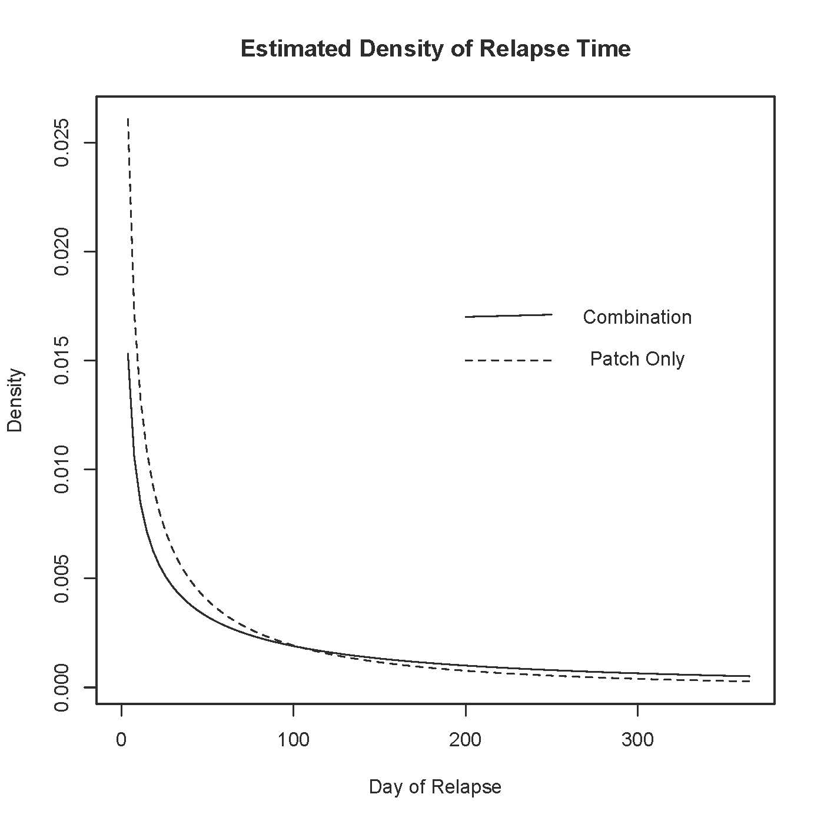
> max(quit$ttr) # Maximum time value (censored)
[1] 182

> # 3) Estimate median time to relapse for the 2 groups, with Cis
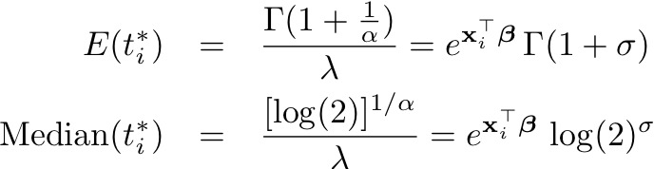

> # Asymptotic covariance matrix comes out in terms of Log(scale), which is
> # unfortunate.
> # Denote log(sigma) by s, and re-write g(theta) = exp(beta0) * log(2)^sigma
> # as g(theta) = exp(beta0) * log(2)^exp(s)
> shat = log(sigmahat)
>
> # Patch Only
> medianhat0 = exp(betahat0)*log(2)^sigmahat
> # gdot will be a 1 x 3 matrix.
> gdot0 = cbind( exp(betahat0)*log(2)^exp(shat), 0, exp(betahat0) * log(2)^exp(shat) * log(log(2)) * exp(shat) )
> se0 = sqrt( as.numeric(gdot0 %*% Vhat %*% t(gdot0)) ); se0
[1] 8.18674
> lower0 = medianhat0 - 1.96*se0; upper0 = medianhat0 + 1.96*se0
> patchonly = c(medianhat0,lower0,upper0)
> names(patchonly) = c('Median','Lower95','Upper95')
> patchonly
Median Lower95 Upper95
30.76581 14.71980 46.81182
>
> # Combination drug treatment
> medianhat1 = exp(betahat0+betahat1)*log(2)^sigmahat
> gdot1 = cbind( exp(betahat0+betahat1)*log(2)^exp(shat), exp(betahat0+betahat1)*log(2)^exp(shat),
+ exp(betahat0+betahat1) * log(2)^exp(shat) * log(log(2)) * exp(shat) )
> se1 = sqrt( as.numeric(gdot1 %*% Vhat %*% t(gdot1)) ); se1
[1] 29.64109
> lower1 = medianhat1 - 1.96*se1; upper1 = medianhat1 + 1.96*se1
> combination = c(medianhat1,lower1,upper1)
> names(combination) = c('Median','Lower95','Upper95')
> combination
Median Lower95 Upper95
98.32767 40.23114 156.42420
>
> # There is an easier way to get these numbers
> # help(predict.survreg)
> Justpatch = data.frame(grp='patchOnly')
> # A data frame with just one case and one variable.
> Combination = data.frame(grp='combination')
> treatments = rbind(Justpatch,Combination); treatments
grp
1 patchOnly
2 combination

> # The 0.5 quantile is the median
> medians = predict(Model1,newdata=treatments,type='quantile',p=0.5,se=TRUE)
> medians
$fit
1 2
30.76581 98.32767

$se.fit
1 2
8.18674 29.64109

> cbind(medians$fit,medians$se)
[,1] [,2]
1 30.76581 8.18674
2 98.32767 29.64109
> rbind(c(medianhat0,se0),
+ c(medianhat1,se1) )
(Intercept)
[1,] 30.76581 8.18674
[2,] 98.32767 29.64109
>

> # 4) Plot the Kaplan-Meier estimates and MLEs of S(t)
>
> KM = survfit(DayOfRelapse~grp, type="kaplan-meier", data=quit)
# Kaplan-Meier is the default estimation method anyway.
> summary(KM)
Call: survfit(formula = DayOfRelapse ~ grp, type = "kaplan-meier")

grp=combination
time n.risk n.event survival std.err lower 95% CI upper 95% CI
1 61 4 0.934 0.0317 0.874 0.999
3 57 3 0.885 0.0408 0.809 0.969
5 54 1 0.869 0.0432 0.788 0.958
6 53 2 0.836 0.0474 0.748 0.934
9 51 2 0.803 0.0509 0.709 0.909
11 49 1 0.787 0.0524 0.691 0.897
13 48 1 0.770 0.0538 0.672 0.884
15 47 1 0.754 0.0551 0.653 0.870
16 46 2 0.721 0.0574 0.617 0.843
17 44 1 0.705 0.0584 0.599 0.829
21 43 1 0.689 0.0593 0.582 0.815
22 42 1 0.672 0.0601 0.564 0.801
31 41 2 0.639 0.0615 0.530 0.772
43 39 1 0.623 0.0621 0.512 0.757
51 38 1 0.607 0.0625 0.496 0.742
57 37 2 0.574 0.0633 0.462 0.712
61 35 2 0.541 0.0638 0.429 0.682
64 33 2 0.508 0.0640 0.397 0.650
66 31 1 0.492 0.0640 0.381 0.635
76 30 1 0.475 0.0639 0.365 0.619
111 29 1 0.459 0.0638 0.350 0.603
141 28 3 0.410 0.0630 0.303 0.554
171 25 1 0.393 0.0625 0.288 0.537

grp=patchOnly
time n.risk n.event survival std.err lower 95% CI upper 95% CI
1 64 8 0.875 0.0413 0.798 0.960
2 56 5 0.797 0.0503 0.704 0.902
3 51 3 0.750 0.0541 0.651 0.864
4 48 1 0.734 0.0552 0.634 0.851
5 47 2 0.703 0.0571 0.600 0.824
7 45 1 0.688 0.0579 0.583 0.811
8 44 1 0.672 0.0587 0.566 0.797
9 43 1 0.656 0.0594 0.550 0.784
13 42 1 0.641 0.0600 0.533 0.770
15 41 6 0.547 0.0622 0.438 0.684
16 35 2 0.516 0.0625 0.407 0.654
22 33 1 0.500 0.0625 0.391 0.639
26 32 1 0.484 0.0625 0.376 0.624
29 31 3 0.437 0.0620 0.331 0.578
31 28 1 0.422 0.0617 0.317 0.562
41 27 1 0.406 0.0614 0.302 0.546
46 26 1 0.391 0.0610 0.288 0.530
50 25 1 0.375 0.0605 0.273 0.515
57 24 3 0.328 0.0587 0.231 0.466
78 21 2 0.297 0.0571 0.204 0.433
81 19 1 0.281 0.0562 0.190 0.416
85 18 1 0.266 0.0552 0.177 0.399
101 17 1 0.250 0.0541 0.164 0.382
106 16 1 0.234 0.0530 0.151 0.365
141 15 1 0.219 0.0517 0.138 0.348
156 14 1 0.203 0.0503 0.125 0.330
171 13 1 0.187 0.0488 0.113 0.312

> # Look at K-M estimates of medians
> KM[1] # Combination
Call: survfit(formula = DayOfRelapse ~ grp, type = "kaplan-meier")

n events median 0.95LCL 0.95UCL
61 37 66 51 NA
> KM[2] # Patch Only
Call: survfit(formula = DayOfRelapse ~ grp, type = "kaplan-meier")

n events median 0.95LCL 0.95UCL
64 52 24 15 57

> # Repeat MLEs for comparison
> combination
Median Lower95 Upper95
98.32767 40.23114 156.42420
> patchonly
Median Lower95 Upper95
30.76581 14.71980 46.81182

> plot(KM, xlab='t', ylab='Survival Probability', lwd=2, col=1:2)
> # 1 is black, 2 is red
> legend(x=125,y=1.0, col=1:2, lwd=2, legend=c('Combination','Patch Only'))
> title(expression(paste(hat(S)(t),': Kaplan-Meier and Maximum Likelihood Estimates')))
> # MLEs
> x = 1:185
> lambda0 = exp(-betahat0); lambda1 = exp(-betahat0-betahat1); alpha=1/sigmahat
> Shat0 = exp(-(lambda0*x)^alpha); Shat1 = exp(-(lambda1*x)^alpha)
> lines(x,Shat0,lty=2,col=2) # Patch only is red
> lines(x,Shat1,lty=2) # Combination is black (default)

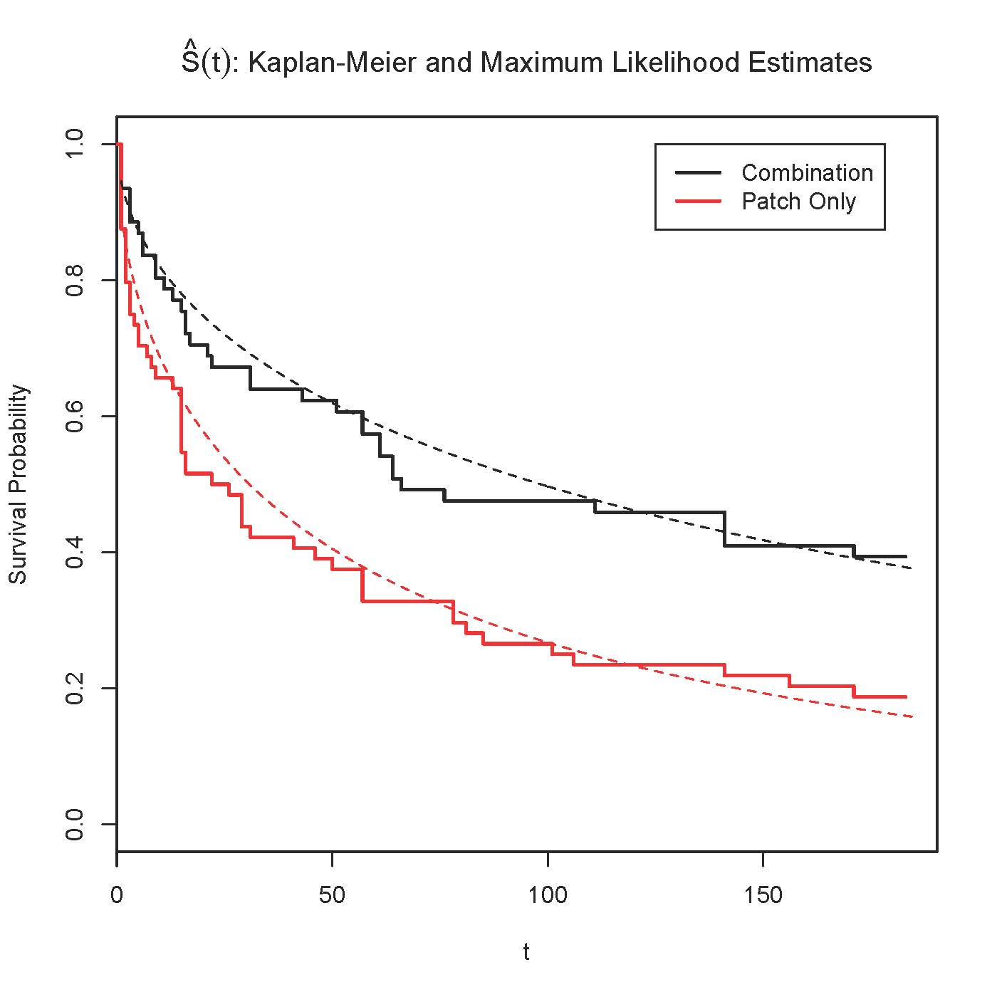

>
> # Non-parametric rank test of equal survival functions
> # See http://dwoll.de/rexrepos/posts/survivalKM.html
> survdiff(DayOfRelapse~grpgrp, data=quit)
Call:
survdiff(formula = DayOfRelapse ~ grp)

N Observed Expected (O-E)^2/E (O-E)^2/V
grp=combination 61 37 49.9 3.36 8.03
grp=patchOnly 64 52 39.1 4.29 8.03

Chisq= 8 on 1 degrees of freedom, p= 0.00461

> # Compare p = 0.00367 from Z-test of H0: beta1=0
>
relapse
grp 0 1
combination 24 37
patchOnly 12 52
> prop.table(twoby2,1) # Proportions of row totals
relapse
grp 0 1
combination 0.3934426 0.6065574
patchOnly 0.1875000 0.8125000
> chisq.test(twoby2)

Pearson's Chi-squared test with Yates' continuity correction

data: twoby2
X-squared = 5.4945, df = 1, p-value = 0.01908

> fisher.test(twoby2) # p = 0.01713

This document was prepared by Jerry Brunner, University of Toronto. It is licensed under a Creative Commons Attribution - ShareAlike 3.0 Unported License: http://creativecommons.org/licenses/by-sa/3.0/deed.en_US. Use any part of it as you like and share the result freely. It is available in OpenOffice.org format from the course website:
http://www.utstat.toronto.edu/brunner/oldclass/312f23

* Copyright information is on the last page.

