Starting Point & Learning Plan

Topic | Starting Status | Learning Path
API Gateways | None
Kong | None
Docker | Read
Kubernetes | Read
Oauth 2.0 / JWT | Used
TLS | Read
CI (Continuos Integration) | Used
LLMs | Used

API Gateways

An API Gateway is a server that acts as a single entry point between clients (web applications, mobile apps, or external systems) and backend services.

In simple terms, it works like a reception desk in an office. Instead of visitors contacting different departments directly, they approach reception, which directs them to the correct department.

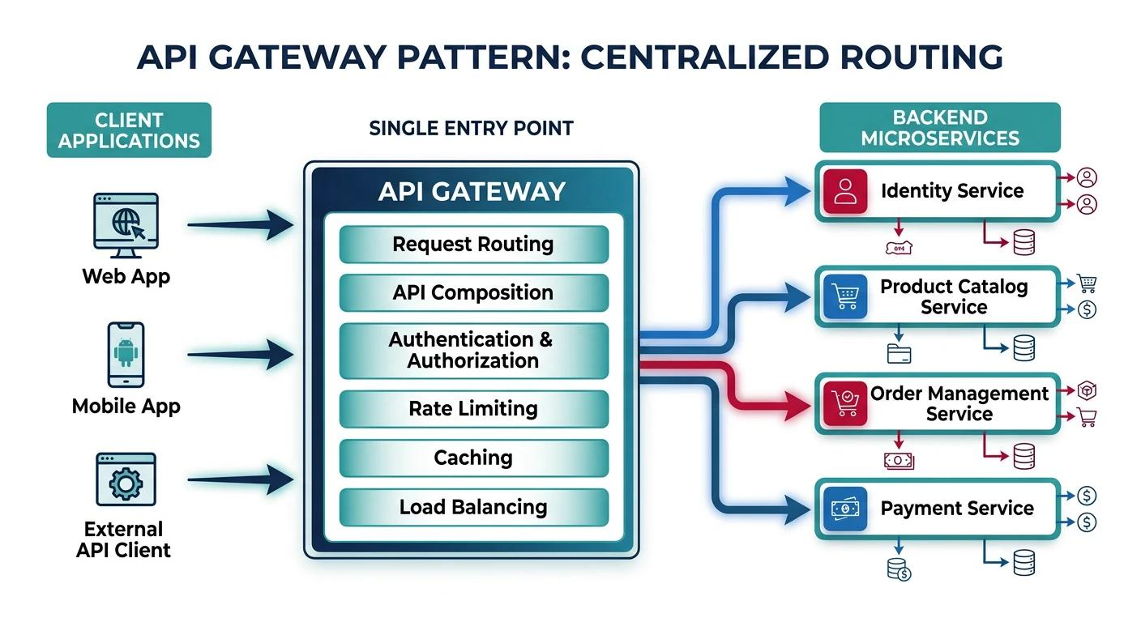

Popular API Gateway products:

1. Kong Gateway - Open-source and enterprise API gateway, commonly used in microservices and Kubernetes environments.
2. AWS API Gateway - Managed API gateway service from Amazon Web Services.
3. Google Apigee - Enterprise API management, analytics, security and API lifecycle management.
4. Azure API Management - Microsoft's API management platform with gateway capabilities.
5. TIBCO Mashery - API management platform from TIBCO.

Docker

Docker is a platform used to package, deploy, and run applications inside lightweight, isolated environments called containers.

In simple words, Docker ensures that an application runs consistently across different environments (developer laptop, testing server, and production server).

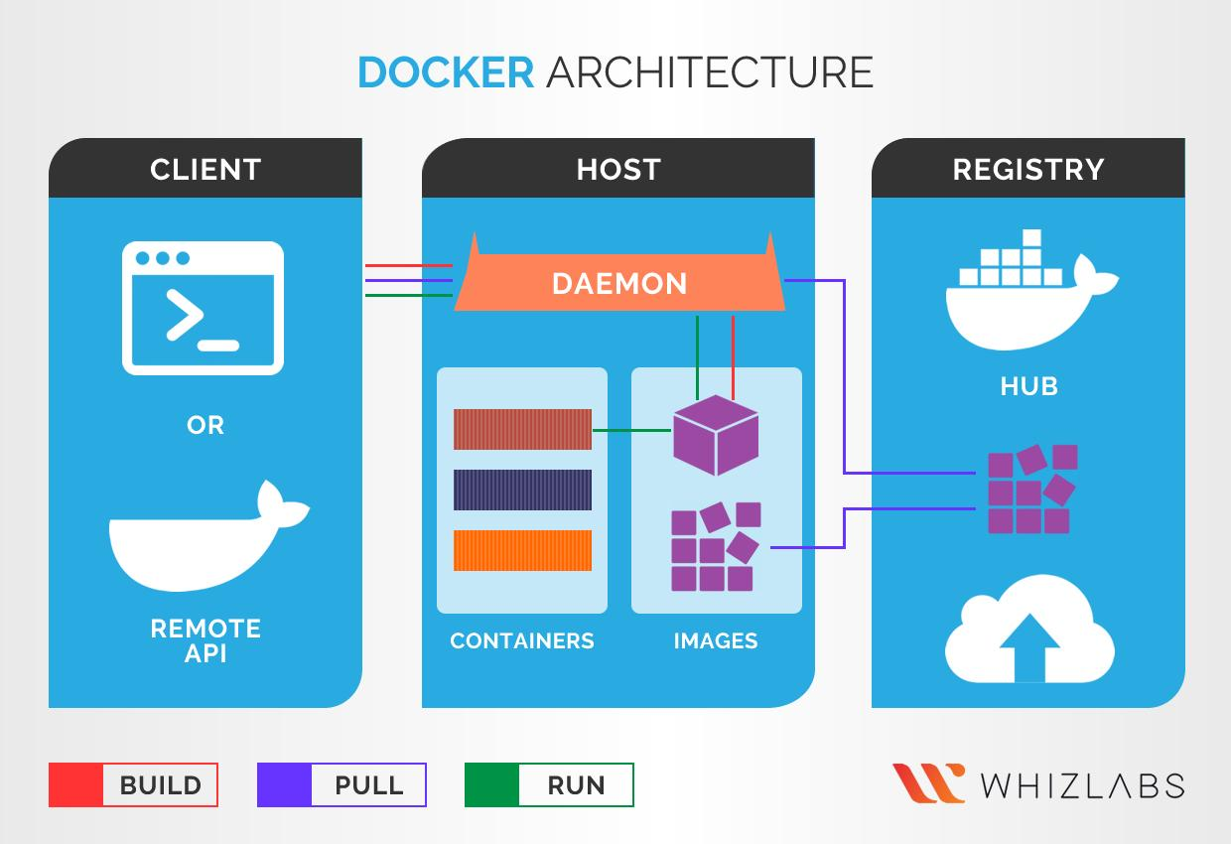

-- Important Docker components
Component Meaning
Docker Engine Platform that builds and runs containers
Docker Image Blueprint/package of an application
Docker Container Running instance of an image
Dockerfile Instructions to build an image
Docker Hub Registry for storing and sharing images
Docker Compose Tool to run multiple containers together
Docker Volume Persistent data storage
Docker Network Communication between containers

-- Important Docker commands
Command Purpose
docker --version Check Docker version
docker pull nginx Download an image
docker images List available images
docker ps List running containers
docker ps -a List all containers
docker run nginx Start a container
docker stop <id> Stop a container
docker start <id> Start stopped container
docker rm <id> Remove container
docker rmi <image> Remove image
docker logs <id> View container logs
docker exec -it <id> bash Enter a running container

Kubernetes

Kubernetes is an open-source container orchestration platform used to deploy, manage, scale, and monitor containerized applications.
In simple terms:
- Docker creates and runs containers.
- Kubernetes manages hundreds or thousands of containers across multiple servers.
Kubernetes is commonly abbreviated as K8s (K + 8 letters + S).

1. Why do we need Kubernetes?
Imagine you have an enterprise application consisting of five microservices:
- User Service
- Order Service
- Payment Service
- Inventory Service
- Notification Service
Each service runs inside a Docker container.

Now imagine:
- One container crashes.
- Traffic increases suddenly.
- You need 10 additional application instances.
- One server goes down.
- You need to deploy a new application version without downtime.
Managing all this manually becomes difficult.

Kubernetes automates these operations.
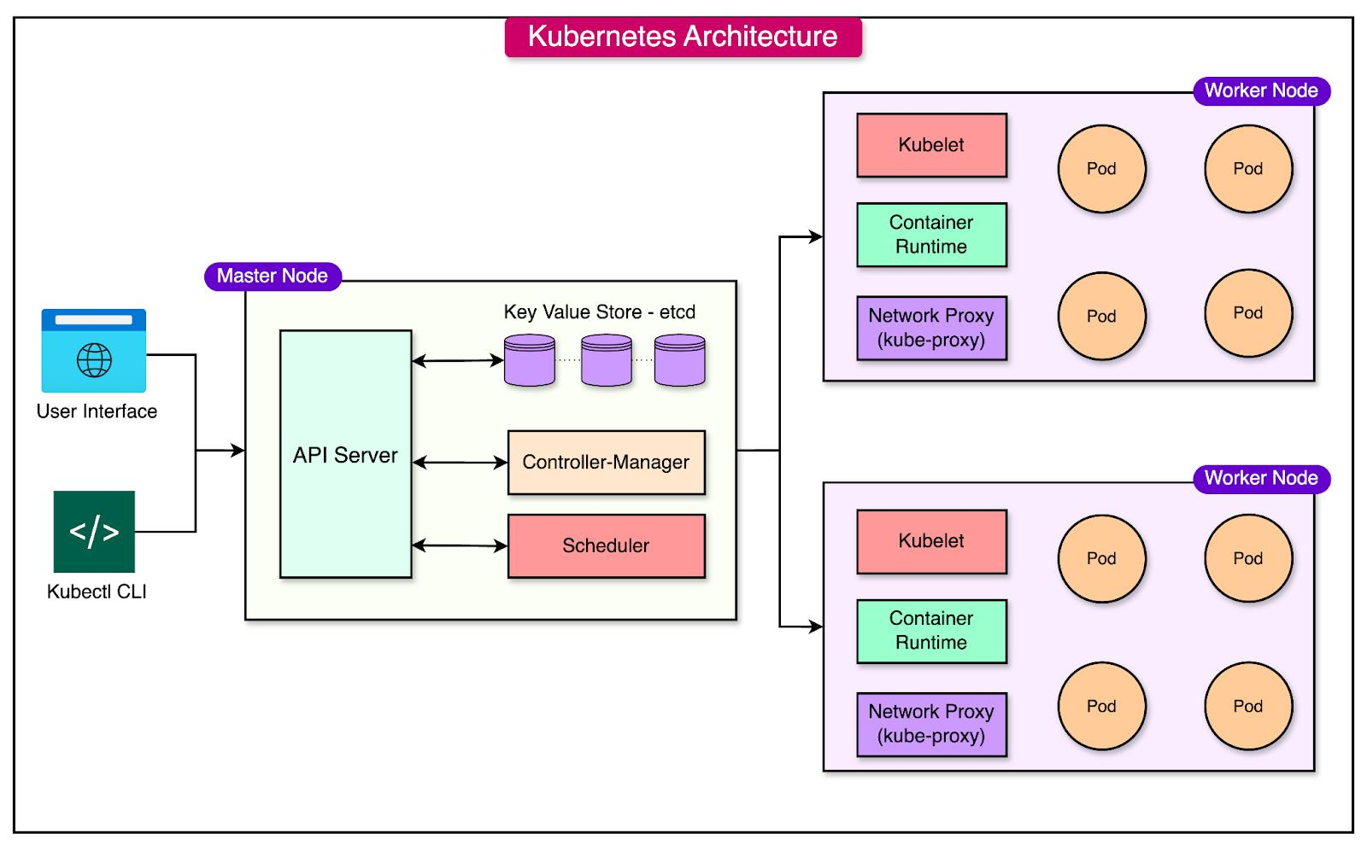

OAuth 2.0

OAuth 2.0 stands for Open Authorization 2.0.
Imagine you log in to an application using Google.
The application wants to access some information from your Google account.
Instead of giving your Google password to that application, OAuth 2.0 allows you to grant limited access through an authorization process.
Real-world example:
You use a travel application and click "Login with Google".

The process:
1. User opens the application.
2. Application redirects the user to the authorization server.
3. User authenticates and grants permission.
4. Authorization server issues an authorization code.
5. Application exchanges the code for an access token.
6. Application uses the access token to access protected APIs.

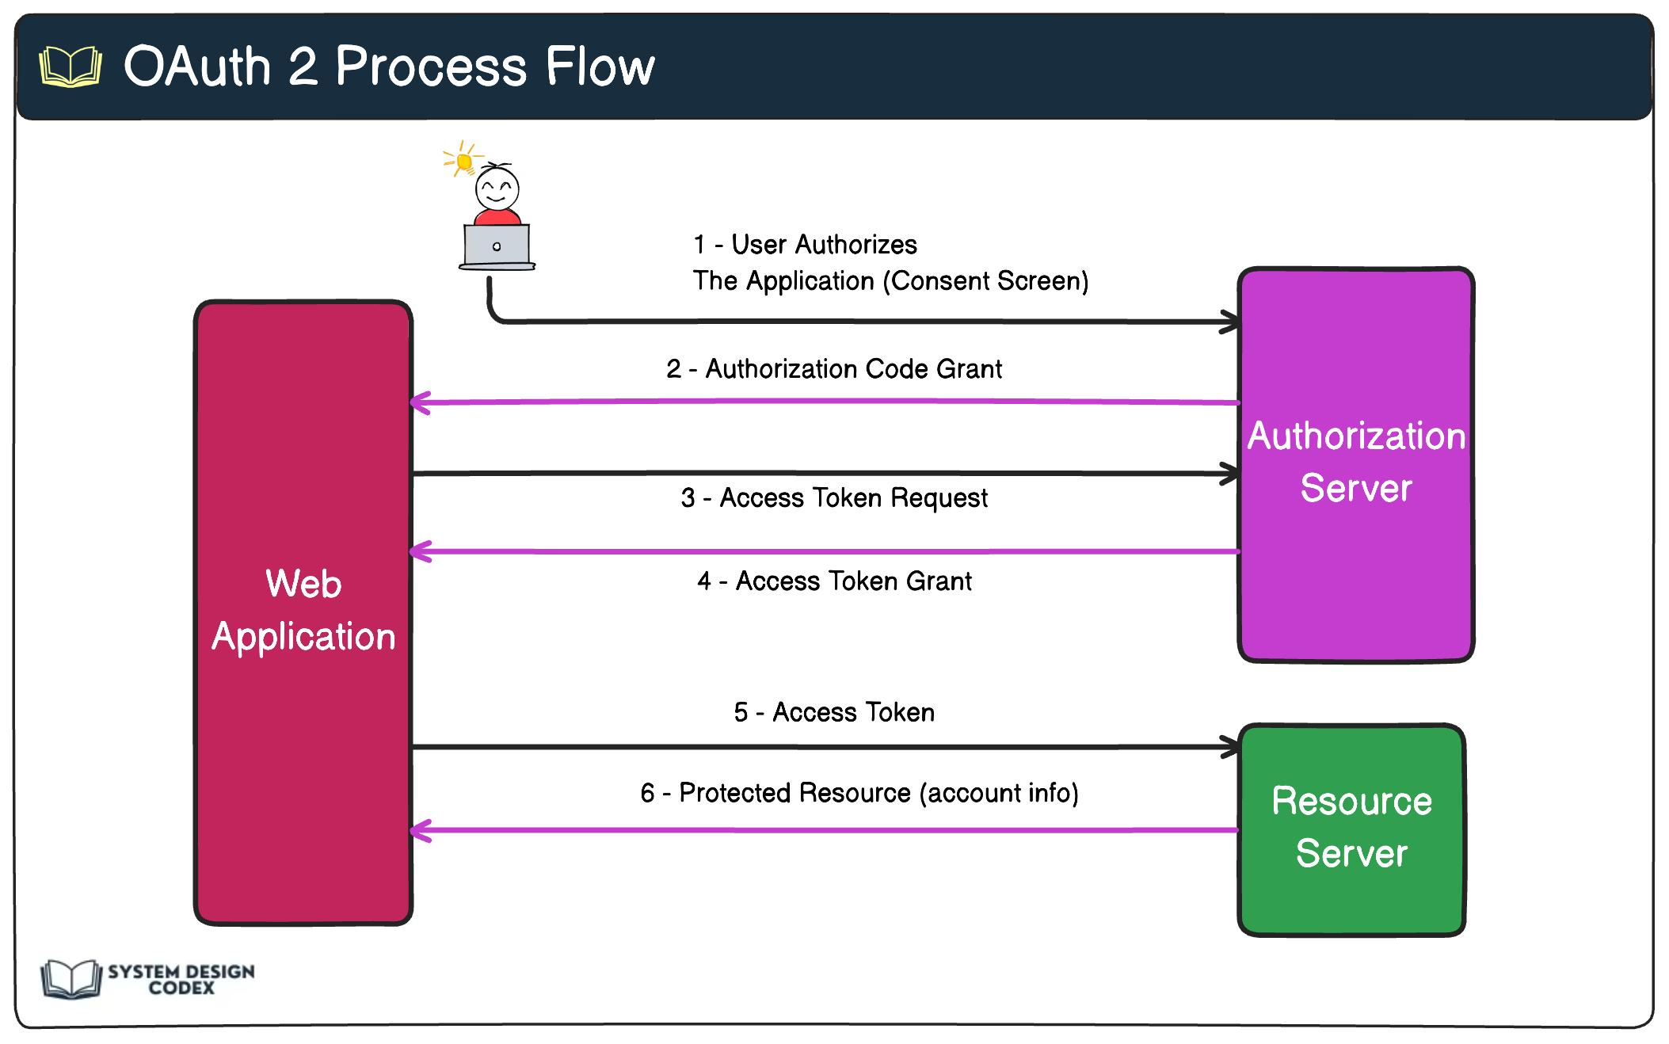
The application never needs to know your Google password.

JWT
JWT stands for JSON Web Token.
It is a compact, URL-safe format for carrying claims (information) between systems.
A JWT commonly contains:
- User ID
- Username
- Roles
- Permissions
- Token expiration time

A JWT has three parts:
- Header [Specifies the token type and signing algorithm.]
- payload [Contains claims about the user and token.]
- Signature [Used to verify that the token has not been modified and was signed by a trusted issuer.]

TLS

TLS is a security protocol that encrypts communication between two systems over a network.

In simple terms, TLS ensures that data transferred between a client and a server remains:
1. Confidential – Others cannot easily read the data.
2. Authenticated – The client can verify the server's identity.
3. Integrity protected – Data cannot be modified without detection.

TLS is the technology behind HTTPS websites.
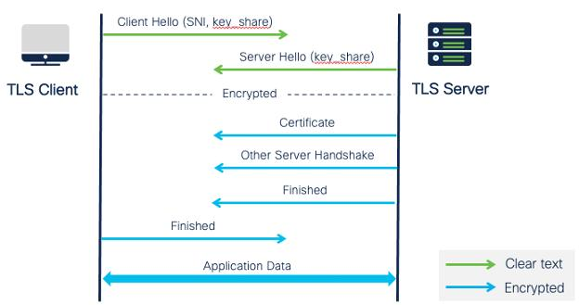
CI (Continuos Integration)

CI automatically checks whether new code changes work correctly before they are integrated into the main application.
CI is an important part of modern DevOps, Docker, Kubernetes and microservices architecture.
Popular CI tools: Jenkins, GitHub Actions, Azure DevOps

LLMs

LLM stands for Large Language Model.
An LLM is an Artificial Intelligence (AI) model trained on enormous amounts of text and other data to understand, process and generate human-like language.
In simple terms, an LLM is the technology behind applications like ChatGPT, Google Gemini and Claude.
You can ask questions, generate code, summarize documents, translate languages and solve problems using LLMs.



