LAB- Securing using oAuth2

---- My Notes ----
OAuth2 is a protocol that allows a user to grant limited access to their resources on one site, to another site, without having to expose their credentials.
Example: Vallet key of car
Different types of Grant:
1. Authorization Code Grant:
Access to resource is provided based on the Authorization code provided by Auth Server:
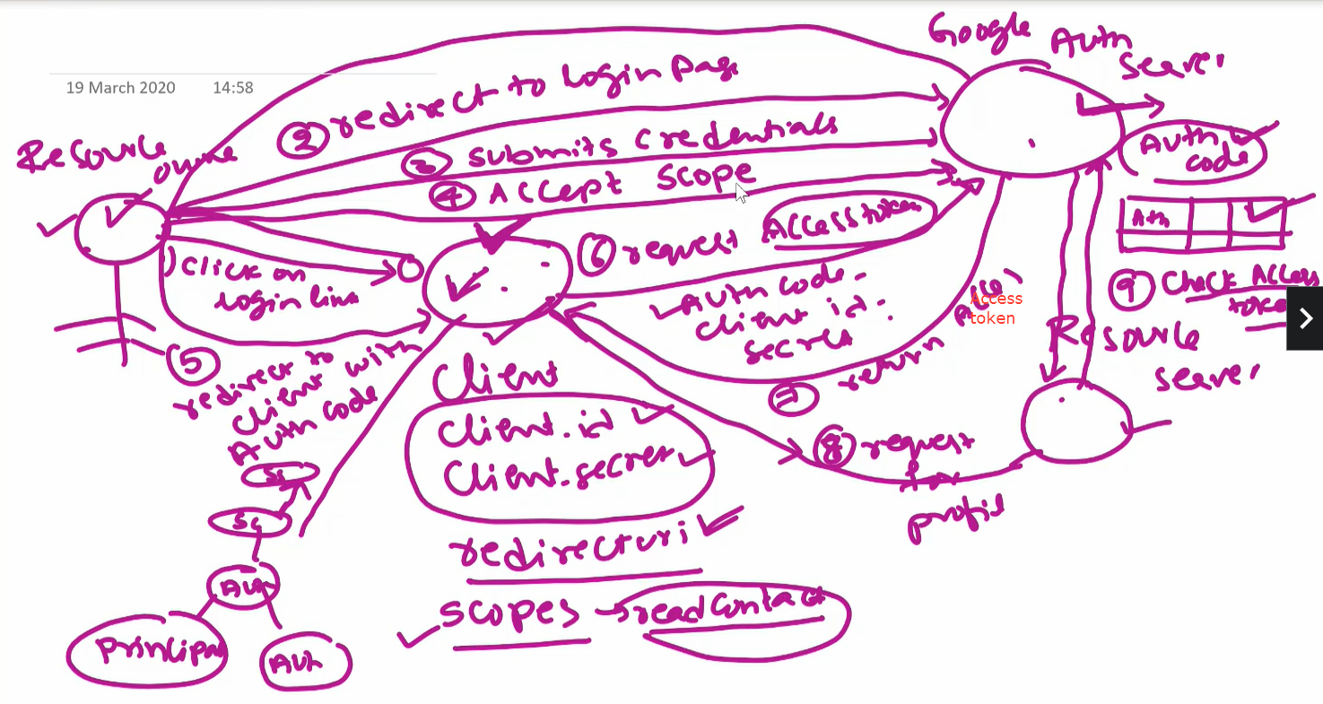

Suppose we(user) need to signup Quora website with Google or Facebook. Here Quora requests to Google to provide user’s details and Google gives partial access to user’s details.
Here user is a Resource Owner. Google is Resource Server which shares resource’s data and client is Quora.
For Google to share user’s data, client must be authenticated by Google’s Auth Server.
- First, client has to register itself with Auth Server and after successful registration Auth Server will provide clientId, client secret key to client. Client can share the redirection url, scopes(like read user’s name, email address, read contacts) to Auth Server during registration.
- Once the user clicks on “Login with Google”, the request first goes to client, then the security filter in the Client App redirects user to Google’s login page.
- After login Google Auth server shares the consent page to user.
If this consent is approved by user (accepts the scopes), Auth server generates a Authorization code. And this Auth code maybe stored in DB of AuthServer that this Auth code is provided to this user Id and the resource owner.
- Auth server now redirects the user to the redirection url provided by client along with Auth code.
- Now client will take this Auth code along with client id, secret key and request the auth server to provide Access Token
- Auth server returns the Access token.
- Using this Access token Client request for user’s data to Resource server(API).
- Resource Server first validates access token from Auth server by client id and details provided by client. And the Auth server returns the JSON which contains details of the access token and user to which this token has been granted.
- After above validation Resource server shares data to the client.
- Once the client got the profile(data) of the user, client have spring security implemented so it can create Principal object with user’s data and assign it some Authorities, then populate it to Authentication object, populate this in Security Context and put this Security context in a Session object. If Security Context is present in Session that means user is logged in.
In this way, the Resource owner is able to login through Google Account. And the Resource owner has granted partial authorities to client.
Here Grants are given to client based on Authorization code ie., Access token is given to client based on authorization code. Hence its called as Authorization Code Grant

2. Client Credentials Grant:
- Consider an example of BookMyShow(BMS). BMS has Resource Server which has the endpoints to book/cancel/display shows.
- BMS has its Auth Server to secure its resources in Resource Server
- suppose there is a App(Client) which wants to use resources of BMS then it has its clientId and client secret key available (after registration)
- In order to access the resources of BMS the client has to get the access token from Auth Server.
- To get the access token Client can just request Auth Server for access token using its clientId and secret key.
- The Auth server then provides the access token after successful authenticating the client id and secret key.
- Now the client can access resources of BMS using this access token.
This process of fetching the resources using client Id and secret key is called as Client Credentials Grant

3. Password Grant:
Now suppose my App also has some resources (rest apis).
When a user of my App books a ticket through my app the details of this is stored in DB of my App through Resource server
Suppose a user(Resource Owner) logs in to check the booked tickets ie., it wants to read the info from DB then it needs access token from App’s Auth Server.
When a user requests for this info to my App(client), the client sends username, password of the user and client’s ID and secret key to Auth server.
After success verification Auth server then generates access token for that user to access the resources of the App.
For the user to share their username and password, the client must be a trusted app.
This way of sharing Resource owner’s credentials along with client ID, secret key is called as Resource Owner Password Grant
JWT (Json Web Token):
As we have seen in Authorization Code Grant above, the Resource server always validates the access token with Auth server in order to provide the data to client.
If the request are huge, consider for millions of users there will be too much n/w traffic between Resource server and Auth Server. This is the issue with opaque token(or simple token).
In order to avoid network traffic, JWT token can be used.
This JWT token has other information like access scopes, grants given to client.
Once this JWT token is received to Resource server it can just validate this token and check if the client has been provided with required access.
JWT token is in the format a.b.c.
a means JSON info in encoded format that contains headers.
b has JSON data which is encoded format that contains information of payload i.e., scopes of token and who issued the token, etc
c has signature of Auth server. This signature is used to verify if this token is granted by Auth server.
Suppose A is sending data(“Hello”) to B using JWT token. Here A will encrypt data as:
Actual data(“Hello”) + digest of actual data(say, “HelloDigest”) (digest is calculated using some Digest Algo) + private key of A.
Once this encrypted data is reached to B, it will decrypt the data using public key of A ie., it will decrypt the digest data and then compare this decrypted digest data with actual data.
If the data is same in the comparison that means it is delivered successfully to B else we can assume that data is tampered and is not appropriate data and B can discard this data.

Configuration to set up AuthServer:
Some mostly used Auth server are :
- Okta
- KeyCloak
First client need to register itself with Auth server. To register client has to define scopes(different access), redirect url
Step 1 – Creating a Custom Authorization Server

In this step you will be working on 01-oauth2-server-start project.

Open pom.xml and observe that we have added
<dependency>
<groupId>org.springframework.security</groupId>
<artifactId>spring-security-oauth2-authorization-server</artifactId>
<version>0.3.0</version>
</dependency>

Authorization Server exposes endpoints for
requesting access token,checking the access token,Authorizing the client,etc

All those beans are registered by AutoConfiguration classes related to oAuth server.

Open AuthorizarionServerConfiguration.java and complete TODO-1 and TODO-2

Observe how we have configured other beans in AuthorizarionServerConfiguration.java

Start this application from boot dashboard and use postman to make a POST request to http://localhost:8000 /oauth2/token

Select Authorization tab in postman, select Basic Auth in the drop down and give client1/myClientSecretValue as username/password

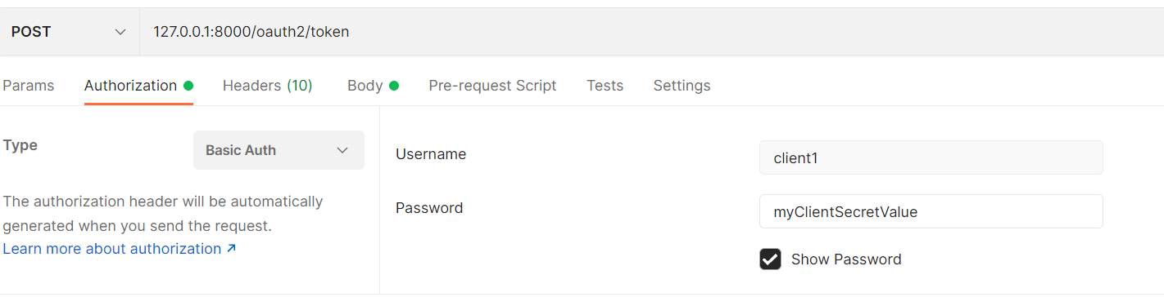
Observe that Authorization header will be added in post man.

Select Body and select x-www.form-url-encoded and give grant_type as client_credentials as shown below:

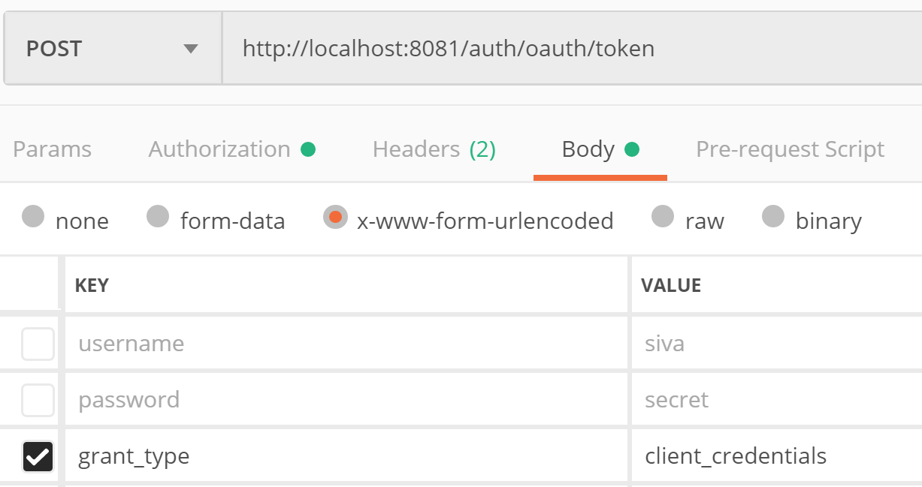

Now click on send in post man to make a request.

You should get the access token.

Congratulations!! U understood how to get access token using client_credentials grant type

Now we want to use authorization code grant for obtaining access token.

Open AuthorizationServerConfiguration.java and configure RegisteredClient to use AuthorizationCode grant instead of ClientCredentials by changing the following

.authorizationGrantType(AuthorizationGrantType.AUTHORIZATION_CODE)

/oauth2/authorize is the authorization endpoint of authorization server. If authorization has to be done, user needs to login and then only user can authorize the client. So, /oauth2/authorize endpoint has to be secured.

Open SpringSecurityConfiguration.java and complete TODO-3 and TODO-4

First we need to get authorization code and then using authorization code we can get access token.

Do the following to get authorization code:

Open browser and make a GET request to http://localhost:8000/oauth2/authorize?response_type=code&client_id=client1&redirect_uri=http://127.0.0.1:8080/authorized&scope=openid read mywrite

U will be redirected to login page of authorization server. Once u login using credentials siva/password, u will be redirected to the consent page. Once u provide consent, u will be redirected to given redirect_uri http://127.0.0.1:8080/authorized with code as query parameter

Once we get auth code, we can exchange it to get access token

Open postman and make a POST request to http://localhost:8000/oauth2/token

Select Authorization tab in postman, select Basic Auth in the drop down and give client1/myClientSecretValue as username/password

Observe that Authorization header will be added in post man.

Select Body and select x-www.form-url-encoded and give grant_type as authorization_code, code and redirect_uri as shown below:

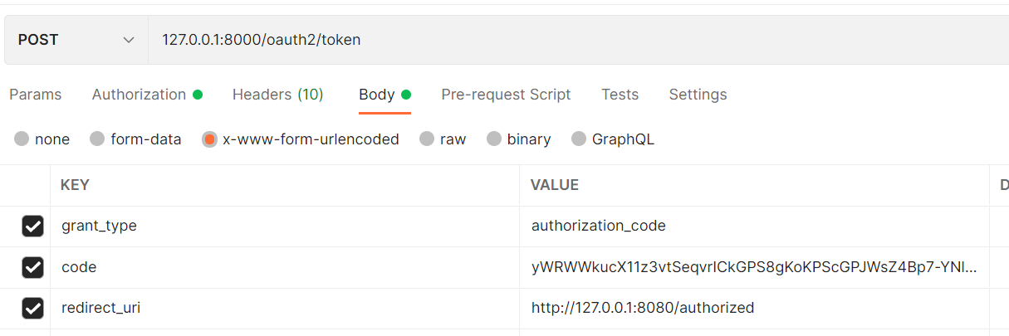

Now, make a request and observe that u get access token

Congratulations!! U understood how to get access token using authorization code grant type

Step 2 – Securing a Resource Server

In this step you will be working on 02-resource-server-start project.

Open pom.xml and observe that we have added below dependency

<dependency>
<groupId>org.springframework.boot</groupId>
<artifactId>spring-boot-starter-oauth2-resource-server</artifactId>
</dependency>

As we have added resource server dependency, the auto configuration will configure all the beans required for securing all URLs in this application.

To access any URL, access token is required.

When access token is received in the request, it need to be validated. To Validate the JWT token, u need the key. So, u need to tell to this resource server where it can obtain keys.

Open application.properties and the following

spring.security.oauth2.resourceserver.jwt.issuer-uri=http://auth-server:8000

Start the application.

Make a request to http://auth-server:8000/.well-known/oauth-authorization-server and observe the response. Did u get what is the authorization endpoint url , token endpoint url ,etc ?

Open OrderController.java and observe the code.

Try to give a GET request to http://127.0.0.1:8091/orders from PostMan and observe that u get 401 status code in response.

So, get the access token by following the step1 as described above.

Now using postman, make a GET request to http://127.0.0.1:8091/orders . Make sure u add Authorization header with value “Bearer <<accesstoken>>” as shown below

Now You should get success response

Congratulations!! U understood how to Secure Resource Server

Step 3 – Securing a web application client with authorization grant flow

In this step you will be working on 03-oauth2-web-client-start project.

Open pom.xml and observe that we have added below dependency

<dependency>
<groupId>org.springframework.boot</groupId>
<artifactId>spring-boot-starter-oauth2-client</artifactId>
</dependency>

Open application.properties and observe that we have configured the following

spring.security.oauth2.client.registration.mywebclient.client-id=client1
spring.security.oauth2.client.registration.mywebclient.client-secret=myClientSecretValue
spring.security.oauth2.client.registration.mywebclient.scope=openid
spring.security.oauth2.client.registration.mywebclient.authorization-grant-type=authorization_code
spring.security.oauth2.client.registration.mywebclient.redirect-uri=http://127.0.0.1:8080/login/oauth2/code/mywebclient

spring.security.oauth2.client.provider.mywebclient.issuer-uri=http://auth-server:8000

spring.security.oauth2.client.provider.mywebclient.authorization-uri = http://auth-server:8000/oauth2/authorize
spring.security.oauth2.client.provider.mywebclient.token-uri = http://auth-server:8000/oauth2/token
spring.security.oauth2.client.provider.mywebclient.jwk-set-uri=http://auth-server:8000/oauth2/jwks

Observe that all the properties are following pattern spring.security.oauth2.client.registration.<<clientregistrationid>>

Observe that clientregistrationid is mywebclient in all the properties

Observe that mywebclient is the registrationid used while configuring RegisteredClient

Open OrderController.java and observe the code.

As we have added the OAuth2 client dependency, autoconfiguration will configure all the beans required for securing this application

If you try to give a request to /orders (Don’t make request now, just read to understand) , u will be redirected to authorization endpoint of authorization server. U already configured below property which tell the authorization endpoint

spring.security.oauth2.client.provider.mywebclient.authorization-uri = http://auth-server:8000/oauth2/authorize

As this end point is secured at authorization server, u will be redirected to login page of authorization server. Once you login using the credentials, you will be redirected to the redirect url specified in the property

spring.security.oauth2.client.registration.mywebclient.redirect-uri=http://127.0.0.1:8080/login/oauth2/code/mywebclient

While redirecting, authorization server will send the authorization code in the URL

At this URL, there will be a security filter which will take authorization code and obtain access token from the authorization server. Using this token, Oauth2AuthorizedClient will be populated and SecurityContext Will also be populated.

So, when ever required, we can access the access token from SecurityContext or Oauth2AuthorizedClient

Open OrderController.java and observe how we are injecting OAuth2AuthorizedClient into getOrders method.

Complete TODO-1 in OrderController.java and understand how we are getting accesstoken and using that token to make a rest api call to resource server

Now start the application and make a request to http://localhost:8080/orders using the browser

You will be redirected to login page of authorization server. Once u login, u can see the orders page with orders.

Observe that access token is logged on the console.

We can use WebClient to make requests instead of RestTemplate.

Open Application.java and observe how we have configured WebClient bean

Complete TODO-2 in OrderController.java to use webclient.

Congratulations!! U understood how to Secure a web application client using authorization CodeGrant Flow

Step 4 – Securing a web application client with using google

In this step you will be working on 04-oauth2-google-login project.

Open pom.xml and observe that we have added

<dependency>
<groupId>org.springframework.boot</groupId>
<artifactId>spring-boot-starter-oauth2-client</artifactId>
</dependency>

Go to https://console.developers.google.com/

Click on Credentials link in the left menu
Click on Create credentials ,select “Oauth Client Id”

Select Application type as “Web Application”

Give Some Name , and redirect uri as http://localhost:8080/myapp/login/oauth2/code/google and create.

Note down the client-id and client-secret shown

Now configure following in application.yml

spring.security.oauth2.client.registration.google.client-id=<<client id obtained from google>>
spring.security.oauth2.client.registration.google.client-secret==<<client secret id obtained from google>>
spring.security.oauth2.client.registration.google.redirect-uri=http://127.0.0.1:8080/login/oauth2/code/google

Open Oauth2AuthenticationSuccessHandler.java given to you in com.way2learnonline package and observe that it is extracting user details from OAuth2AuthenticationToken
And saving MyAppUser into database if user is not existing.

Open WebSecurityConfiguration.java and observe that we have configured SecurityFilterChain as shown below:

@Bean
@Order(2)
SecurityFilterChain mySecurityFilterChain(HttpSecurity http) throws Exception {

http
.authorizeRequests()
.antMatchers("/h2-console/**","/mylogin","/login/**").permitAll()
.anyRequest().authenticated()
.and()
.oauth2Login().loginPage("/mylogin")
.successHandler(oauth2authSuccessHandler)
.and().csrf().disable();

;

http.headers().disable();

return http.build();

}

Open login.html under templates folder and observe how we have added link for Google Login

That’s all !!
Now give a request to http://localhost:8080/orders so that you will be redirected to login page.

In the login page choose to login using google.

You should be successfully logged in.

Congratulations!! U understood how to Secure a web application client using Google Login!!

https://cloud.spring.io/spring-cloud-static/spring-cloud-security/2.1.3.RELEASE/single/spring-cloud-security.html#_client_token_relay_in_spring_cloud_gateway

-: Self Notes :-
OAuth Playground :

