Introduction to Data Analysis in R

Derek Sollberger

2022-05-31

Table of Contents

library("corrplot")  
library("forcats")  
library("janitor")  
library("skimr")  
library("tidyverse")

# Today’s Data Set

This survey is the result of a partnership between Axios and Harris Poll to gauge the reputation of the most visible brands in America, based on 20 years of Harris Poll research. From Trader Joe’s to Disney, here’s how this year’s class stacks up.

“Methodology: The Axios Harris Poll 100 is based on a survey of 33,096 Americans in a nationally representative sample conducted March 11-April 3, 2022. The two-step process starts fresh each year by surveying the public’s top-of-mind awareness of companies that either excel or falter in society.

“These 100 “most visible companies” are then ranked by a second group of Americans across the seven key dimensions of reputation to arrive at the ranking. If a company is not on the list, it did not reach a critical level of visibility to be measured.”

Since we have CSV files (comma-separated values), we can use the read_csv function in the readr package to load the file into our current programming session.

reputation <- readr::read_csv("reputation.csv",  
 name_repair = janitor::make_clean_names)  
reputation_wide <- readr::read_csv("reputation_wide.csv",  
 name_repair = janitor::make_clean_names)

# Exploring the Data

At this point, you can look at the environment pane (upper-right area in RStudio), and click on the name of a data frame (e.g. reputation) to open up a viewer to take a look at the data.

Another way to take a quick look at the data is with the head command to view the first few rows.

head(reputation)

## # A tibble: 6 × 5  
## company industry name score rank  
## <chr> <chr> <chr> <dbl> <dbl>  
## 1 Trader Joe's Retail TRUST 82.7 3  
## 2 Trader Joe's Retail ETHICS 82.5 2  
## 3 Trader Joe's Retail GROWTH 84.1 2  
## 4 Trader Joe's Retail P&S 83.5 9  
## 5 Trader Joe's Retail CITIZENSHIP 80 3  
## 6 Trader Joe's Retail VISION 81.9 13

head(reputation_wide)

## # A tibble: 6 × 9  
## company industry trust ethics growth p_s citizenship vision culture  
## <chr> <chr> <dbl> <dbl> <dbl> <dbl> <dbl> <dbl> <dbl>  
## 1 Trader Joe's Retail 82.7 82.5 84.1 83.5 80 81.9 83.1  
## 2 HEB Grocery Retail 83.7 81.8 83.6 83.1 81 81.3 81   
## 3 Patagonia Retail 81.3 81.7 81.9 83.7 80.8 82.2 82.9  
## 4 The Hershey Com… Food & … 79.9 79.8 82.3 81.4 75.2 81.8 79.1  
## 5 Wegmans Groceri… 80.7 81.4 83.1 81.1 78.6 80.9 81.7  
## 6 Samsung Tech 79.8 80.2 83.8 84.3 75 84.1 81.6

For our purposes, we should look at the structure of each data set. In R, this is processed with the str command. In particular, this view clarifies which columns are numerical and which are categorical.

str(reputation, give.attr = FALSE)

## spec_tbl_df [700 × 5] (S3: spec_tbl_df/tbl_df/tbl/data.frame)  
## $ company : chr [1:700] "Trader Joe's" "Trader Joe's" "Trader Joe's" "Trader Joe's" ...  
## $ industry: chr [1:700] "Retail" "Retail" "Retail" "Retail" ...  
## $ name : chr [1:700] "TRUST" "ETHICS" "GROWTH" "P&S" ...  
## $ score : num [1:700] 82.7 82.5 84.1 83.5 80 81.9 83.1 83.7 81.8 83.6 ...  
## $ rank : num [1:700] 3 2 2 9 3 13 1 1 4 4 ...

str(reputation_wide, give.attr = FALSE)

## spec_tbl_df [100 × 9] (S3: spec_tbl_df/tbl_df/tbl/data.frame)  
## $ company : chr [1:100] "Trader Joe's" "HEB Grocery" "Patagonia" "The Hershey Company" ...  
## $ industry : chr [1:100] "Retail" "Retail" "Retail" "Food & Beverage" ...  
## $ trust : num [1:100] 82.7 83.7 81.3 79.9 80.7 79.8 79.9 78.7 78.9 78.2 ...  
## $ ethics : num [1:100] 82.5 81.8 81.7 79.8 81.4 80.2 78.9 79.7 79.7 77.2 ...  
## $ growth : num [1:100] 84.1 83.6 81.9 82.3 83.1 83.8 82.9 83.5 83 81 ...  
## $ p_s : num [1:100] 83.5 83.1 83.7 81.4 81.1 84.3 81.8 83.6 83.6 83.5 ...  
## $ citizenship: num [1:100] 80 81 80.8 75.2 78.6 75 77 76.6 74.2 73.5 ...  
## $ vision : num [1:100] 81.9 81.3 82.2 81.8 80.9 84.1 84.1 82.4 82.4 80.1 ...  
## $ culture : num [1:100] 83.1 81 82.9 79.1 81.7 81.6 79.1 80.2 81.5 79.5 ...

# Sample Statistics

To get a sense of the numbers, we can compute sample statistics (such as the mean, median, and standard deviation) for a numerical variable.

reputation |>  
 summarize(mean = mean(score, na.rm = TRUE),  
 median = median(score, na.rm = TRUE),  
 sd = sd(score, na.rm = TRUE))

## # A tibble: 1 × 3  
## mean median sd  
## <dbl> <dbl> <dbl>  
## 1 74.8 75.9 6.00

The R programming language becomes really useful when we want to perform our tedious calculations across several categories. Notice how the inclusion of one line of code below helps us compute the sample statistics for each survey category.

reputation |>  
 group_by(name) |>  
 summarize(mean = mean(score, na.rm = TRUE),  
 median = median(score, na.rm = TRUE),  
 sd = sd(score, na.rm = TRUE))

## # A tibble: 7 × 4  
## name mean median sd  
## <chr> <dbl> <dbl> <dbl>  
## 1 CITIZENSHIP 71.2 72.2 5.25  
## 2 CULTURE 74.4 76 5.96  
## 3 ETHICS 74.0 75.4 6.05  
## 4 GROWTH 76.8 77.8 5.69  
## 5 P&S 76.3 78 5.97  
## 6 TRUST 74.1 75.8 5.96  
## 7 VISION 77.0 78.4 5.02

In today’s exploration, I am interested in the possible differences in the survey scores across the industries.

reputation |>  
 group_by(industry) |>  
 summarize(mean = mean(score, na.rm = TRUE),  
 median = median(score, na.rm = TRUE),  
 sd = sd(score, na.rm = TRUE))

## # A tibble: 19 × 4  
## industry mean median sd  
## <chr> <dbl> <dbl> <dbl>  
## 1 Airline 69.3 70.1 5.10  
## 2 Automotive 78.1 78.3 2.95  
## 3 Consumer Goods 77.3 77.8 2.53  
## 4 Ecommerce 70.1 69.4 7.17  
## 5 Energy 70.3 71.1 4.26  
## 6 Financial Services 74.3 74.8 4.70  
## 7 Food & Beverage 75.7 75.4 4.70  
## 8 Food Delivery 72.7 73 2.44  
## 9 Groceries 71.6 79.1 12.6   
## 10 Healthcare 79.1 79.4 2.16  
## 11 Industrial 78.4 78.4 3.13  
## 12 Insurance 75.3 75.8 2.59  
## 13 Logistics 79.1 79.4 2.28  
## 14 Media 67.8 67.5 5.91  
## 15 Other 77.0 77.8 4.31  
## 16 Pharma 74.6 74.6 3.48  
## 17 Retail 75.8 76.5 5.24  
## 18 Tech 75.0 76.9 7.11  
## 19 Telecom 73.7 73.1 3.82

# Data Visualization

## Histogram

A histogram allows us to visualize the distribution of one numerical variable.

reputation |>  
 ggplot(aes(x = score)) +  
 geom_histogram(color = "black", fill = "blue") +  
 labs(title = "Company Reputation Survey",  
 subtitle = "2022",  
 caption = "Source: Axios and Harris, TidyTuesday",  
 x = "reputation score")

## `stat_bin()` using `bins = 30`. Pick better value with `binwidth`.

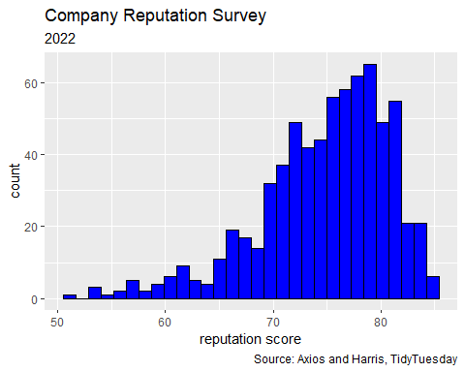

## Scatterplot

A scatterplot allows us to visualize a pair of numerical variables.

correlation_value <- reputation_wide |>  
 summarize(r = cor(trust, culture,  
 use = "pairwise.complete.obs")) |>  
 unlist()  
  
reputation_wide |>  
 ggplot(aes(x = trust, y = culture)) +  
 geom_point() +  
 geom_smooth(method = "lm", se = FALSE) +  
 labs(title = "Company Reputation Survey",  
 subtitle = paste0("correlation: r = ",  
 round(correlation_value, 4)),  
 caption = "Source: Axios and Harris, TidyTuesday",  
 x = "trust score",  
 y = "culture score")

## `geom_smooth()` using formula 'y ~ x'

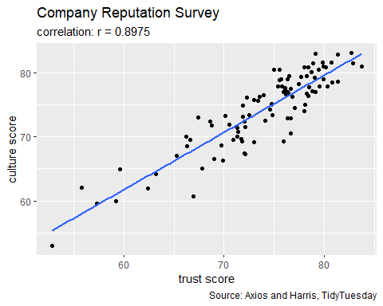

## Boxplot

A boxplot allows us to visualize numerical distributions across a categorical variable.

reputation |>  
 ggplot(aes(y = score)) +  
 geom_boxplot(color = "black", fill = "red") +  
 labs(title = "Company Reputation Survey",  
 subtitle = "an example of a single boxplot",  
 caption = "Source: Axios and Harris, TidyTuesday",  
 x = "",  
 y = "reputation score")

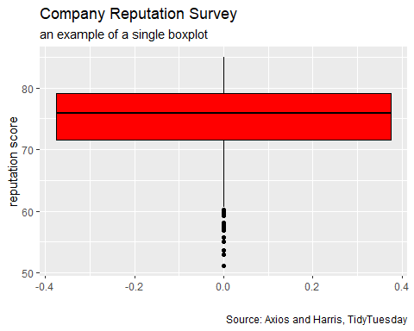

reputation |>  
 ggplot(aes(x = name, y = score,   
 fill = name, group = name)) +  
 geom_boxplot(color = "black") +  
 labs(title = "Company Reputation Survey",  
 subtitle = "an example of a single boxplot",  
 caption = "Source: Axios and Harris, TidyTuesday",  
 x = "",  
 y = "reputation score")

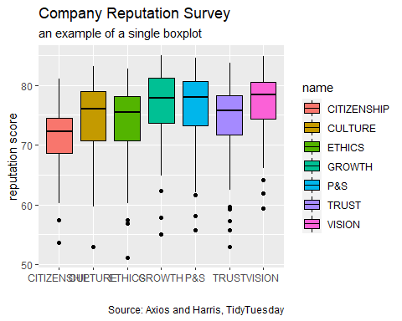 Let us see what happens if we explore the industry categorical variable.

reputation |>  
 ggplot(aes(x = industry, y = score,   
 fill = industry, group = industry)) +  
 geom_boxplot(color = "black") +  
 labs(title = "Company Reputation Survey",  
 subtitle = "an example of a single boxplot",  
 caption = "Source: Axios and Harris, TidyTuesday",  
 x = "",  
 y = "reputation score")

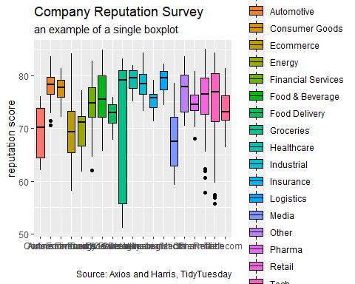

To start to ease the complexity, we can (for example)

* focus on two of the categories
* remove the legend

reputation |>  
 filter(industry %in% c("Healthcare", "Media")) |>  
 ggplot(aes(x = industry, y = score,  
 fill = industry)) +  
 geom_boxplot() +  
 labs(title = "Reputation Survey",  
 subtitle = "March 11 to April 3, 2022",  
 caption = "Source: Axios and Harris, TidyTuesday",  
 x = "industry",  
 y = "reputation") +  
 theme(legend.position = "none")

