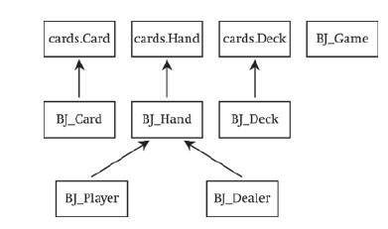

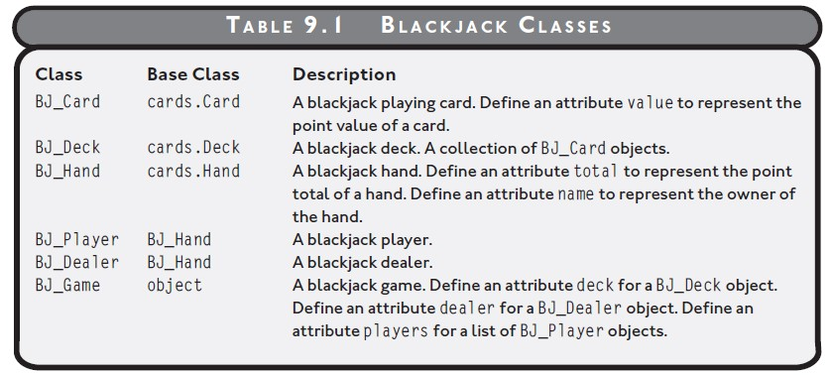

Deal each player and dealer initial 2 cards

For each player

While the player asks for a hit and the player is not busted

Deal the player an additional card

If there are no players still playing

Show the dealer's

Otherwise

While the dealer must hit and the dealer is not busted

Deal the dealer an additional card

If the dealer is busted

For each player who is still playing

The player wins

Otherwise

For each player who is still playing

If the player's

The player wins

Otherwise, if the player's

The player loses

Otherwise

The player pushes

Clear each players’ hand and the dealer’s hand.