HOMEWORK 3 – NETWORK PROGRAMMING
Submission requirements:
- Place the source code of each program in a separate directory, named as suggested below.
- Create a Makefile to compile the programs at the same time, with the resulting executable files named server and client respectively.
- Package these directories into a compressed file named in the format StudentName_StudentID_HW03.zip. For example, for this week's assignment, the submitted archive should have the following structure:
StudentName_StudentID_HW03.zip
|-- UDP_Client
|-- Source code files
|-- UDP_Server
|-- Source code files
|-- Makefile
Assignment description
Write a domain name resolution application using UDP sockets:
Server:
- Runs on any port number, using a command-line parameter with the following syntax:
./server PortNumber
Example: ./server 5500
- Receives a message containing a domain name or IP address sent by the client.
- Sends back a message containing the resolution result to the client. Logs the processing result.
- Mandatory requirement: The server program must not terminate automatically under any processing situation.
Client:
- Launches the program with command-line parameters for the IP address and port number of the server to which requests will be sent, using the following syntax:
./client IPAddress PortNumber
Example: ./client 127.0.0.1 5500
- The user enters a domain name or IP address from the keyboard.
- The client sends the request to the server.
- Receives the result from the server and displays it.
- This process repeats until the user enters an empty string.
The server must log its activity to a file named log_StudentID.txt, e.g., log_20201234.txt. Each line has the following structure:
[dd/mm/yyyy hh:mm:ss]$Request received$Query result
Where:
dd/mm/yyyy: Format of the date the request was received
hh:mm:ss: Format of the time the request was received
Example:
[31/03/2023 14:42:24]$google.com$+216.58.197.110 216.58.197.123 126.58.99.199
[31/03/2023 14:42:28]$126.58.99.199$+hkg07s22-in-f3.net hkg07s22-in-f99.net
[31/03/2023 14:43:28]$5giay.vn$+210.211.109.164
[31/03/2023 14:43:29]$aznsc.test.com$-Not found information
Grading scale:
- Functional score (FS):
[1] Perform forward resolution: 3 points
a. Display the first IP address: 1 point
b. Display all IP addresses: 2 points
[2] Perform reverse resolution: 1 point
[3] Write logs: 1 point
[3] Design the response message with a prefix: 2 points
[4] The following errors will incur point deductions:
➢ The server fails to serve multiple clients continuously: -3 points
➢ Runtime error causing the client to terminate: -1 point
➢ Runtime error causing the server to terminate, but functions can still be tested: -3 points
➢ Runtime error preventing all functions from being tested: -100%
➢ Compilation error: -100%
➢ Other errors: points deducted according to the severity of the error
- Code organization and presentation score (SS):
If 0 ≤ FS < 1: SS = 0
If 1 ≤ FS < 3: SS is at most 1 point
If 3 ≤ FS ≤ 5: SS is at most 2 points
If 5 < FS ≤ 7: SS is at most 3 points
Environment requirements:
- Operating system: Ubuntu 20.04
- Compiler: GCC
Suggestions:
1. Designing the server's response message
The result returned from the server has 2 types:
- A message containing the result
- An error message.
It is necessary to design a way to distinguish between these two message types by using different prefixes (a character/group of characters at the start of the message). The client relies on the prefix to determine which type of result the message contains.
A suggested design is as follows:
- Prefix is ‘+’ to indicate success. Example: +202.191.56.65
- Prefix is ‘-’ to indicate failure. Example: -Not found information
2. Issues related to source code organization and presentation
- Clean code: https://viblo.asia/p/tom-tat-cuon-clean-code-cua-uncle-bob-6J3Zg07MlmB
- Structure the program into functional modules/functions.
- Use naming conventions. For example:
➢ Camel case: https://en.wikipedia.org/wiki/Camel_case
➢ Snake case: https://en.wikipedia.org/wiki/Snake_case
➢ Other conventions: https://viblo.asia/p/naming-rules-cac-quy-tac-vang-trong-lang-dat-ten-ByEZkMXE5Q0
- Comment functions/modules following a consistent convention. Example:
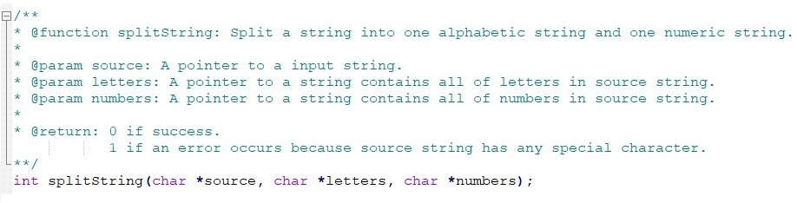
3. Testing
- Functional testing: Students may perform testing on their own following the scenario below (not mandatory to follow):
Step | Command Prompt Window 1 | Command Prompt Window 2 | Command Prompt Window 3 | Command Prompt Window 4
1 | Start the server
2 |  | Start client 1
3 |  |  | Start client 2
4 |  |  |  | Start client 3
5 |  |  |  | Enter some string
6 |  |  | Enter some string
7 |  | Enter arbitrary test strings
8 |  | Enter an empty string
9 |  |  | Press Ctrl+C
10 |  |  |  | Enter arbitrary test strings
12 |  | Start client 1
13 |  | Enter some string
14 |  | Press Ctrl+C
15 |  |  |  | Enter arbitrary test strings
16 |  |  |  | Enter an empty string
- Performance testing: Students may use the udp_test.c program.
➢ Compile: gcc -pthread udp_test.c -o test
➢ Syntax: test <#server_port> <#threads>
Where:
#server_port: The server application's port number
#threads: The number of concurrent test threads
Example: test 5500 10

