HOMEWORK 4 – IT4062
Submission requirements:
- Place the source code of each program in a separate directory, named as suggested below.
- Create a Makefile to compile the programs at the same time, with the resulting executable files named server and client respectively.
- Package these directories into a compressed file named in the format StudentName_StudentID_HW04.zip. For example, for this week's assignment, the submitted archive should have the following structure:
StudentName_StudentID_HW04.zip
|-- TCP_Client
|-- Source code files
|-- TCP_Server
|-- Source code files
|-- Makefile
Assignment description
Write an application using TCP Socket to transfer a file from the client to the server. The file can be of any format, with its size limited to up to 2³² bytes.
- Server:
➢ Starts with the application's port number and storage directory passed as command-line parameters:
$./server Port_Number Directory_name
Where Directory_name is the name of the directory used to store files uploaded by the client
(Example: $./server 5500 storage)
➢ Uses a directory named from the command-line parameter to store files uploaded by the client.
➢ When a new client connects, sends a welcome message with the content +OK Welcome to file server
➢ Receives a message indicating the file name and size (in bytes) sent by the client. Sends back the message +OK Please send file
➢ Receives the file data sent by the client and writes it to a file with the name requested by the client. Operates in overwrite mode.
➢ If the file transfer completes successfully (the full number of bytes is received), sends the response +OK Successful upload.
➢ Mandatory requirement: The server program must not terminate automatically under any processing situation.
- Client:
➢ Starts with the server's address passed as command-line parameters:
$./client IP_Addr Port_Number (Example: $./client 10.0.0.1 5500)
➢ Receives and displays the welcome message.
➢ Receives the file path entered by the user. Sends a message to the server using the syntax UPLD File_name File_size
Example: UPLD test.txt 1024
➢ Sends the file to the server.
➢ Displays the file transfer result.
➢ This process repeats until the user enters an empty string as the file path.
The activity of both sides is illustrated in the following diagram:
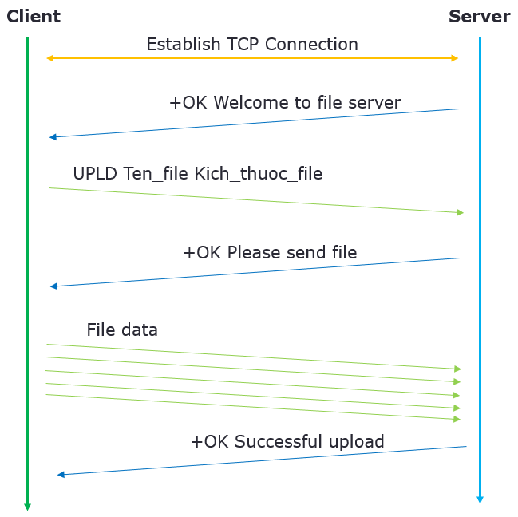
The server must log its activity to a file named log_StudentID.txt, e.g., log_20201234.txt. Each line has the following structure:
[dd/mm/yyyy hh:mm:ss]$Client address$Request received$Query result
Where:
dd/mm/yyyy: Format of the date the request was received
hh:mm:ss: Format of the time the request was received
Client address has the format IPAddress:PortNumber
Example:
[31/03/2023 14:42:24]$127.0.0.1:40000$+OK Welcome to file server
[31/03/2023 14:42:28]$127.0.0.1:40000$UPLD test.txt 1024\r\n$+OK Successful upload
Grading scale:
- Functional score (FS):
[1] Connect successfully and receive the welcome message: 1 point
[2] Successfully process the message containing the file name and size: 1 point
[3] Successfully transfer a small file (< 10KB): 1 point
[4] Successfully transfer a large file up to 2³² bytes: 2 points
[5] Successfully handle streamed transfer: 2 points
[4] The following errors will incur point deductions:
➢ The server fails to serve multiple clients continuously: -3 points
➢ Runtime error causing the client to terminate: -1 point
➢ Runtime error causing the server to terminate, but functions can still be tested: -3 points
➢ Runtime error preventing all functions from being tested: -100%
➢ Compilation error: -100%
➢ Other errors: points deducted according to the severity of the error
- Code organization and presentation score (SS):
If 0 ≤ FS < 1: SS = 0
If 1 ≤ FS < 3: SS is at most 1 point
If 3 ≤ FS ≤ 5: SS is at most 2 points
If 5 < FS ≤ 7: SS is at most 3 points
Environment requirements:
- Operating system: Ubuntu 20.04
- Compiler: GCC
Suggestions:
- When transferring a file, read the file in data blocks to send it. The block size should be sufficiently large (e.g., a minimum of 16KB) for good transfer performance.
- A possible test scenario is as follows:
Step | Client 1 | Client 2 | Client 3
1 | Start client 1
2 |  | Start client 2
3 |  |  | Start client 3
4 |  |  | Send a compressed file
5 |  | Send an image file
6 | Send a .txt file
7 | Wait for completion  Result: Success. The file can be viewed on the server
8 | Terminate the program
9 |  | Wait for completion  Result: Success. The image can be viewed on the server
10 |  | Terminate the program
11 |  |  | Wait for completion  Result: Success. The file can be extracted on the server
12 |  |  | Terminate the program

