**Empathy Map Canvas**

|  |  |  |  |  |  |  |
| --- | --- | --- | --- | --- | --- | --- |
| *Designed for:* |  | *Designed by:* |  | *Date:* |  | *Version:* |
|  |  |  |  |  |  |  |

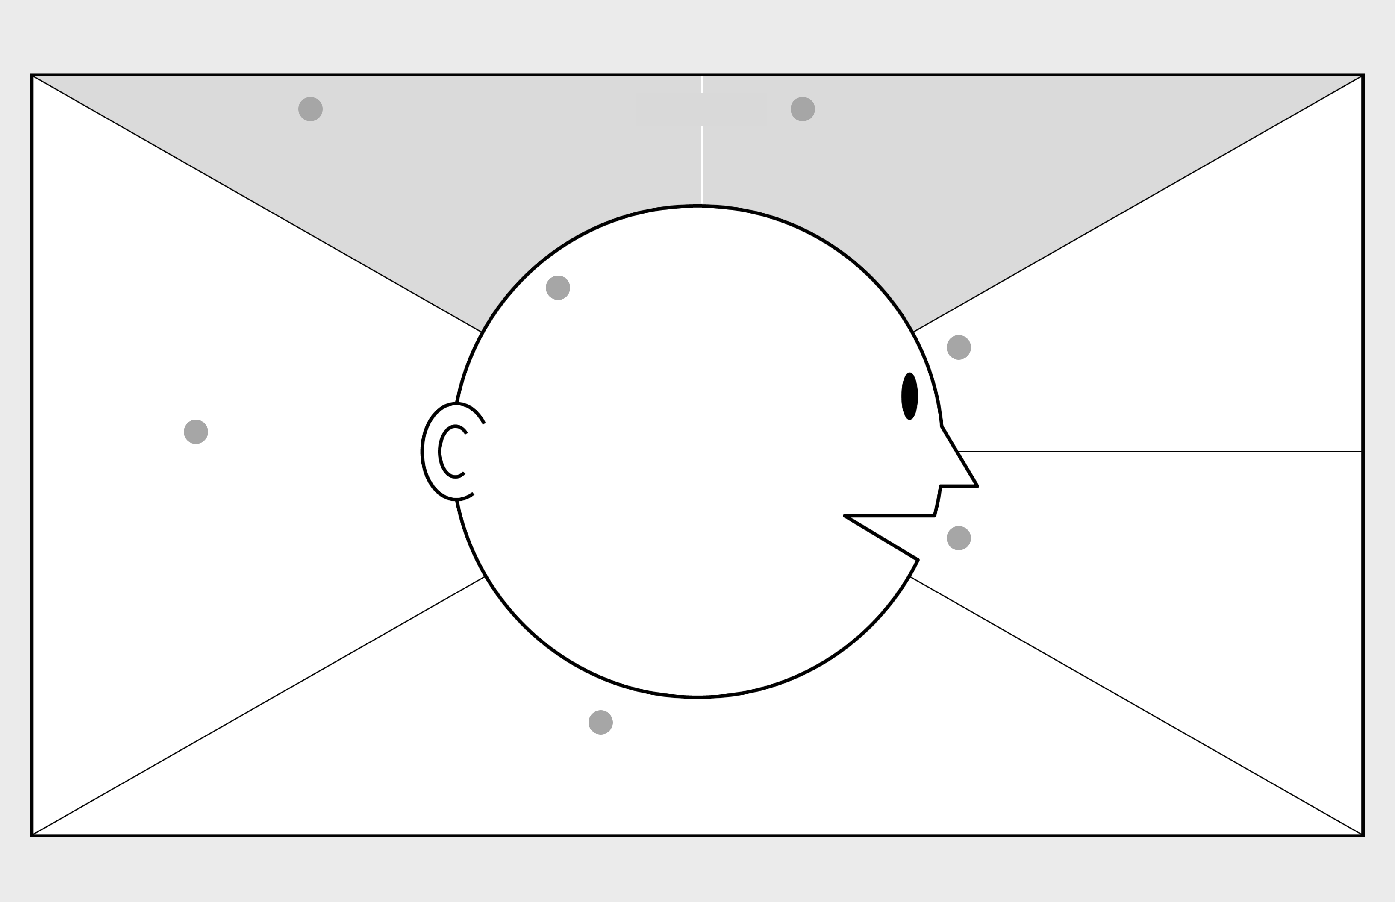

|  |  |  |
| --- | --- | --- |
| 1 WHO are we empathizing with? | **GOAL** | 2 What do they need to DO? |

Who is the person we want to understand?

What is the situation they are in?

What is their role in the situation?

What do they need to do differently?

What job(s) do they want or need to get done?

What decision(s) do they need to make?

How will we know they were successful?

1. What do they THINK and FEEL?
2. What do they HEAR?

What are they hearing others say?

What are they hearing from friends?

What are they hearing from colleagues?

What are they hearing second-hand?

|  |  |
| --- | --- |
| PAINS | GAINS |
| What are their fears, | What are their wants, |
| frustrations, and anxieties? | needs, hopes and dreams? |
|  |  |

What other thoughts and feelings might motivate their behavior?

1. What do they DO?

What do they do today?

What behavior have we observed?

What can we imagine them doing?

1. What do they SEE?

What do they see in the marketplace?

What do they see in their immediate environment?

What do they see others saying and doing?

What are they watching and reading?

1. What do they SAY?

What have we heard them say?

What can we imagine them saying?

Last updated on 16 July 2017. Download a copy of this canvas at http://gamestorming.com/empathy-map/ © 2017 Dave Gray, xplane.com