2019

Daniel Sørenes n10572465

Anshul Jangra

10/28/2019

Twitter Analyzer



CAB432

Assignment 2

Contents

Introduction 2

Purpose & description 2

Services used 2

API 1 2

API 2 2

API n 2

Use cases 2

US 1 2

US 2 2

US n 2

Technical breakdown 3

Architecture 3

Context diagram 3

Sequence Diagram 3

Process flow Diagram 3

Network diagrams (Cloud specific) 4

Client / server demarcation of responsibilities 4

Response filtering / data object correlation 5

Test plan 6

Difficulties / Exclusions / unresolved & persistent errors 7

Extensions 7

User guide 7

References 7

Appendices as you require them 7

*This is a template for your assignment you don’t have to use it / all of it*

*Just ensure you cover all the areas to qualify for a good mark*

*This report should be around 12-15 pages including screenshots*

*Please note there are examples for previous students work in this template & examples from Google searches. They are here to give you ideas on what you can do* ***We do not guarantee their accuracy*** *You must do your own research to ensure you are producing well formed examples*

## Introduction

### Purpose & description

### 

The purpose for the Twitter Analyzer is to receive context pertaining to the queried hashtags. For example, you can search for the hashtags #Hongkong and #China, relevant because of the ongoing protests happening in Hong Kong, to get an overall view of the content and discussions around those events. It’s a minimalistic application that does its job well.

The Twitter Analyzer analyses the tweets from Twitter with the hashtags specified by the user and the amount and performs sentiment analysis and extracts the most important words. This is the base of the application.

### Services used

# Twitter search API (<https://developer.twitter.com/en/docs/tweets/search/api-reference/get-search-tweets>).

The Twitter search API is the data source for the application. The data received is parsed down so only the relevant data remains. The parsed data is then analysed using Natural Language Processing, specifically sentiment analysis and feature extraction via TF-IDF. The analysed data is then sent as a response to the initial client request.

## Use cases

#### Use case 1

|  |  |
| --- | --- |
| As a | Frequent follower of global events |
| I want | To discover the overall context of the Hong Kong protests |
| So that | So that I get a better overview of the current situation happening in real time. |

#### Use case 2

|  |  |
| --- | --- |
| As a | Avid Kim Kardashian fan |
| I want | to see what hashtag(s) she is involved in |
| So that | I can get to know the news and stories around her better |

#### Use case 3

|  |  |
| --- | --- |
| As a | Guy interested in computer science and data analytics |
| I want | To see what the words most relevant to the hashtag #memes is |
| So that | I can see what words are most associated with the #memes hashtag |

## Technical breakdown

### Architecture

Explain how your system operates, making it clear how data flows around the system through requests and responses.

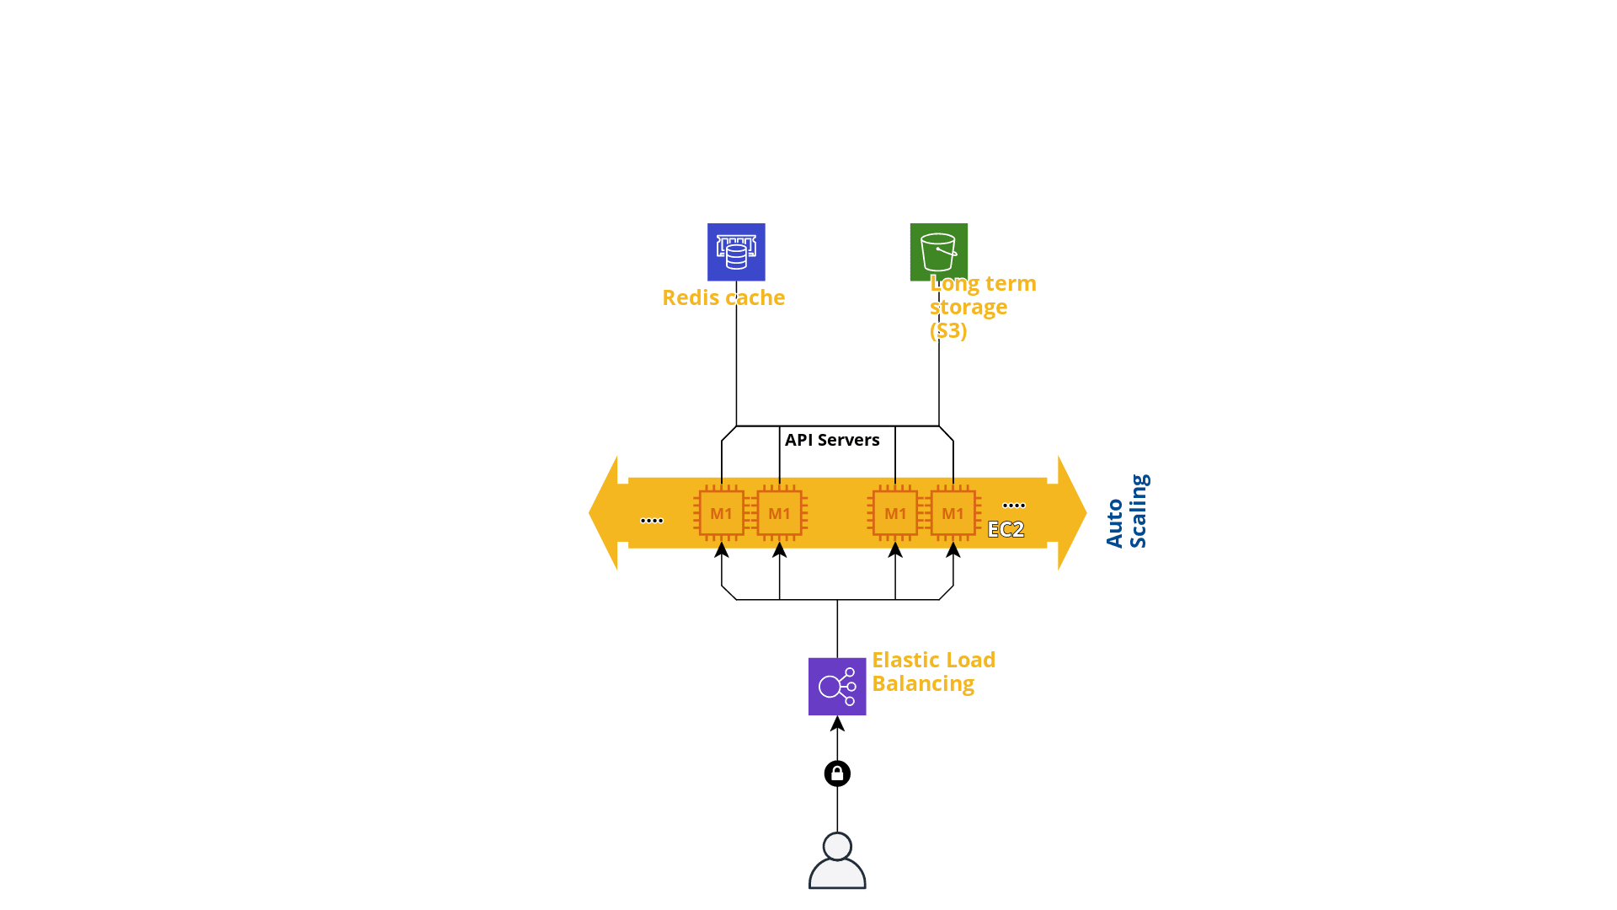

Explain what libraries you used & what you used them for

It is very important to include Diagram/s – especially the overall architecture. Many students use diagram generators such as the tools at <https://cloudcraft.co/>. For assignment 2, this is the most important diagram used to document your approach. The ‘network diagrams’ below show some more complicated alternatives.

Below you will find some examples of the types of diagrams you could consider. Other than the architecture diagram, which is essential for assignment 2, none of these are compulsory. However, if it helps you to explain what is going on, then you should use them.

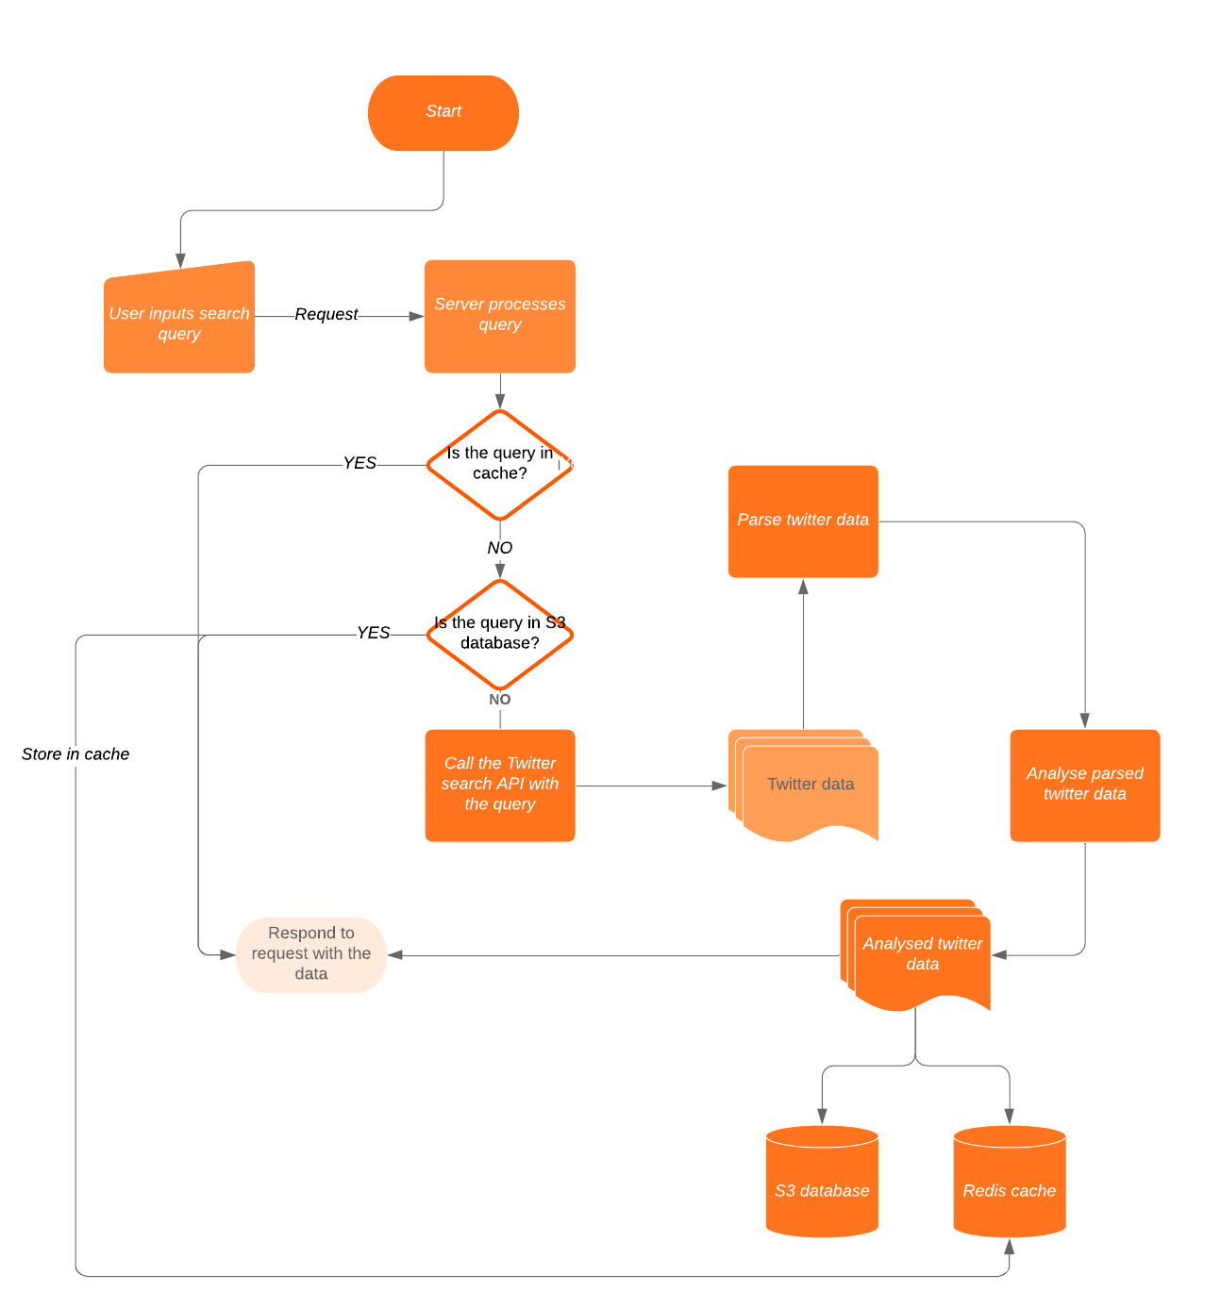

#### 

#### Client / server demarcation of responsibilities

Explain to us what is doing what & where. Refer to the architecture diagram and any others that you find appropriate. This is particularly effective if you support your comments with well-chosen code fragments. These should be short and focused and you should give us any context that we need to work with them.

#### Response filtering / data object correlation

Show us how you manipulated the data. The same comments apply about referring to the diagrams and supporting your work with code fragments as appropriate.

*An example of how to show this diagramatically. Please note that this example is quite specific to the system being explained. Yours might have an entirely different look, but do a similar job.*

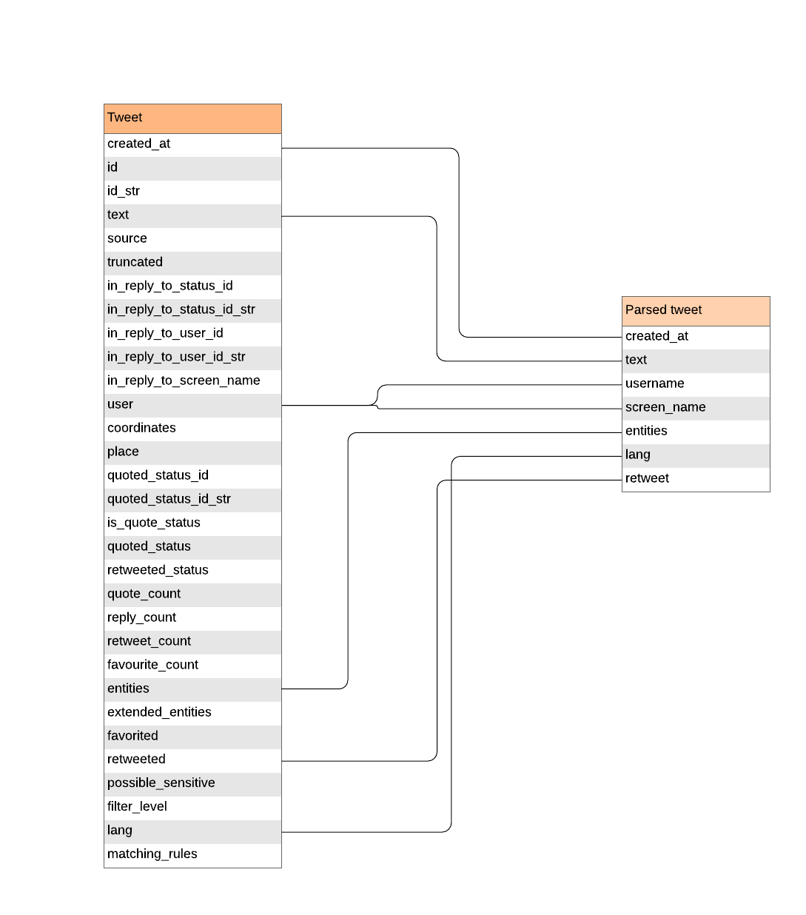

### 

### Test plan

Manual testing is fine

A suite of tests that can be performed

Don’t forget to cover:

* Positive outcome cases
* Negative outcome cases (error scenarios)
* edge cases
* non-functional cases

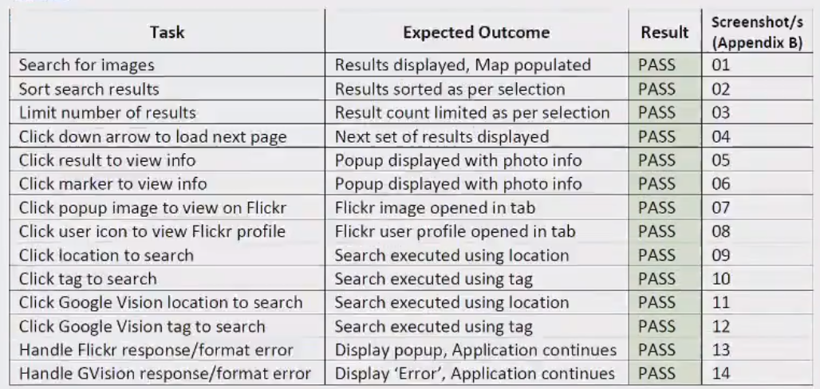

As they are common in industry you could define your *Acceptance Criteria* as *GWT statements.*  You will find a guide here: <https://www.agilealliance.org/glossary/gwt/>. Here is an example:

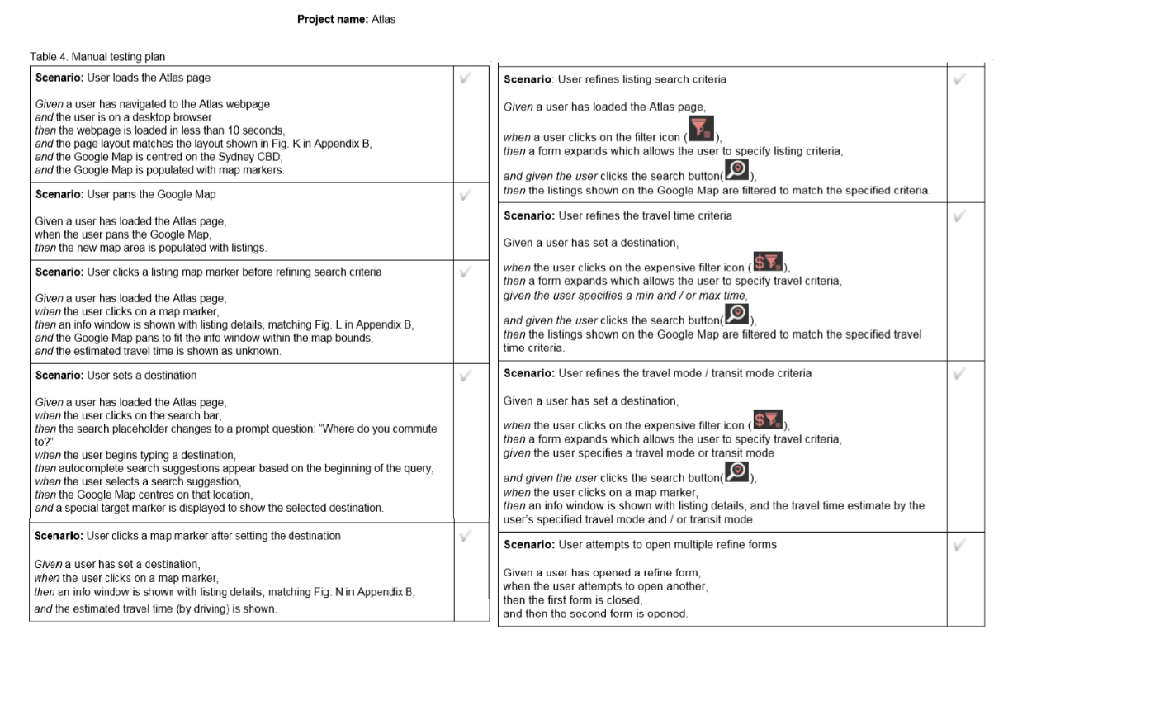

Difficulties / Exclusions / unresolved & persistent errors /

Topics to include here could be:

* What were your major roadblocks / how did you resolve them
* Any functionality you didn’t or couldn’t finish
* Is there any differences between your brief and what you delivered, explain why
* Is there any outstanding bugs

## Extensions

Where could you take this:

tell us about Potential future extensions / improvements for your app

## User guide

Tell us how to use your application

Use screenshot liberally here

## References

Don’t forget to use QUT cite

## Appendices as you require them

[Our thanks to those students who allowed us to use their work in the examples presented here.]