1. Create a folder and store “movie_dataset.csv “, “movie_recom_app.py” and “Movie_Recommender.ipynb” in it.
2. Create 2 sub-folders and name them as “static” and “templates”

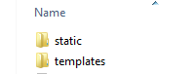

1. Store “style.css” inside the folder “static”
2. Store “home.html” and “result.html” inside the folder “templates”.
3. Run the code 'Movie_Recommender.ipynb' in the Jupyter Notebook, which saves a file 'Movie_Cosine_Scores.pkl' in the main folder.

**Note:** *Change the path where ever required in 'Movie_Recommender.ipynb' and movie_recom_app.py”*

1. Open Command Prompt -🡪 type “ python movie_recom_app.py ” and press enter



1. You should get the output as follows:

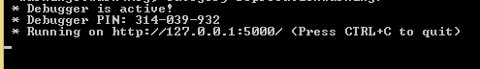

1. In your web browser go to <http://127.0.0.1:5000/>
2. You will get a window as below. Enter the Movie Name in the text box and click on “predict”

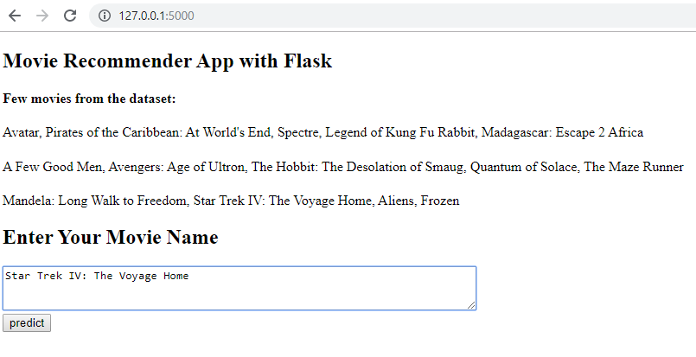

1. You will get an output like shown below:

