Enter text to describe each LCD menu.

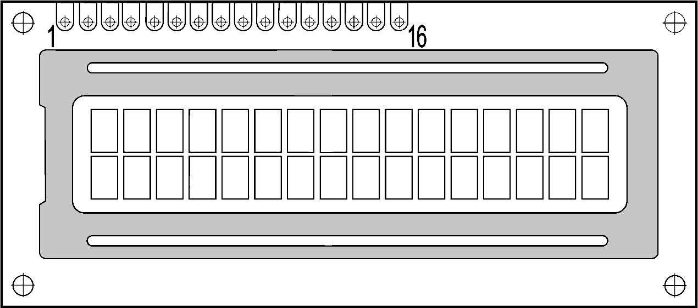

123456789.123456  
8888888888888888

1

2

3

4

Enter text to describe each LCD menu.



123456789.123456  
8888888888888888

1

2

3

4

Enter text to describe each LCD menu.



123456789.123456  
8888888888888888

1

2

3

4

Enter text to describe each LCD menu.



123456789.123456  
8888888888888888

1

2

3

4