Execution_logs screenshots:

- BRONZE LAYER:
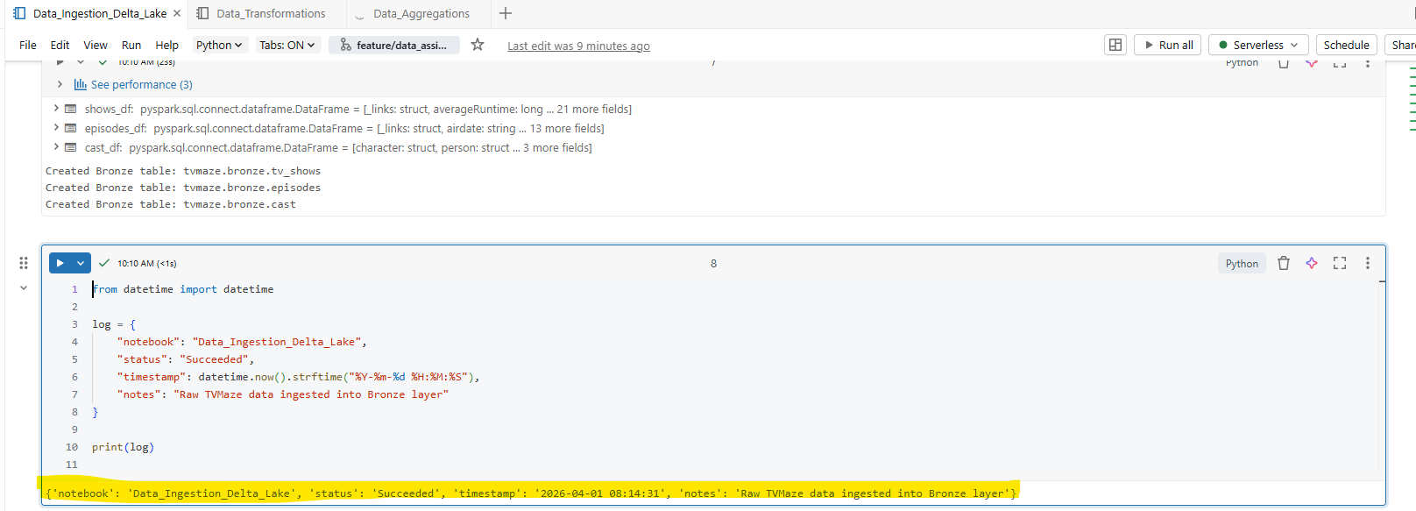

- SILVER LAYER:
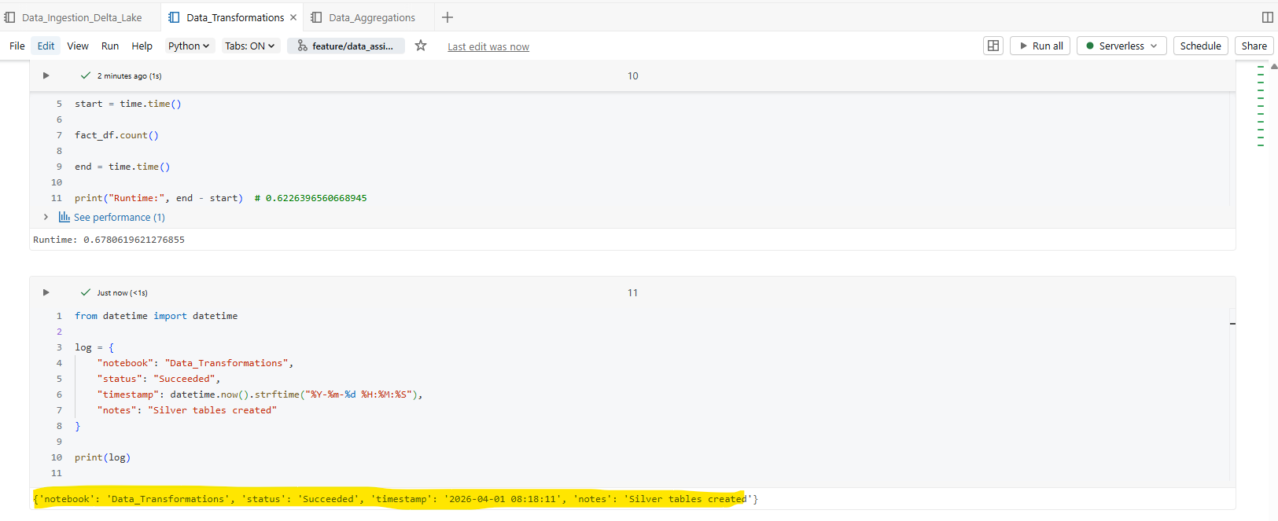
- GOLD LAYER:
