**MongoDB - Introduction**

* **What is MongoDB?**

* **How it works?**

* + MongoDB is schema-less.
  + It uses JSON data format.
  + Here single json can contain complex documents, this gives the flexibility of saving a complex data at a single document, and the retrieval of data will be fast. But to do the same on SQL, we must have different tables to save the value, and we have to write a complex joins to fetch the values.
  + MongoDB converts the JSON data to BSON (Binary) when it saves the document.
  + Main feature of MongoDB is flexibility and optimization for usability.
* **Key characteristics of MongoDB**
  + Schema-less.

* + No / Few relations.

* + There is no need of merging.
  + MongoDB will be a perfect fit for all kind of applications (web, blog, any applications which sends sensor data etc) because of its performance.
* **Understanding MongoDB Ecosystem**
  + The company which manages MongoDB is MongoDB.
  + It has all other products which is listed in below figure.
  + Compass – Is an UI for MongoDB.
  + Stitch – Serverless backend solution.

* **Installing MongoDB**
  + Go to MongoDB official website and download the version you want for a desired OS.
  + In Mac, extract the zip file and copy the extracted content and paste it wherever you want.
  + Now under the user folder -> create a new folder named “data” and inside data create another folder named “db”.
  + Set the PATH of “bin” folder wherever you installed your on your computer and set that as a PATH in .bash_profile file.
  + Now restart the terminal.
  + After that when you execute mongo – then you should get the details of MongoDB version etc.,

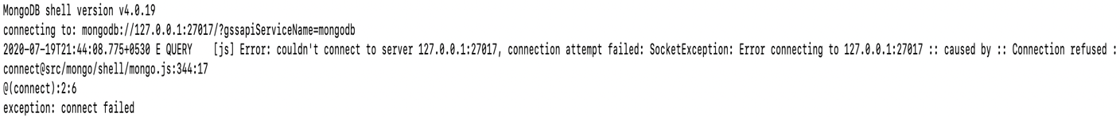

* + Execute this command to start the mongoDB server.
    - mongod –dbpath = “”
* **MongoDB + Clients:**

