**Dockerizing Multiple Services**

* **Dockerizing a react app again:**

* **Adding postgress as a service:**

* **Environment variable with Docker compose:**

* **Nginx Path Routing:**

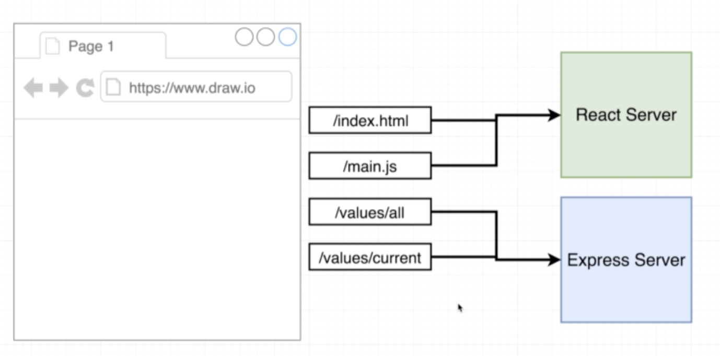

* **Routing with Nginx:**

* **Building custom nginx image:**