**Production Multi-Container Deployments**

* **Production Multi-Container Deployments:**

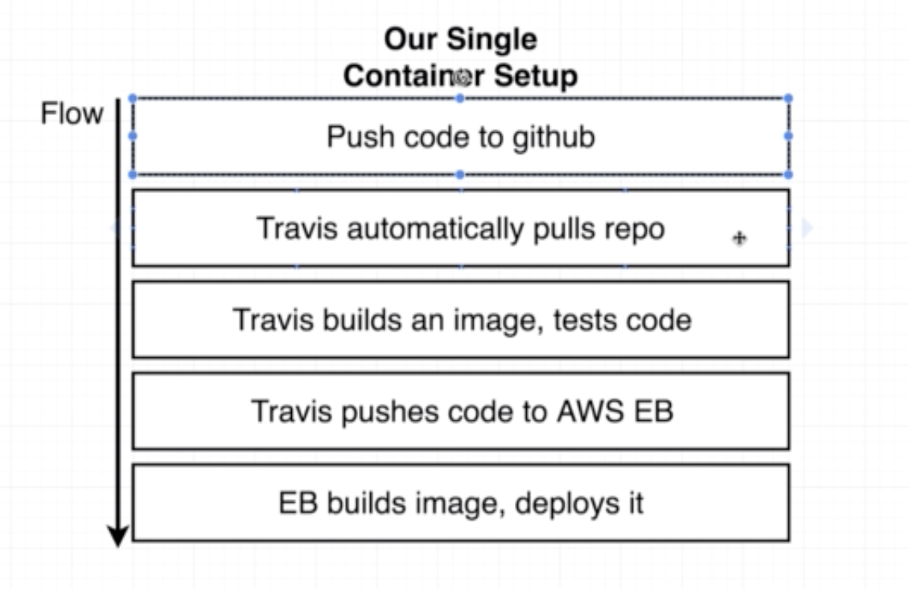

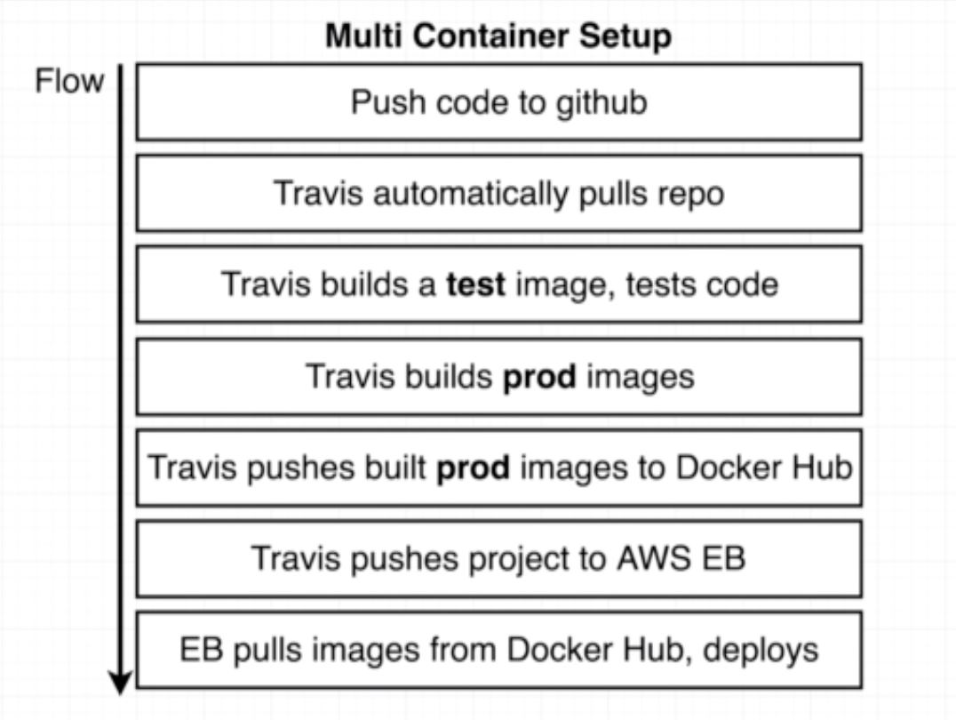

* **Travis CI yml:**

* **Travis file:**

sudo: required

services:

- docker

before_install:

- docker build -t dspandiyan/react-test -f ./client/Dockerfile.dev ./client

scripts:

- docker run dspandiyan/react-test npm test -- --watchAll=false

after_success:

- docker build -t dspandiyan/multi-client ./client

- docker build -t dspandiyan/multi-nginx ./nginx

- docker build -t dspandiyan/multi-server ./server

- docker build -t dspandiyan/multi-worker ./worker

- echo "$DOCKER_PASSWORD" | docker login -u "$DOCKER_ID" --password-stdin

- docker push dspandiyan/multi-client

- docker push dspandiyan/multi-nginx

- docker push dspandiyan/multi-server

- docker push dspandiyan/multi-worker