**Multi-Container Deployments to AWS**

* **Multi-Container Definition Files:**

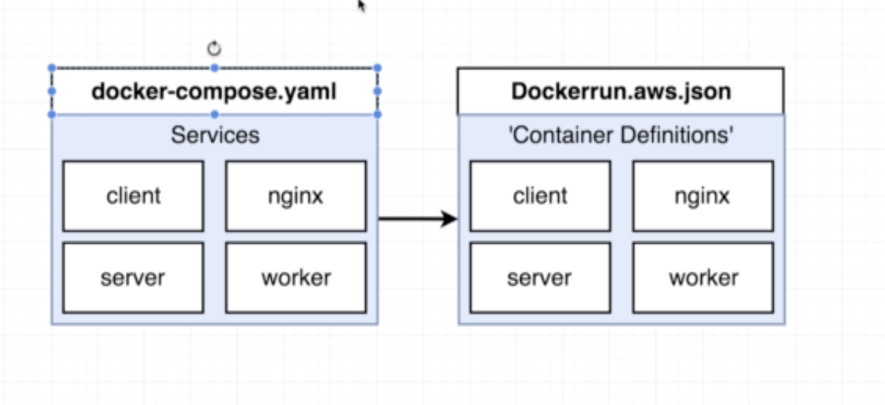

* **Finding Docs on Container Definitions:**

* **Forming Container Links:**

* **Managed Data Service Providers:**

* **Overview of AWS VPC’s and Security Groups:**

Whenever we create any resource or services on AWS, that must be accessed only by the specific person, to achieve that it will create a VPC (Virtual Private Cloud).

