**Kubernetes Production Deployment**

* **The Deployment Process:**

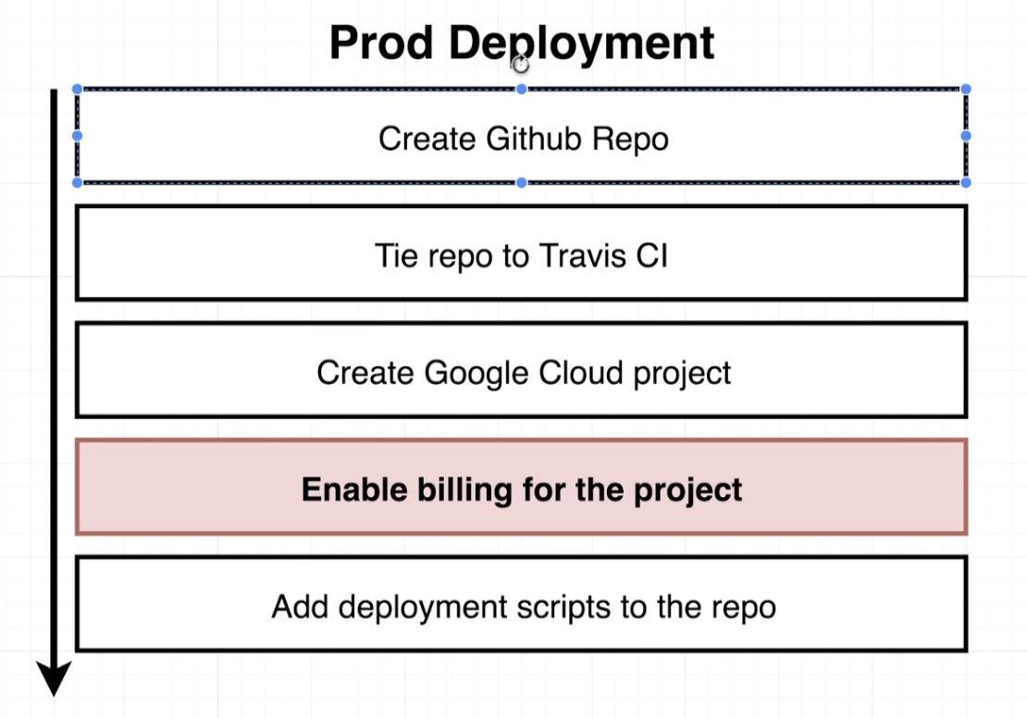

**Note: If you do complete deployment as explained in the course in GCE, you have to pay little amount, even though you use the free tier.**

* **Google Cloud vs AWS for Kubernetes:**

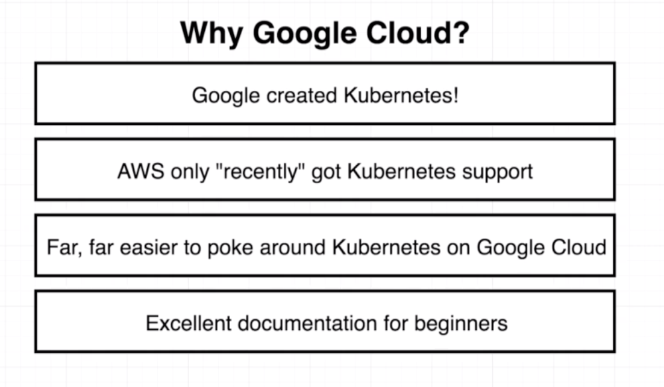

* **Creating a Git Repo:**

Create a new repo named “multi-k8s” on Git.

Execute below command to check whether you have an existing remote added

git remote -v

Execute below command to delete remote

git remote remove origin

Execute below command to add new repo origin.

git remote add remote_url

Add all the files, commit and push it to the repo.

* **Linking the Github Repo to Travis:**

Link newly created repo on Travis.

* **Creating a Google Cloud Project:**

Use the existing tier if you have or create a new free tier.

Log in to console.

And click on a project link (left side of search bar).

Click on new project and give a name as “multi-k8s”

* **Kubernetes Engine Init:**

Once the project setup is over.

Click on the left-hand side button and select “Kubernetes”

Very first time you will see a message saying “initializing”

* **Creating a cluster with Google Cloud:**
* **Travis Config:**

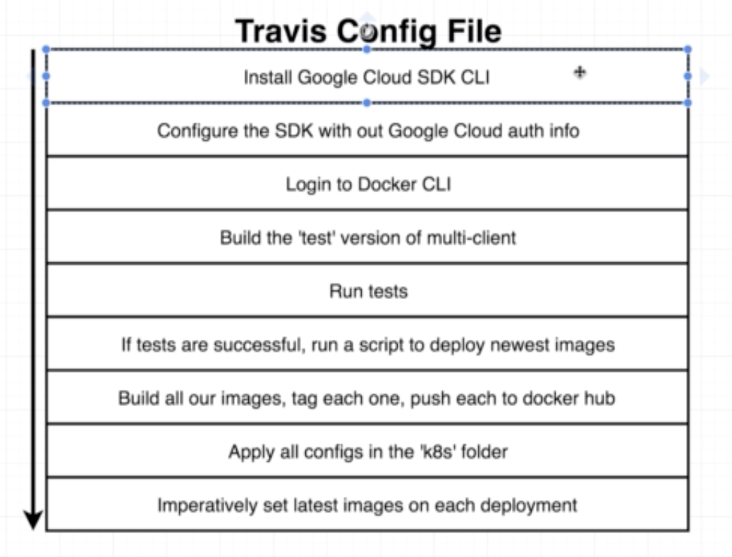

* **Helm Setup:**